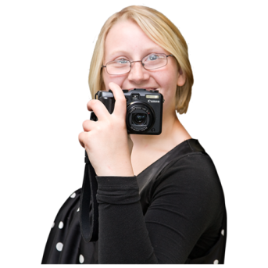
All our futures photo competition
Entry form

About me
Name | Click here to enter text.
Phone number | Click here to enter text.
Email address | Click here to enter text.
Address | Click here to enter text.
 | Click here to enter text.
 | Click here to enter text.
Postcode | Click here to enter text.

About my photo
Title | Click here to enter text.
What does this picture mean to you | Click here to enter text.

Permission
It is very important to us that we only use pictures that we are allowed to.
We can only accept your photo if you answer all of these questions
If there are any people in your picture do you have their permission to give this photo to Learning Disability Wales and Able Radio? | ☐ Yes
 | ☐ No
Do you give permission for Learning Disability Wales and Able Radio to show this picture at our conference and use it in future to promote our work and the rights of disabled people? | ☐ Yes
 | ☐ No

Send your completed application form and photo to harriett.johnson@ldw.org.uk by 29 October 2018.
If you have trouble sending your picture give Harriett a ring on 029 20681161

You can decide at any time that you don’t want us to use your photo anymore. Just phone or email us and let us know. 029 2068 1160 Enquiries@ldw.org.uk
We will not give your photo to anyone else to use.

