Hi there!
Thanks for being interested in being a Gig Buddy!
We have included below some information about volunteering as a Gig Buddy, and our project. If you are interested, please can you complete the attached application form and send it back to us.
If you have any questions please let us know. Our contact details are at the end of this document, or you can ask us whatever you need to when we meet.

How Gig Buddies helps people to improve people’s lives
Many people with a learning disability find it difficult to go out and enjoy the things that they love to do. For example, almost 1 in 3 young people with a learning disability spend less than an hour a day outside their homes (2016 Mencap survey of 18-35 year olds with a learning disability).
Barriers that prevent people going out, especially at night, include: lack of support, fear of bullying and discrimination, transport issues, confidence, nobody to go with, and not knowing what’s on.
By being a Gig Buddy you will play a really important part in supporting someone to overcome these issues.

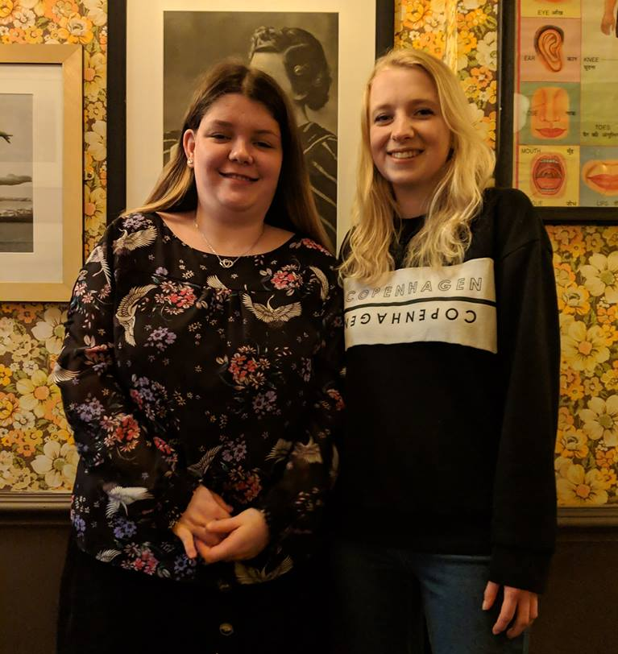
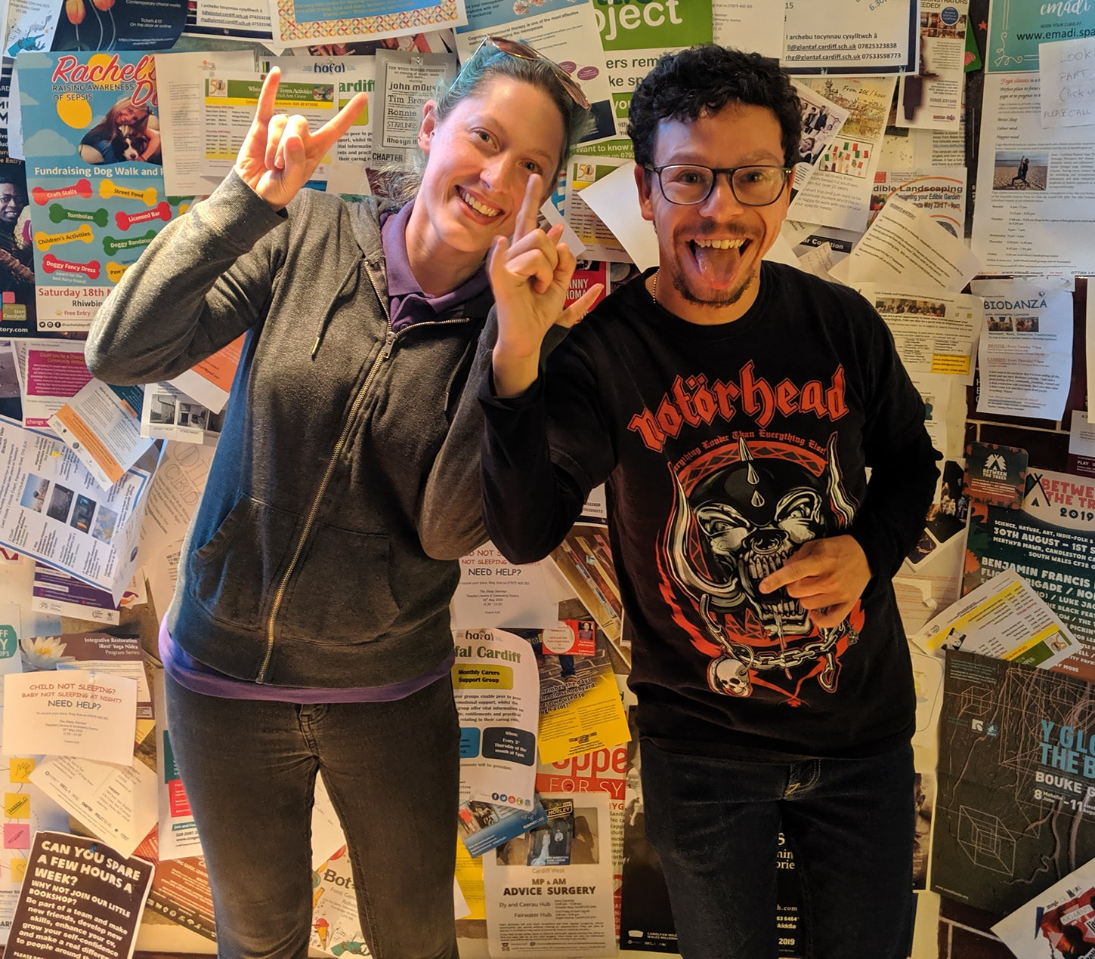

What happens next?
As soon as we receive your application form we will arrange to meet you for an informal interview. This is so we can find out a little more about you, and start to think about who you will make a perfect Gig Buddy for.
We will let you know when we think we have made a good match, and can then arrange for you and your Gig Buddy to meet each other.
In the meantime we will invite you to attend a free training day which covers all aspects about being a great Gig Buddy.

Gig Buddies training
All our Gig Buddy volunteers have to attend a free Gig Buddy training day, as well as pass a DBS check – this is a police check that makes sure our Gig Buddies are safe to support vulnerable people.
The free training covers all parts about being a great Gig Buddy, including:
- an introduction to learning disability and autism
- the barriers that people with a learning disability and autism face in life, and how having a Gig Buddy can help improve their lives
- communication
- safeguarding (keeping your Gig Buddy safe)
- how to make sure your Gig Buddy has a great time when you are out together.
The free training is a relaxed and fun day and takes about 6 hours. Lunch, refreshments and snacks are provided.

What is expected of Gig Buddy volunteers?
We ask you to attend, on average, 1 gig or event with your Gig Buddy every month.
We also ask you Gig Buddy to meet up with you for a short meeting every month, to through gig and events listings together and plan your next gig. You can do this at a café or pub, or somewhere else that your Gig Buddy likes to go.
Every month we also hold Gig Buddies socials, where we invite all our Gig Buddies to get together for an event.
This is usually in the evening, somewhere central in Cardiff, and sometimes followed by a gig.
We will support you and your Gig Buddy at your first gig together.

More information
You can more information about our project on our website at http://www.ldw.org.uk/project/ffrindiau-gigiau-caerdydd-gig-buddies-cardiff/
There is also a very good FAQ about Gig Buddies at the Gig Buddies Brighton website: https://stayuplate.org/faqs-gig-buddies/
Best wishes
Kai and Kylie
Ffrindiau Gigiau / Gig Buddies
Mobile: 07707 605 314 / 07594 938 522
Office (Learning Disability Wales): 029 2068 1160

Email: gigbuddies@ldw.org.uk
(Our working days are Wednesdays and Thursdays)

www.facebook.com/FfrindiauGigiau
https://twitter.com/FfrindiauGigiau
www.ffrindiaugigiau.org.uk
https://www.ldw.org.uk/project/ffrindiau-gigiau-caerdydd-gig-buddies-cardiff/
Application to volunteer for…

Please fill out the following information on pages 1 and 2. Then make a profile about yourself on page 3 – please make your language as accessible as possible on this page.

Name
Address
Telephone (home and mobile)
Email
Date of birth
Are you on social media (give us the names of any Twitter handles etc you’d like to connect through)
Do you have a driving licence and access to a car?
Are you willing to travel (either driving or public transport) in order to volunteer?
Do you have any health needs that we should be aware of? (please get in touch if you would like to discuss support that you will need to volunteer)
Please give us the name of an emergency contact for you | Name:  Relationship to you:  Telephone:  Address:
Are you happy for photos of yourself to be used to promote gig buddies? | Yes No
Please provide details of two referees that we can contact to confirm that you will make a great volunteer: one referee must know professionally, the other can be a friend (not family member). | Name:  Relationship to you:  Address:  Email:  Telephone:
Second referee | Name:  Relationship to you:  Address:  Email:  Telephone:
Criminal convictions

Gig Buddies Cardiff has to make sure that all our volunteers are safe to work with people with a learning disability – all information you give will be treated confidentially.

All Gig Buddies volunteers will need to have a police check through the Disclosure and Barring Service before they can start.

If you have a conviction we will need to meet and talk about it, but it won’t necessarily prevent you from volunteering. We will only take into account a criminal record if it could be important to your role as a Gig Buddy.
Have you ever been convicted of any criminal offence by a court of law? | Yes No  (If yes please give details)
Please declare | As far as I know, all information that I have provided on this form is correct.  Name:  Date:  And return this form to: Gig Buddies, Learning Disability Wales, 41 Lambourne Crescent, Llanishen, Cardiff, CF14 5GG  or email: gigbuddies@ldw.org.uk  Kylie- 07707605314 Kai- 07594938522
All about (write your name here)
Replace this picture of Elton John with a photo of yourself

I live in… | Write the name of your town
I am aged | Write your age
Music I like | Tell us your favourite artists and genres – and anything you really don’t like.
My hobbies and interests
Experience of disability or people with a learning disability and/or autism | Please tell us if you what experience you have. For example, do you have any family members or friends who are disabled, or have you worked with disabled people or people with a learning disability.  Don’t worry if you don’t have any experience – you can still be a great Gig Buddy. This information is helpful when we start to think of who you would be a great Gig Buddy for.
Why I want to join gig buddies!

Why I would be a good gig buddy! | You could list your experience of working with or socialising with people with a Learning Disability and /or Autism, things you’re good at and / or your personal qualities (Don’t worry if you haven’t any ‘formal’ experience, you can still make an awesome Gig Buddy!)

