Hello
Thanks for being interested in having a Gig Buddy!
We have attached an easy read application form for you to complete.
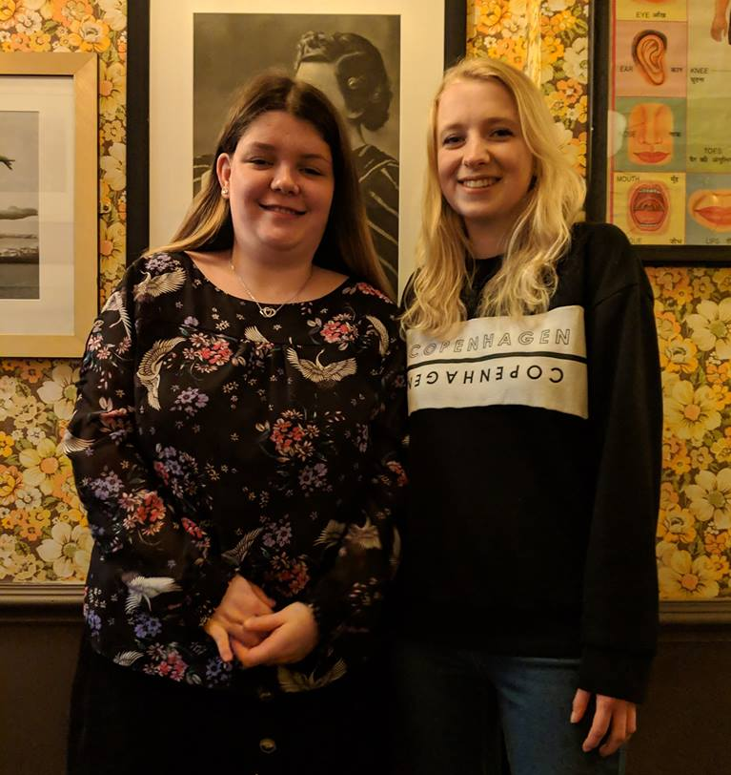
If you need any help, ask someone to support you to answer the questions. You can also phone or email us, and we can help you. Our contact details are at the end of this letter.
We have included an easy read leaflet about our Gig Buddies project. And we have included below some more information for you.
If you have any questions please let us know.

What happens next?
As soon as we receive your application form we will arrange to meet with you. This is so we can find out a little more about you.
After this, we will start to match you with a Gig Buddy. This may take a little time as we want to make sure we make a match with a volunteer who has similar interests to you, and you will get on together.
We will let you know when we think we have made a good match, and can then arrange for you and your Gig Buddy to meet each other.
About the training that volunteers get
All our Gig Buddy volunteers have to attend a day’s free Gig Buddy training, as well as pass a DBS check – a police check, to make sure they are safe people. And provide two references.
The free training covers all parts about being a great Gig Buddy, including:
- an introduction to learning disability and autism
- communication
- safeguarding (keeping your Gig Buddy safe)
- how to make sure your Gig Buddy has a good time when you are out together.

What is expected of Gig Buddy volunteers?
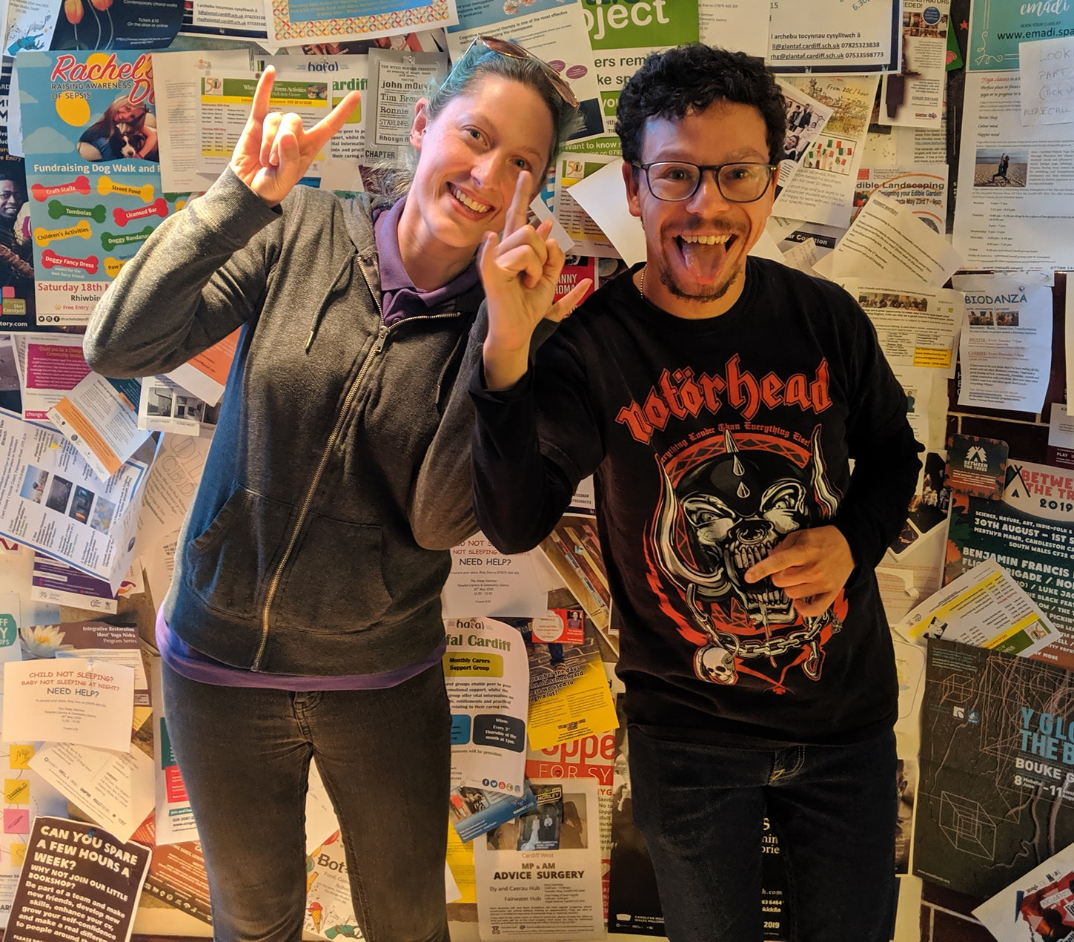
We ask your Gig Buddy to attend, on average, 1 gig or event with you every month.
We also ask your Gig Buddy to meet up with you for a short meeting every month so you look through gig and events listings together and plan your next gig. You can do this at a café or pub, or somewhere else that you like to go.
Every few months we also hold Gig Buddies socials, where we invite all our Gig Buddies to get together for an event.
This is usually in the evening, somewhere central in Cardiff, and sometimes followed by a gig.
We will support you and your Gig Buddy at your first gig together.

More information
You can more information about our project on our website at http://www.ldw.org.uk/project/ffrindiau-gigiau-caerdydd-gig-buddies-cardiff/
There is also a very good FAQ about Gig Buddies at the Gig Buddies Brighton website: https://stayuplate.org/faqs-gig-buddies/
Best wishes
Kai and Kylie
Ffrindiau Gigiau Caerdydd / Gig Buddies Cardiff

Mobile: 07707 605 314 / 07594 938 522
Office (Learning Disability Wales) 029 2068 1160

Email: gigbuddies@ldw.org.uk
(Our working days are Wednesdays and Thursdays)

www.facebook.com/FfrindiauGigiau
https://twitter.com/FfrindiauGigiau
www.ffrindiaugigiau.org.uk
https://www.ldw.org.uk/project/ffrindiau-gigiau-caerdydd-gig-buddies-cardiff/
Application form to have a Gig Buddy

All about me…
 | Your name:
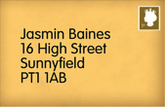 | Your address:
 | Your date of birth:
Your telephone numbers:

Home:

Mobile:

 | Your email address:
 | What music are you into? (this could be types of music, like ‘rock’ or bands / singers, like ‘Beyonce’)
 | What are your hobbies?
 | Do you have any preferences about the person you are matched with (age, gender, interests)?
Do you have support worker(s) or PA(s) to help you, and if so approximately how many hours a week do they work with you?
What provider (or direct payments) do they work for?

 | How do you get to places? Do you travel alone or do you need support to travel?
 | Do you have any specific health needs (for example, epilepsy)? Would your buddy need any special training to help you with this?
 | Is there anything else that your buddy will need to know about support that you need?
Please could you give us the name of somebody else we can contact if we cannot get hold of you (this could be a parent or support worker)

Name:

Relationship to you:

Address:

Telephone:

You can email the form back to us, or scan a copy and forward it to gigbuddies@ldw.org.uk
You can also post it to us- Gig Buddies-Learning Disability Wales
Lambourne Crescent, Cardiff Business Park, 41, Cardiff CF14 5GG
Any questions please ring Kylie 07707605314 or Kai on 07920289674

