**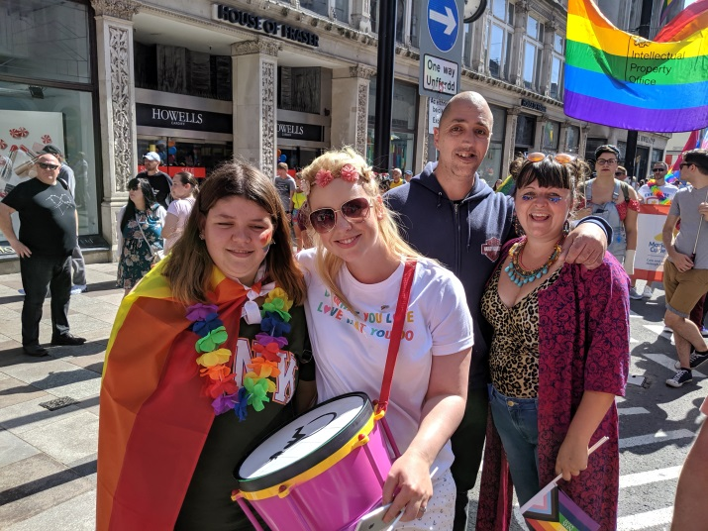

**Would you like to get out more and do the things you love?**

A **Gig Buddy** can help you go to gigs and events that you may find difficult attending.

A **'gig'** can be a concert or a festival. But it can also be a rugby match, a trip to a museum or theme park, or a visit to the beach.

We can find you a **Gig Buddy** if you live in:

* South Wales - **Bridgend, Cardiff, Merthyr Tydfil, RCT, Vale of Glamorgan.**
* North Wales - **Anglesey, Conwy, Denbighshire, Flintshire, Gwynedd, Wrexham**.

Your **Gig Buddy** could be a **Football Buddy**, a **Bowling Buddy**, a **Rambling Buddy**, a **Quiz Buddy**, a **Roller Skating Buddy**, a **Surfing Buddy**……

It’s up to you to tell us what type of **Gig Buddy** you want!

**I’m interested. So what does a Gig Buddy do?**

****A **Gig Buddy** is a volunteer who shares the same interests in music and hobbies as you. They can support you to go to gigs and events that are sometimes hard to get to.

A **Gig Buddy** can help you:

* Go to 1 gig or event every month.
* Meet up every month to plan your next gig.
* Attend regular social events with other **Gig Buddies**.
* Meet on the internet for activities and events – this is helpful when there is a lockdown.



Getting a **Gig Buddy** is free – it doesn’t cost you anything.

All **Gig Buddy** volunteers get a day of free training before they are matched with their **Gig Buddy**.

We make sure **Gig Buddy** volunteers have a police check to make sure they are safe and good people.

**I like the sound of this! How do I get a Gig Buddy?**All you need to do is fill out an easy read application form and send it to the Gig Buddies team. You can download a form at: [www.ldw.org.uk/gigbuddies](http://www.ldw.org.uk/gigbuddies)

The form asks you things like what hobbies and interests you have. And what support needs you have.

After we get your form we will contact you and arrange to meet you for a chat. So we can find out more about you.

And then we can start to find a **Gig Buddy** to match you with!

For more information contact the Gig Buddies team:

Email: [gigbuddies@ldw.org.uk](mailto:gigbuddies@ldw.org.uk)

Phone **029 2068 1160**  
  
  
Follow us on Facebook and Instagram:  
[@FfrindiauGigiau](https://www.instagram.com/ffrindiaugigiau)

