Agored Cymru
Course title: | Friends
Unit Code: | HB1E1CY022/HB1E2CY020/ HB1E3CY006
Level: | Entry One/Entry Two/Entry Three
Credit Value: | 1
Learner Name:
Learner Email:
Learner Date of Birth:
Learner Contact Details:
Start Date:
Tutor:
Date Submitted:

Plagiarism statement:

Plagiarism (unacknowledged borrowing and quotation) is an offence.
I declare that, apart from properly referenced information, this workbook is my own work and contains no plagiarism; it has not been submitted previously for any other assessed unit on this or other course.

Signed: |  | Date:

Authenticity Statement:

I certify that all statements and information contained herein and in all my submission materials submitted by me are true, correct and accurate to the best of my knowledge and belief. I further certify that the writing was written solely by me and is my original work

Signed: |  | Date:

Friends
Unit Code: HB1E1CY022
Level: Entry One
Credit Value: 1
Unit ID: CCX327
learndirect: HB1
Sector: 14.1 Foundations for Learning and Life
LEARNING OUTCOMES | ASSESSMENT CRITERIA
The learner will: | The learner can (with assistance):
  1. | Understand relationships with friends, with assistance.
  1.1 | Respond to pictures of friends.
  1.2 | Give examples of activities undertaken with friends.
  1.3 | Indicate why friends can make one happy or sad.

Assessment Methods:
There is no assessment information available for this unit. Assessments used should be fit for purpose for the unit and learners, and generate evidence of achievement for all the assessment criteria.
Assessor Requirements:
There is no information regarding specific assessor requirements for this unit. Centres should select assessors who are trained in assessment, and who have subject specific competence to assess at this level.
© 2011 Agored Cymru

To access policies and procedures please contact your local Agored Centre. Al Units are subject to change.

Friends
Unit Code: HB1E1CY022
Level: Entry One
Credit Value: 1
Unit ID: CCX327
learndirect: HB1
Sector: 14.1 Foundations for Learning and Life
LEARNING OUTCOMES | ASSESSMENT CRITERIA | Method | Assessor | Evidence | Date | Signature
The learner will: | The learner can (with assistance): | Assessment method | Who will assess? | Evidence which will be available for verification | Date achieved
  1. | Understand relationships with friends, with assistance.
  1.1 | Respond to pictures of friends.
  1.2 | Give examples of activities undertaken with friends.
  1.3 | Indicate why friends can make one happy or sad.

Assessment Methods:
There is no assessment information available for this unit. Assessments used should be fit for purpose for the unit and learners, and generate evidence of achievement for all the assessment criteria.
Assessor Requirements:
There is no information regarding specific assessor requirements for this unit. Centres should select assessors who are trained in assessment, and who have subject specific competence to assess at this level.
© 2011 Agored Cymru

Friends
Unit Code: HB1E2CY020
Level: Entry Two
Credit Value: 1
Unit ID: CCX061
learndirect: HB1
Sector: 14.1 Foundations for Learning and Life
LEARNING OUTCOMES | ASSESSMENT CRITERIA
The learner will: | The learner can (with verbal/gestural prompts):
  1. | Understand relationships with friends, with verbal and gestural prompts.
  1.1 | Identify and comment on pictures of friends.
  1.2 | Give examples of activities undertaken with friends.
  1.3 | Give examples of how friends can have a positive and negative effect.
  1.4 | Give examples of where you can meet new friends.
  1.5 | State why appropriate behaviour is important.
  1.6 | Give examples of people who can help you with friendship problems.

Assessment Methods:
- Oral question and answer
- Written exercise
- Role play/simulation
- Practical demonstration
- Group discussion
Assessor Requirements:
There is no information regarding specific assessor requirements for this unit. Centres should select assessors who are trained in assessment, and who have subject specific competence to assess at this level.
© 2011 Agored Cymru
To access policies and procedures please contact your local Agored Centre. Al Units are subject to change.

Friends

Unit Code: HB1E2CY020
Level: Entry Two
Credit Value: 1
Unit ID: CCX061
learndirect: HB1
Sector: 14.1 Foundations for Learning and Life
LEARNING OUTCOMES | ASSESSMENT CRITERIA | Method | Assessor | Evidence | Date | Signature
The learner will: | The learner can (with verbal/gestural prompts): | Assessment method | Who will assess? | Evidence which will be available for verification | Date achieved
  1. | Understand relationships with friends, with verbal and gestural prompts.
  1.1 | Identify and comment on pictures of friends.
  1.2 | Give examples of activities undertaken with friends.
  1.3 | Give examples of how friends can have a positive and negative effect.
  1.4 | Give examples of where you can meet new friends.
  1.5 | State why appropriate behaviour is important.
  1.6 | Give examples of people who can help you with friendship problems.

Assessment Methods:
- Practical demonstration
- Group discussion
- Oral question and answer
- Written exercise
- Role play/simulation
Assessor Requirements:
There is no information regarding specific assessor requirements for this unit. Centres should select assessors who are trained in assessment, and who have subject specific competence to assess at this level.
© 2011 Agored Cymru

Friends
Unit Code: HB1E3CY006
Level: Entry Three
Credit Value: 1
Unit ID: CCX062
learndirect: HB1
Sector: 14.1 Foundations for Learning and Life
LEARNING OUTCOMES | ASSESSMENT CRITERIA
The learner will: | The learner can:
  1. | Understand relationships with friends.
  1.1 | Give examples of activities undertaken with friends.
  1.2 | State why friends can have a positive and negative effect on behaviour.
  1.3 | Give examples of peer group pressure.
  1.4 | Give examples of conflict resolution techniques.

Assessment Methods:
There is no assessment information available for this unit. Assessments used should be fit for purpose for the unit and learners, and generate evidence of achievement for all the assessment criteria.
Assessor Requirements:
There is no information regarding specific assessor requirements for this unit. Centres should select assessors who are trained in assessment, and who have subject specific competence to assess at this level.
© 2011 Agored Cymru

To access policies and procedures please contact your local Agored Centre. Al Units are subject to change.

Friends
Unit Code: HB1E3CY006
Level: Entry Three
Credit Value: 1
Unit ID: CCX062
learndirect: HB1
Sector: 14.1 Foundations for Learning and Life
LEARNING OUTCOMES | ASSESSMENT CRITERIA | Method | Assessor | Evidence | Date | Signature
The learner will: | The learner can: | Assessment method | Who will assess? | Evidence which will be available for verification | Date achieved
  1. | Understand relationships with friends.
  1.1 | Give examples of activities undertaken with friends.
  1.2 | State why friends can have a positive and negative effect on behaviour.
  1.3 | Give examples of peer group pressure.
  1.4 | Give examples of conflict resolution techniques.

Assessment Methods:
There is no assessment information available for this unit. Assessments used should be fit for purpose for the unit and learners, and generate evidence of achievement for all the assessment criteria.
Assessor Requirements:
There is no information regarding specific assessor requirements for this unit. Centres should select assessors who are trained in assessment, and who have subject specific competence to assess at this level.
© 2011 Agored Cymru

Additional Activity – What is a good friend?

Sit in a circle. Take turns to tell the group about one of your friends. What makes them such a good friend?

Think about all the comments made. What makes a good friend?



Additional Activity – Keeping Friends

The key to keeping friends is to be a good friend yourself.

Sit in a circle. Take turns to tell the group why you are a good friend.

I am a good friend because…

1.

2.

3.

 | HB1E1CY022 – Entry One | HB1E2CY020 – Entry Two | HB1E3CY006 - Entry Three
Learning Outcome: | 1. Understand relationships with friends, with assistance. | 1. Understand relationships with friends, with verbal and gestural prompts | 1. Understand relationships with friends
Assessment Criteria: | 1.1 Respond to pictures of friends. | 1.1 Identify and comment on pictures of friends | 1.1 Give examples of activities undertaken with friends

Worksheet: Friend Groups

Tick the boxes where you can see a group of friends. What are these groups of friends doing?



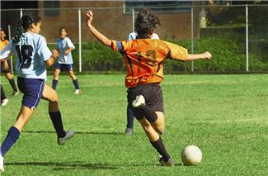
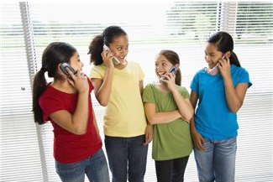
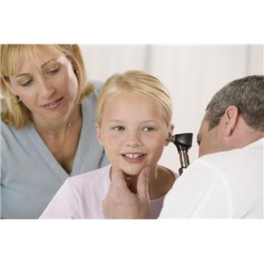

 | HB1E1CY022 – Entry One | HB1E2CY020 – Entry Two | HB1E3CY006 - Entry Three
Learning Outcome: | 1. Understand relationships with friends, with assistance. | 1. Understand relationships with friends, with verbal and gestural prompts | 1. Understand relationships with friends
Assessment Criteria: | 1.2 Give examples of activities undertaken with friends. | 1.2 Give examples of activities undertaken with friends | 1.1 Give examples of activities undertaken with friends

Worksheet: Activities You Can Do With Friends

Can you list or draw 3 other activities that you can do with friends?

1.

3.
2.



 | HB1E1CY022 – Entry One | HB1E2CY020 – Entry Two | HB1E3CY006 - Entry Three
Learning Outcome: | 1. Understand relationships with friends, with assistance. | 1. Understand relationships with friends, with verbal and gestural prompts | 1. Understand relationships with friends
Assessment Criteria: | 1.3 Indicate why friends can make one happy or sad. | 1.3 Give examples of how friends can have a positive and negative effect | 1.2 State why friends can have a positive and negative effect of behaviour

Worksheet: Activities

Why can friends make you happy?




Why can friends make you sad?




 | HB1E1CY022 – Entry One | HB1E2CY020 – Entry Two | HB1E3CY006 - Entry Three
Learning Outcome: |  | 1. Understand relationships with friends, with verbal and gestural prompts | 1. Understand relationships with friends
Assessment Criteria: |  | 1.3 Give examples of how friends can have a positive and negative effect | 1.2 State why friends can have a positive and negative effect of behaviour

Worksheet: Friendship Positives

What can be positive about friendships? Think about how you behave.

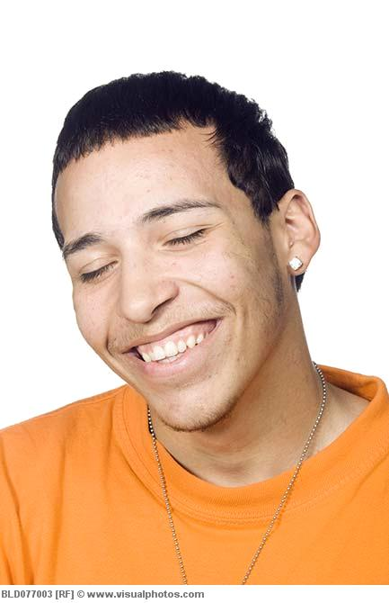

 | HB1E1CY022 – Entry One | HB1E2CY020 – Entry Two | HB1E3CY006 - Entry Three
Learning Outcome: |  | 1. Understand relationships with friends, with verbal and gestural prompts | 1. Understand relationships with friends
Assessment Criteria: |  | 1.3 Give examples of how friends can have a positive and negative effect | 1.2 State why friends can have a positive and negative effect of behaviour

Worksheet: Friendship Negatives

What can be negative about friendships? Think about how you behave.



 | HB1E1CY022 – Entry One | HB1E2CY020 – Entry Two | HB1E3CY006 - Entry Three
Learning Outcome: |  | 1. Understand relationships with friends, with verbal and gestural prompts
Assessment Criteria: |  | 1.4 Give examples of where you can meet new friends

Worksheet: Meeting New Friends

Give 3 examples of where you can meet new friends:



Hand Out - What is peer pressure?

“Peer Pressure is the feeling someone your own age is pushing you toward making a certain choice, good or bad.”

- It can be when a person asks you directly to do something, or says things to you that push you.



- It can also be when nothing is actually said to you, but because you see others doing something, you feel pressure to do the same.



 | HB1E1CY022 – Entry One | HB1E2CY020 – Entry Two | HB1E3CY006 - Entry Three
Learning Outcome: |  |  | 1. Understand relationships with friends
Assessment Criteria: |  |  | 1.3 Give examples of peer group pressure
Worksheet: Peer Pressure

As a group, discuss peer pressure. Share examples of what peer pressure is and write them below:



 | HB1E1CY022 – Entry One | HB1E2CY020 – Entry Two | HB1E3CY006 - Entry Three
Learning Outcome: |  |  | 1. Understand relationships with friends
Assessment Criteria: |  |  | 1.3 Give examples of peer group pressure

Worksheet: Examples of Peer Pressure

Can you spot examples of peer pressure?

Scenario: Chloe has met up with some of her friends from school. Her friend Jessica says:

“I’ve got us some lager. Do you want one?”

Chloe does not like drinking alcohol, so she says:

“No thanks, I’ve got some orange juice.”

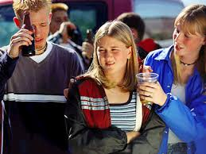

Tick the sentence below that shows peer pressure:

Jessica says: “Ok, no problem, I didn’t know that you didn’t like alcohol.”

OR

Jessica says: “Don’t be so boring Chloe, have a proper drink”

 | HB1E1CY022 – Entry One | HB1E2CY020 – Entry Two | HB1E3CY006 - Entry Three
Learning Outcome: |  |  | 1. Understand relationships with friends
Assessment Criteria: |  |  | 1.3 Give examples of peer group pressure

Worksheet: Examples of Peer Pressure Continued

Scenario: Dylan and Sarah have been boyfriend and girlfriend for a couple of months.

They do not feel ready to have sex yet.

Dylan’s friend Ross asks him if he has had sex with Sarah.

Dylan says:

“No we haven’t had sex and it is not your business!”



Tick the sentence below that shows peer pressure…

Ross says: “I understand, it’s your business and your decision”

OR

Ross says: “Everyone else has done it, why haven’t you?”

 | HB1E1CY022 – Entry One | HB1E2CY020 – Entry Two | HB1E3CY006 - Entry Three
Learning Outcome: |  |  | 1. Understand relationships with friends
Assessment Criteria: |  |  | 1.3 Give examples of peer group pressure

Worksheet: Examples of Peer Pressure Continued

Rachel is talking to her best friend Laura when Amy arrives.

Laura starts calling Amy nasty names.

She asks Rachel to join in, but Rachel says:

“No! Amy has not done anything wrong and I don’t want to be nasty”.

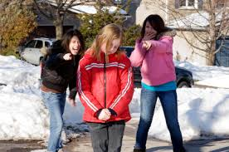

Tick the sentence below that shows peer pressure…

Laura says: “Ok, it’s your choice.”

OR

Laura says: “I will not be your friend if you don’t join in.”

 | HB1E1CY022 – Entry One | HB1E2CY020 – Entry Two | HB1E3CY006 - Entry Three
Learning Outcome: |  | 1. Understand relationships with friends, with verbal and gestural prompts
Assessment Criteria: |  | 1.5 State why appropriate behaviour is important

Worksheet: Meeting New People

Look at the pictures and circle the one that shows how you should behave when you meet someone for the first time.

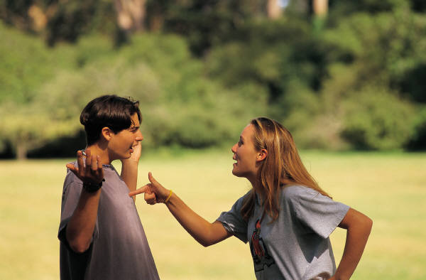





 | HB1E1CY022 – Entry One | HB1E2CY020 – Entry Two | HB1E3CY006 - Entry Three
Learning Outcome: |  | 1. Understand relationships with friends, with verbal and gestural prompts
Assessment Criteria: |  | 1.5 State why appropriate behaviour is important

Worksheet: How to Behave with Friends

What is the right way to behave with friends?

- Put a tick (  ) by the statements that show how you should behave around your friends.
- Put a cross (  ) by the statements that show how you shouldn’t behave around your friends.

Should you…..?
Kiss your friend

Laugh with your friend

Hold hands with your friend

Hit your friend

Say nasty things about your friends

Smile at your friend

Listen to your friend

Tell lies about your friend

Keep your friends secrets if they ask you to

Hug your friend

Give your friend support if they’ve got a problem

Laugh at your friends

Share with your friends

 | HB1E1CY022 – Entry One | HB1E2CY020 – Entry Two | HB1E3CY006 - Entry Three
Learning Outcome: |  | 1. Understand relationships with friends, with verbal and gestural prompts
Assessment Criteria: |  | 1.5 State why appropriate behaviour is important

Worksheet: How to Behave with Friends

List 3 of the statements that you have just ticked:

Why is it important to behave in this way?



Handout – Conflict Resolution
(www.cyh.com/HealthTopics)

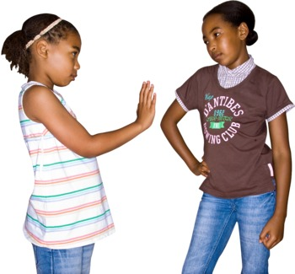

Sometimes, in friendships, small disagreements can happen. This is okay. However, it is important to deal with these disagreements in an appropriate way.

To try and sort things out so that everyone gets a fair go, there are 4 things you need to do.

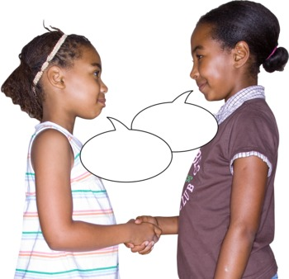
- Understand
- Avoid making things worse
- Work together
- Find the solution

Understand:

Everyone needs to know what the disagreement is about. To do this everyone involved needs to:

- Say what they feel about it (without interruptions)
- Listen to what other people have to say about their feelings (without interrupting them)
- Try to put themselves in the other person’s shoes and try to understand their point of view

Avoid making things worse:

- No put-downs
- No mean, nasty remarks that will hurt people’s feelings – no personal remarks about a person’s looks, gender, their ’secrets’ or things that have happened in the past.
- No screaming or shouting
- No fighting, hitting, kicking, pushing or any kind of hurting the other person’s body

Work together:

- Make ‘I’ statements, like:
- ‘I feel hurt when…’
- ‘I need to feel or be…’
- ‘I hear what you are saying, but I feel…’
- Say what you feel without blaming the other person.
- Take turns in speaking.
- Talk quietly.
- Write down what you each see as the problem and then read what the other person has written.
- Listen – look at them, nod, make listening noises (uh-huh), repeat what you have heard.

Find the solution:
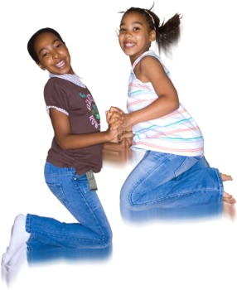
Once you have listened to each other and found what the problem is, then you need to look for a solution.

- Think together of ways in which you could resolve the conflict. You will need to write them down.
- You may want to involve another person to suggest ways of making your ideas work.

Hand Out – Conflict Resolution

Remember to:

Think about the problem

Say what you feel

Listen to the other person

Suggest solutions

Decide what each one will do

Stick to what you have decided

Talk again if the solution is not working

 | HB1E1CY022 – Entry One | HB1E2CY020 – Entry Two | HB1E3CY006 – Entry Three
Learning Outcome: |  |  | 1. Understand Relationships with friends.
Assessment Criteria: |  |  | 1.4 Give examples of conflict resolution techniques.
Hand Out – Friendship Scenarios

Read the scenario below:

Your friend Paul is finding his maths class difficult. He starts to copy your work. You notice this and get annoyed as you have worked hard in class.

As Paul’s friend, what should you do to solve this issue? Underline the conflict resolution techniques you would use.

Say, ‘Paul, I understand it, so why don’t you?’
Say, ‘Can you tell me what you are finding difficult?’
Shout, ‘Stop copying me!’
Listen to Paul’s problem and find out why he is copying you.
Ignore the problem. It will go away in time.
Tell a teacher that the Paul is copying you and annoying you.
Make fun of Paul for not understanding the work and call him nasty names.
Ask a teacher for help.
Shout at Paul as he is frustrating you. The work is easy.
Ask Paul if he would like your help.

 | HB1E1CY022 – Entry One | HB1E2CY020 – Entry Two | HB1E3CY006 – Entry Three
Learning Outcome: |  |  | 1. Understand Relationships with friends.
Assessment Criteria: |  |  | 1.4 Give examples of conflict resolution techniques.

Hand Out – Friendship Scenarios

Read the scenario below and answer the question that follows:

You are out with your friend Joe and decide to call into the local shop. Joe has no money, so you lend her £1 to buy some chocolate. You ask your friend to pay you back the following day as you need the money for your lunch. Joe agrees.

The following day, you ask Joe for the money that she owes you. Joe says that she hasn’t got it as their mother didn’t have any change to give her that day.

You are VERY annoyed at Joe as she promised to give you your money back today. Joe is annoyed that you are being grumpy. She says it is not her fault she hasn’t got the money for you.

What should you do to solve this issue?

 | HB1E1CY022 – Entry One | HB1E2CY020 – Entry Two | HB1E3CY006 – Entry Three
Learning Outcome: |  |  | 1. Understand Relationships with friends.
Assessment Criteria: |  |  | 1.4 Give examples of conflict resolution techniques.

Hand Out – Conflict Quiz



Complete the following quiz…

1. Your friend has not talked to you for a few days and you are not sure why. What should you do?
a) Ask your friend if everything is ok
b) Shout at your friend until they talk to you
c) Ignore your friend

2. Two of your friends have argued and are not talking. What should you do?
a) Decide to only stay friends with one of them
b) Talk to both of your friends to find out what has happened
c) Not talk to either of your friends again

3. Your friend keeps borrowing money from you and doesn’t give it back. What should you do?
a) Not speak to them again
b) Shout at them and hit them until you get your money
c) Ask your friend for your money back and not lend them any more

4. Your friend sometimes pushes you and hits you for no reason. What should you do?
a) Ask them to stop
b) Push them or hit them back
c) Shout at them until they stop

5. Your friend tells you something and asks you to keep it a secret. What should you do?
a) Tell one of your other friends but ask them not to tell anyone
b) Keep it to yourself
c) Tell all of your other friends
 | HB1E1CY022 – Entry One | HB1E2CY020 – Entry Two | HB1E3CY006 – Entry Three
Learning Outcome: |  | 1. Understand relationships with friends, with verbal and gestural prompts
Assessment Criteria: |  | 1.6 Give examples of people who can help you with friendship problems

Hand Out – Getting Help

Write down 3 people that could help you if you had a problem with a friend…
1.

2.

3.

Tutor Observation Record

The assessment criteria should be signed off depending on how the learner has achieved their workbook answers. During the taught sessions, has the learner completed the relevant exercises with assistance, with verbal/gestural prompts or have they completed each of the assessment criteria independently?

For example: If a learner has completed 1.2, ‘Give examples of activities undertaken with friends’, with assistance, then sign and date the relevant section in the Entry One table. However, if they have completed the assessment criteria with verbal/gestural prompts, then sign the relevant section in the Entry Two table.

If the assessment criteria for each unit are the same or similar, only one should be signed. For example, if the learner has given examples of activities undertaken with friends with assistance, then only 1.2 in the Entry One table should be signed and not in the Entry Two table.

It is important to note that to achieve the award at a certain level ALL assessment criteria at that level MUST be met.

See the following example:

I confirm that I have observed the learner carrying out the activities for the following assessment criteria.

LEARNING OUTCOMES  The learner will: | ASSESSMENT CRITERIA  The learner can  (with assistance): | Tutor Signature | Date Achieved
 |  | Joe Bloggs | 01.01.12
  1. | Understand relationships with friends, with assistance.
  1.1 | Respond to pictures of friends.
  1.2 | Give examples of activities undertaken with friends.
  1.3 | Indicate why friends can make one happy or sad.

Tutor Observation Record – Entry One

I confirm that I have observed the learner carrying out the activities for the following assessment criteria.

LEARNING OUTCOMES  The learner will: | ASSESSMENT CRITERIA  The learner can  (with assistance): | Tutor Signature | Date Achieved
  1. | Understand relationships with friends, with assistance.
  1.1 | Respond to pictures of friends.
  1.2 | Give examples of activities undertaken with friends.
  1.3 | Indicate why friends can make one happy or sad.

Tutor Observation Record – Entry Two

I confirm that I have observed the learner carrying out the activities for the following assessment criteria.

LEARNING OUTCOMES  The learner will: | ASSESSMENT CRITERIA  The learner can  (with verbal/gestural prompts): | Tutor Signature | Date Achieved
  1. | Understand relationships with friends, with verbal and gestural prompts.
  1.1 | Identify and comment on pictures of friends.
  1.2 | Give examples of activities undertaken with friends.
  1.3 | Give examples of how friends can have a positive and negative effect.
  1.4 | Give examples of where you can meet new friends.
  1.5 | State why appropriate behaviour is important.
  1.6 | Give examples of people who can help you with friendship problems.

Tutor Observation Record - Entry Three

I confirm that I have observed the learner carrying out the activities for the following assessment criteria.

LEARNING OUTCOMES  The learner will: | ASSESSMENT CRITERIA  The learner can: | Tutor Signature | Date Achieved
  1. | Understand relationships with friends.
  1.1 | Give examples of activities undertaken with friends.
  1.2 | State why friends can have a positive and negative effect on behaviour.
  1.3 | Give examples of peer group pressure.
  1.4 | Give examples of conflict resolution techniques.

