Agored Cymru
Course title: | Tackling Bullying
Unit Code: | HB11CY015
Level: | ONE
Credit Value: | 1
Learner Name:
Learner Email:
Learner Date of Birth:
Learner Contact Details:
Start Date:
Tutor:
Date Submitted:

Plagiarism statement:

Plagiarism (unacknowledged borrowing and quotation) is an offence.
I declare that, apart from properly referenced information, this workbook is my own work and contains no plagiarism; it has not been submitted previously for any other assessed unit on this or other course.

Signed: |  | Date:

Authenticity Statement:

I certify that all statements and information contained herein and in all my submission materials submitted by me are true, correct and accurate to the best of my knowledge and belief. I further certify that the writing was written solely by me and is my original work.

Signed: |  | Date:

Tackling Bullying
Unit Code: HB11CY015
Level: One
Credit Value: 1
Unit ID: BZS173
learndirect: HB1
Sector: 14.1 Foundations for Learning and Life
LEARNING OUTCOMES | ASSESSMENT CRITERIA
The learner will: | The learner can:
  1. | Understand the terms bullying and victim.
  1.1 | State what bullying is.
  1.2 | State what a victim is.
  2. | Understand how to deal with bullying.
  2.1 | State at least three different forms of bullying.
  2.2 | Identify at least three effects of bullying.
  2.3 | Identify coping/support mechanisms.
  3. | Recognise sources of help and support.
  3.1 | Identify how others can help both the bully and the victim.
  3.2 | Identify the difference between 'seeking help' and 'grassing'.

Assessment Methods:
There is no assessment information available for this unit. Assessments used should be fit for purpose for the unit and learners, and generate evidence of achievement for all the assessment criteria.
Assessor Requirements:
There is no information regarding specific assessor requirements for this unit. Centres should select assessors who are trained in assessment, and who have subject specific competence to assess at this level.
All units are subjects to change. To access policies and procedures please contact your local Agored Centre.
© 2011 Agored Cymru

Tackling Bullying
Unit Code: HB11CY015
Level: One
Credit Value: 1
Unit ID: BZS173
Sector: 14.1 Foundations for Learning and Life

LEARNING OUTCOMES | ASSESSMENT CRITERIA | Method | Assessor | Evidence | Date | Signature
The learner will: | The learner can: | Assessment method | Who will assess? | Evidence which will be available for verification | Date achieved
1. Understand the terms bullying and victim. | 1.1 State what bullying is.  1.2 State what a victim is. | Workbook – Written Definition  Workbook – Written Definition |  | Page 4  Page 5
2. Understand how to deal with bullying. | 2.1 State at least three different forms of bullying.  2.2 Identify at least three effects of bullying.  2.3 Identify coping/support mechanisms. | Workbook – Written Activity  Workbook – Written Activity  Workbook – Written Activity |  | Page 6  Page 8  Page 10
3. Recognise sources of help and support. | 3.1 Identify how others can help both the bully and the victim.  3.2 Identify the difference between 'seeking help' and 'grassing'. | Workbook – Written Activity  Workbook – Matching Game and  Written Activity |  | Page 13  Page 14  Page 15

Assessment Methods:
There is no assessment information available for this unit. Assessments used should be fit for purpose for the unit and learners, and generate evidence of achievement for all the assessment criteria.
Assessor Requirements:
There is no information regarding specific assessor requirements for this unit. Centres should select assessors who are trained in assessment, and who have subject specific competence to assess at this level.
© 2011 Agored Cymru

Learning Outcome: | 1 Understand the terms bullying and victim
Assessment Criteria: | 1.1 State what bullying is

Worksheet: Bullying Definition

In a large group, discuss what you think bullying is. Note down your ideas on the flip chart.

Once you have finished the discussion write the ideas below:
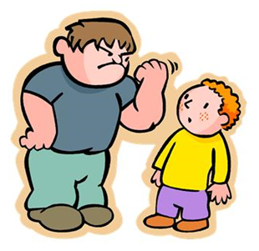
Bullying is…
__________________________________

__________________________________

__________________________________

__________________________________

__________________________________

_____________________________

Learning Outcome: | 1 Understand the terms bullying and victim
Assessment Criteria: | 1.2 State what a victim is

Worksheet: Victim Definition

On your own, think about what you think is meant by the term ‘victim’. Write your idea on a piece of paper and pass it to the tutor.

Once each person in the group has done this, the tutor will read the ideas to the larger group for discussion.


Now write your own explanation below:
A victim is…
__________________________________

__________________________________

__________________________________

__________________________________

__________________________________

_____________________________

Learning Outcome: | 2 Understand how to deal with bullying
Assessment Criteria: | 2.1 State at least three different forms of bullying

Worksheet: Written Activity

Can you name different types of bullying?
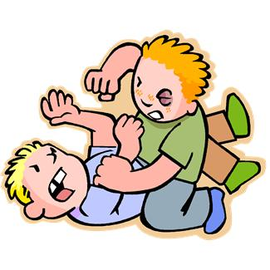



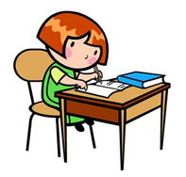
Additional Activity

In small groups discuss the following statement:

‘If you laugh with a bully, you are a bully too’.

What are your views about this statement?

In my opinion...

Learning Outcome: | 2 Understand how to deal with bullying
Assessment Criteria: | 2.2 Identify at least three effects of bullying

Worksheet: Written Activity

The boy below is being bullied. Think about how he is feeling. What could be the effects of bullying here?



Additional Activity

Read each statement below and decide if it is TRUE or FALSE.

- If you are being bulled, you should keep it a secret
This statement is True/False.

- If a bully hits you, you should hit them back
This statement is True/False.

- It is not your fault if you are being bullied

This statement is True/False.


Learning Outcome: | 2 Understand how to deal with bullying
Assessment Criteria: | 2.3 Identify coping/support mechanisms

Worksheet: Written Activity
Identify some ways of coping with bullying:

Using the resources provided and the internet, list 3 people/places that could support a person who is being bullied.
1 _____________________________________ ___
2 ______________________________ __________
3 ________________________ ________________

Additional Activity
You may want to write or stick the information you find here:

Additional Activity

Why do people bully others?
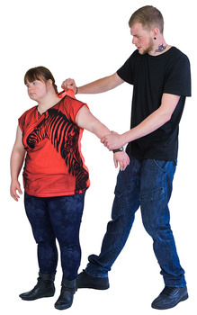

Learning Outcome: | 3. Recognise sources of help and support
Assessment Criteria: | 3.1 Identify how others can help both the bully and the victim

Worksheet: Written Activity

How can bullies be supported to stop bullying others?

___________________________________________________________

___________________________________________________________

___________________________________________________________

___________________________________________________________

___________________________________________________________

___________________________________________________________

How could you support a friend if they were being bullied?

___________________________________________________________

___________________________________________________________

___________________________________________________________

___________________________________________________________

___________________________________________________________

___________________________________________________________

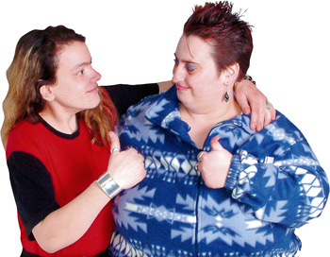

Learning Outcome: | 3. Recognise sources of help and support
Assessment Criteria: | 3.2 Identify the difference between ‘seeking help’ and ‘grassing’.

Worksheet: Matching Game

Match each of the statements to either ‘grassing’ or ‘seeking help’.

Telling on someone

Finding support

Betraying someone

Getting someone into trouble

Making positive changes

Grassing
Seeking Help

Learning Outcome: | 3. Recognise sources of help and support
Assessment Criteria: | 3.2 Identify the difference between ‘seeking help’ and ‘grassing’.

Worksheet: Written Activity

Read the stories below and decide which young person is ‘grassing’ and which young person is ‘seeking help’.

Story 1


Emily’s brother lends her a CD to listen to whilst she does her homework. When she has finished with it, Emily takes it out of the CD player and accidentally scratches it. It is now broken. When Emily returns the CD her brother is upset that it is broken. In a temper he runs downstairs and tells his mother that Emily has ruined his CD.

Is Emily’s brother grassing or seeking help? ______ _________

Story 2
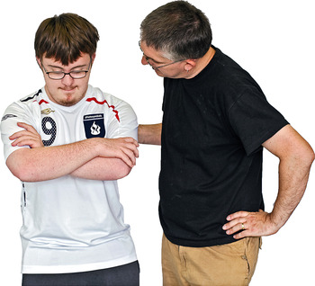
John is in the school yard when a group of older boys come up to him and start calling him names. This happens every day for a whole week, which upsets John. By Friday he has had enough. He decides to tell a teacher as he doesn’t want this to happen any more.

Is John grassing or seeking help? __________________ _____

What is the difference between grassing and seeking help?

______________________________________________________________

______________________________________________________________

______________________________________________________________

______________________________________________________________

