Participant Questionnaire

Participant Name:
Participant Number:
Date:
Signed Participant:
Signed Staff Member:

This form is available in Welsh, and in other languages and formats on request.
Mae’r cyhoeddiad hwn ar gael yn Gymraeg, ac mewn ieithoedd a fformatau eraill ar gais.

Things I love

PEOPLE


TV or FILMS


PETS


MUSIC
FOOD

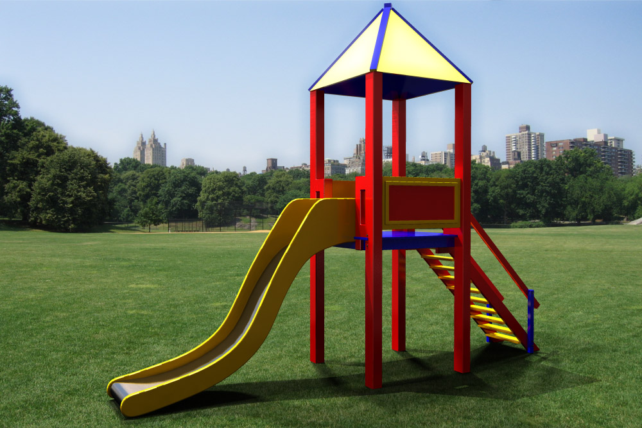


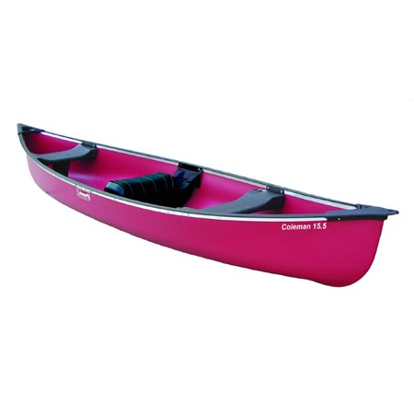

PLACES

ACTIVITIES





Tell me about a typical day

Morning
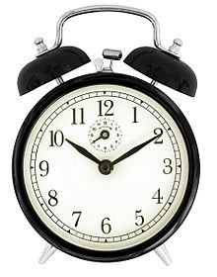

School


After school



Weekend
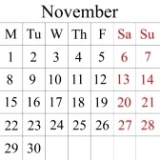

Bedtime


What areas of the project are you interested in? |   YES | 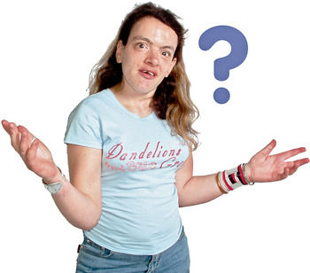  NOT SURE |   NO

Person Centered Planning for the Future

My Life

Independent Living Skills
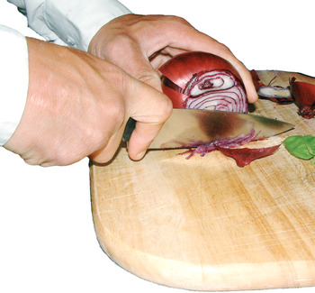



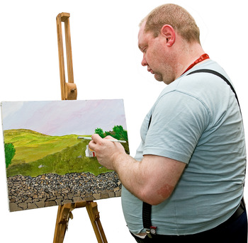

Leisure Opportunities




Relationships
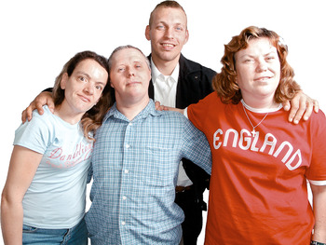

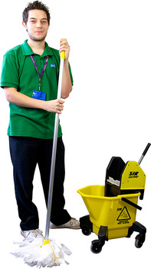
Lifelong Learning/Employment
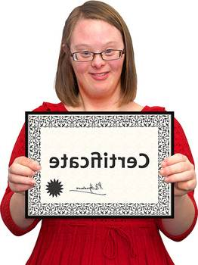


THANK YOU

Use the table below to help explain the areas of activity.

Independent Living Skills  Using money  Dressing/undressing  Personal hygiene  Doing household tasks  Being able to live away from home  Cooking  Having a range of hobbies  Using telephone  Travel independently  Telling time  Healthy living  PERSON CENTRED  PLANNING FOR THE FUTURE  Choices  Wishes  Aspirations  Decisions  Support  Transition  Information  Shopping | Leisure Opportunities  Attending youth club  Keeping fit  Using local leisure facilities e.g. swimming  Making new friends  Going out with friends  Earning a Duke of Edinburgh Award  Going to a disco  Trying new activities
Keeping safe  Asking for help  Having a girlfriend  Having a boyfriend  Communicating with people  Learning good social skills  Self esteem  Having more confidence  Appropriate / inappropriate behaviour  Asking for what you want  Sexual health  Phobias / anxieties  Relationships | Understanding the world of work  Preparing for work  Being able to earn money  Voluntary work  Getting qualifications  Work experience  Having a ‘Saturday’ job  Having a job  Vocational training  Going to college / university  Lifelong Learning/Employment  Voluntary work

