Agored Cymru
Course title: | RESPECT Disability Awareness Youth Training
Unit Code: | AF42CY004
Level: | Two
Credit Value: | 1
Learner Name:
Learner Email:
Learner Date of Birth:
Learner Contact Details:
Start Date:
Tutor:
Date Submitted:

Plagiarism statement:

Plagiarism (unacknowledged borrowing and quotation) is an offence.
I declare that, apart from properly referenced information, this workbook is my own work and contains no plagiarism; it has not been submitted previously for any other assessed unit on this or other course.

Signed: |  | Date:

Authenticity Statement:

I certify that all statements and information contained herein and in all my submission materials submitted by me are true, correct and accurate to the best of my knowledge and belief. I further certify that the writing was written solely by me and is my original work

Signed: |  | Date:

RESPECT Disability Awareness Youth Training
Unit Code: AF42CY004
Level: Two
Credit Value: 1
Unit ID: BZW377
learndirect: AF4
Sector: 14.2 Preparation for Work
LEARNING OUTCOMES | ASSESSMENT CRITERIA
The learner will: | The learner can:
  1. | Understand disability issues.
  1.1 | Discuss what disability means.
  1.2 | Identify types of disability people may have.
  1.3 | Discuss the idea that disabled people want what others enjoy.
  2. | Recognise the effects of disability discrimination.
  2.1 | Discuss the idea that disabled people may miss out on fun.
  3. | Recognise how language, behaviour and actions can achieve inclusion.
  3.1 | Identify appropriate and inappropriate language with respect to disability.
  3.2 | Illustrate the impact of word use.
  3.3 | Describe ways in which behaviour and actions may help people feel confident to join in.
  4. | Understand the concept of inclusion and how to develop strategies to encourage it.
  4.1 | Identify ways of including disabled people in everyday trips and games.
  4.2 | Discuss the importance of including people.
  5. | Actively participate in group activities and discussions.
  5.1 | Discuss the importance of listening to others.
  5.2 | Participate in training activity.

Assessment Methods:
- Role play/simulation
- Group discussion
- Production of artefact
- Case study
- Oral question and answer
- Written exercise
Assessor Requirements:
There is no information regarding specific assessor requirements for this unit. Centres should select assessors who are trained in assessment, and who have subject specific competence to assess at this level.

RESPECT Disability Awareness Youth Training
Unit Code: AF42CY004
Level: Two
Credit Value: 1
Unit ID: BZW377
learndirect: AF4
Sector: 14.2 Preparation for Work
LEARNING OUTCOMES | ASSESSMENT CRITERIA | Method | Assessor | Evidence | Date | Signature
The learner will: | The learner can: | Assessment method | Who will assess? | Evidence which will be available for verification | Date achieved
 | 1.1 Discuss what disability means.  1.2 Identify types of disability people may have.  1.3 Discuss the idea that disabled people want what others enjoy. | Workbook - Discussion notes & Tutor Observation  Workbook – Written Activity,  Matching Game & Picture Quiz  Workbook – Discussion Notes &  Tutor Observation |  | Page 5  Page 9  Page 10 – 12  Page 13
  1. | Understand disability issues.
 | 2.1 Discuss the idea that disabled people may miss out on fun. | Workbook – Discussion Notes &  Tutor Observation |  | Page 14
  2. | Recognise the effects of disability discrimination.
 | 3.1 Identify appropriate and inappropriate language with respect to disability.  3.2 Illustrate the impact of word use.  3.3 Describe ways in which behaviour and actions may help people feel confident to join in. | Workbook – Written Activity  Workbook – Role Play and Tutor Observation  Written Activity  Workbook – Quiz  Workbook – Written Activity |  | Page 15 and 17  Page 15 & 16  Page 17  Page 18 & 19  Page 19
  3. | Recognise how language, behaviour and actions can achieve inclusion.
 | 4.1 Identify ways of including disabled people in everyday trips and games.  4.2 Discuss the importance of including people. | Workbook - Written Activity  Workbook – Discussion Noyes &  Tutor Observation |  | Pages 20, 21 & 22  Page 23
  4. | Understand the concept of inclusion and how to develop strategies to encourage it.
 | 5.1 Discuss the importance of listening to others.  5.2 Participate in training activity. | Workbook – Discussion Notes &  Tutor Observation  Workbook – Practical Activity Notes & Tutor Observation |  | Page 27  Page 28
  5. | Actively participate in group activities and discussions.

Assessment Methods:
- Role play/simulation
- Group discussion
- Production of artefact
- Case study
- Oral question and answer
- Written exercise
Assessor Requirements:
There is no information regarding specific assessor requirements for this unit. Centres should select assessors who are trained in assessment, and who have subject specific competence to assess at this level.

Learning Outcome: | 1. Understand disability issues
Assessment Criteria: | 1.1 Discuss what disability means

Worksheet: Disability Discussion

As a large group read and discuss the handouts on pages 6, 7 and 8. In smaller groups, talk about the word ‘Disability’. What does this mean to you?
Note your ideas on the flip chart provided and feedback to the larger group.

Now write your own definition in the box below:

Disability means…

___________________________________________________________________

___________________________________________________________________

___________________________________________________________________

___________________________________________________________________

Criteria | Assessment | Date Achieved
1.1 | Discuss what disability means.
Tutor Comments:

Tutor’s Signature: |  | Date:

Learning Outcome: | 1. Understand disability issues
Assessment Criteria: | 1.1 Discuss what disability means

Handout: Medical and Social Models

Medical Model

Weak hands so cannot open jar
Social Model

Packaging needs re-designing
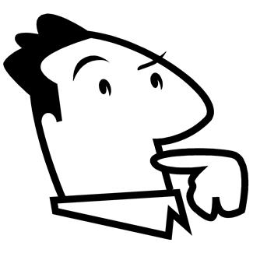

Learning Outcome: | 1. Understand disability issues
Assessment Criteria: | 1.1 Discuss what disability means

HANDOUT

Impairment: an injury, illness or congenital condition that causes or is likely to cause a long-term effect on physiological or psychological functions

Disability: the loss or limitation of opportunities to take part in society on an equal level with others due to social and environmental barriers.

www.daii.org

HANDOUT – What is Disability?

What is disability?
Many people don't realise that disability can be looked at in more than one way. People normally see disability as an individual's problem, and they talk to us about 'your disability'. Perhaps the most important thing that the Disabled People's Movement has learnt is that it isn't our disability. We know that the problem is the barriers we face in life, as people with particular conditions or impairments. It is these barriers that disable us. And it is society, designed and run by non-disabled people, that puts those barriers up. It can take a while to grasp this idea but once you do it is liberating.

Disability as an individual's problem
Most non-disabled people, especially doctors and disability professionals, think disability is an individual's problem. Any difficulties we face are seen as caused by the particular impairment (or condition) we have. We cannot do what we want to because of 'our disability'. So, if someone who uses a wheelchair cannot get upstairs to a meeting, people blame the wheelchair, and not the stairs. Or if someone who has dyslexia cannot fill in a job application form, employers blame the person, not the application form. People think we are limited in what we can do, because we are not 'the same' as the rest of society. This is often called the 'medical model' of disability. It has been around for a long time, and it is used by a lot of people, including Government departments, to decide what they should be doing about disability.

Disability as society's problem
The Disabled People's Movement has developed a very different way of looking at disability. We have learnt that disability is not caused by us - it is caused by society. This is often called the 'social model' of disability. It is not our impairment or condition that stops us doing what everyone else does. What stops us is the fact that we live in a world which ignores our needs - for access, understanding, transport, education, employment, and so on. So the wheelchair user couldn't get to the meeting because it was upstairs. The building was built with no lift, and the people organising the meeting didn't move it to a ground floor room. The wheelchair user was quite able to take part in the meeting -the way the building was designed, and the meeting organised, 'disabled' them.
(The Disabled People’s Movement)

Learning Outcome: | 1. Understand disability issues
Assessment Criteria: | 1.2 Identify types of disability people may have

Worksheet: Types of Disabilities

Identify the types of disability people may have.

Sensory impairments
e.g. Blind or deaf.



Learning Outcome: | 1. Understand disability issues
Assessment Criteria: | 1.2 Identify types of disability people may have
Worksheet: Identifying Disabilities

Read each of the explanations below and note which disability you think it is describing from the list below.

* ASPERGER’S SYNDROME * ASTHMA * ATTENTION DEFICIT DISORDER * * AUTISM * CEREBRAL PALSY * COELIAC DISEASE * CYSTIC FIBROSIS
* DOWN’S SYNDROME * DYSLEXIA * DYSPRAXIA * EPILEPSY
* MUSCULAR DYSTROPHY * SPINA BIFIDA * SPINAL CORD INJURIES

Explanation | Disability
A form of autism. People with this usually have fewer problems with language than people with autism. They are less likely to have a learning disability, so they often have average or above average intelligence.
Individuals often like to have regular routines and can find changes upsetting.
Chronic, progressive, degenerative and fatal musculoskeletal disorder, which begins in early childhood. Symptoms usually begin between the ages of 3 to 7, predominantly in boys. They gradually loses motor skills. Death usually occurs at between 20 and 25 years. It is caused by a hereditary sex-linked recessive gene.
Wheezing and breathlessness. Varies from mild to severe. Attacks of ‘wheezing’ gradually become incapacitating.
It is probably an inherited allergy – a sensitivity that may manifest as asthma, eczema or hay fever.
A specific learning disability, namely the inability to translate letter sounds into letter symbols. Sometimes known as word blindness. It may be any degree from a mild spelling difficulty to complete illiteracy. It may be inherited. Associated with a lack of cerebral dominance.
A term used to describe a person of average or above average intelligence who have developmentally inappropriate degrees of inattention, impulsiveness and hyperactivity. They may be uncoordinated or clumsy. Boys are more commonly affected than girls. Other terms are impulse disorder and hyperactive child syndrome.
A lack of enzymes in the digestive and respiratory system, causing problems with breathing and digestion. The mucus glands secrete abnormally sticky mucus, which clogs the digestive and respiratory systems. Sweat glands produce very salty sweat.
It is a hereditary genetic chromosome abnormality.
A disorder of early childhood characterised by the following:
Lack of responsiveness and difficulties forming relationships with other
People; Difficulties with communication or language skills; Bizarre responses to various aspects of the environment; Peculiar speech patterns; Difficulties with using the imagination; Onset within the first 30 months of life.
They may exhibit self-stimulating behaviours such as hand-flicking or body-spinning and may also have a learning disability.
A spinal cord disorder characterised by the failure of the vertebral column to close. The person may have paralysis below the involved level when the spinal cord is involved. Muscle weakness may be present at or above the lesion.
There are two major classifications of this disability:
1. Dyskinetic: refers to a group of disorders characterised by abnormal fluctuating muscle tone, involuntary muscle action and uncoordinated movement patterns.
2. Spastic: is a non-progressive brain disorder, which causes impairment and abnormalities of voluntary movement and posture.
Intelligence and language may also be affected.
It is caused by damage to the movement centres of the brain. This can occur before birth or during birth (lack of oxygen to the brain)
An inability to absorb gluten because of a missing enzyme, leading to inflammation of the intestinal cells that produce mucus and interference with the absorption of fats. A child may have delayed growth, poor appetite and a pot-belly.
It is hereditary. The body is unable to make a necessary enzyme.
The inability to perform purposeful learned motor acts in the absence of paresis, ataxia or disturbance of muscle tone such as plasticity. There may be problems with co-ordination, language, perception and thought. Mainly affects males.
A recurrent disorder of the brain characterised by sudden brief attacks of altered consciousness, motor activity, sensory phenomena or inappropriate behaviour. It may be related to a minute scar or metabolic abnormalities in the brain.
Other examples are infectious diseases of the nervous system, heat stroke and trauma to the brain
A developmental disorder caused by inherited genetic variations of the chromosomes. The person tends to have a characteristic appearance. The hands may be short and broad, interfering with coordination and dexterity. The child usually has delayed or missed milestones in physical development. The person may have heart disease. All individuals will have a learning disability. The person may have possible visual disorders.
Its cause is unknown. Associated with mothers over 40.

There are two categories:
- Paraplegia: the loss of motor and sensory function below the level of a spinal cord injury (lesion)
- Quadriplegia: the partial or complete paralysis of the upper and lower extremities caused by compression or dislocation of the spinal cord, which results in disruption of nerve impulses to and from the brain and spinal nerves.
Loss of function depends on levels of spinal cord injuries.
It is caused by trauma, accidents and infectious diseases of the central nervous system. Accidents most frequently occur in adolescents and young adults.

Learning Outcome: | 1. Understand disability issues
Assessment Criteria: | 1.2 Identify types of disability people may have

Worksheet: Celebrities

All of the celebrities below are said to have an impairment or disability. Do you know they type of impairment/disability each person is said to have?
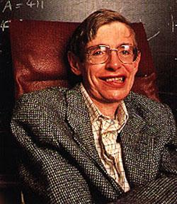
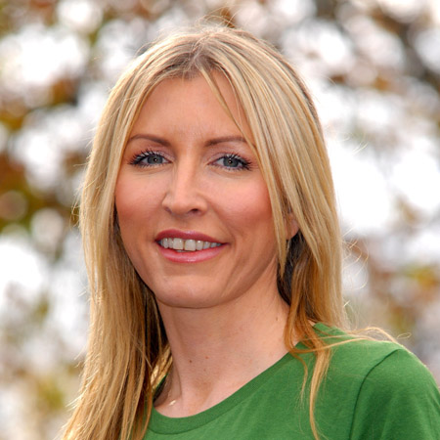

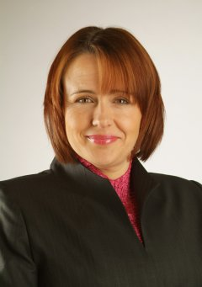


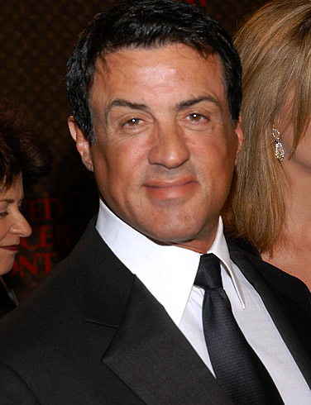
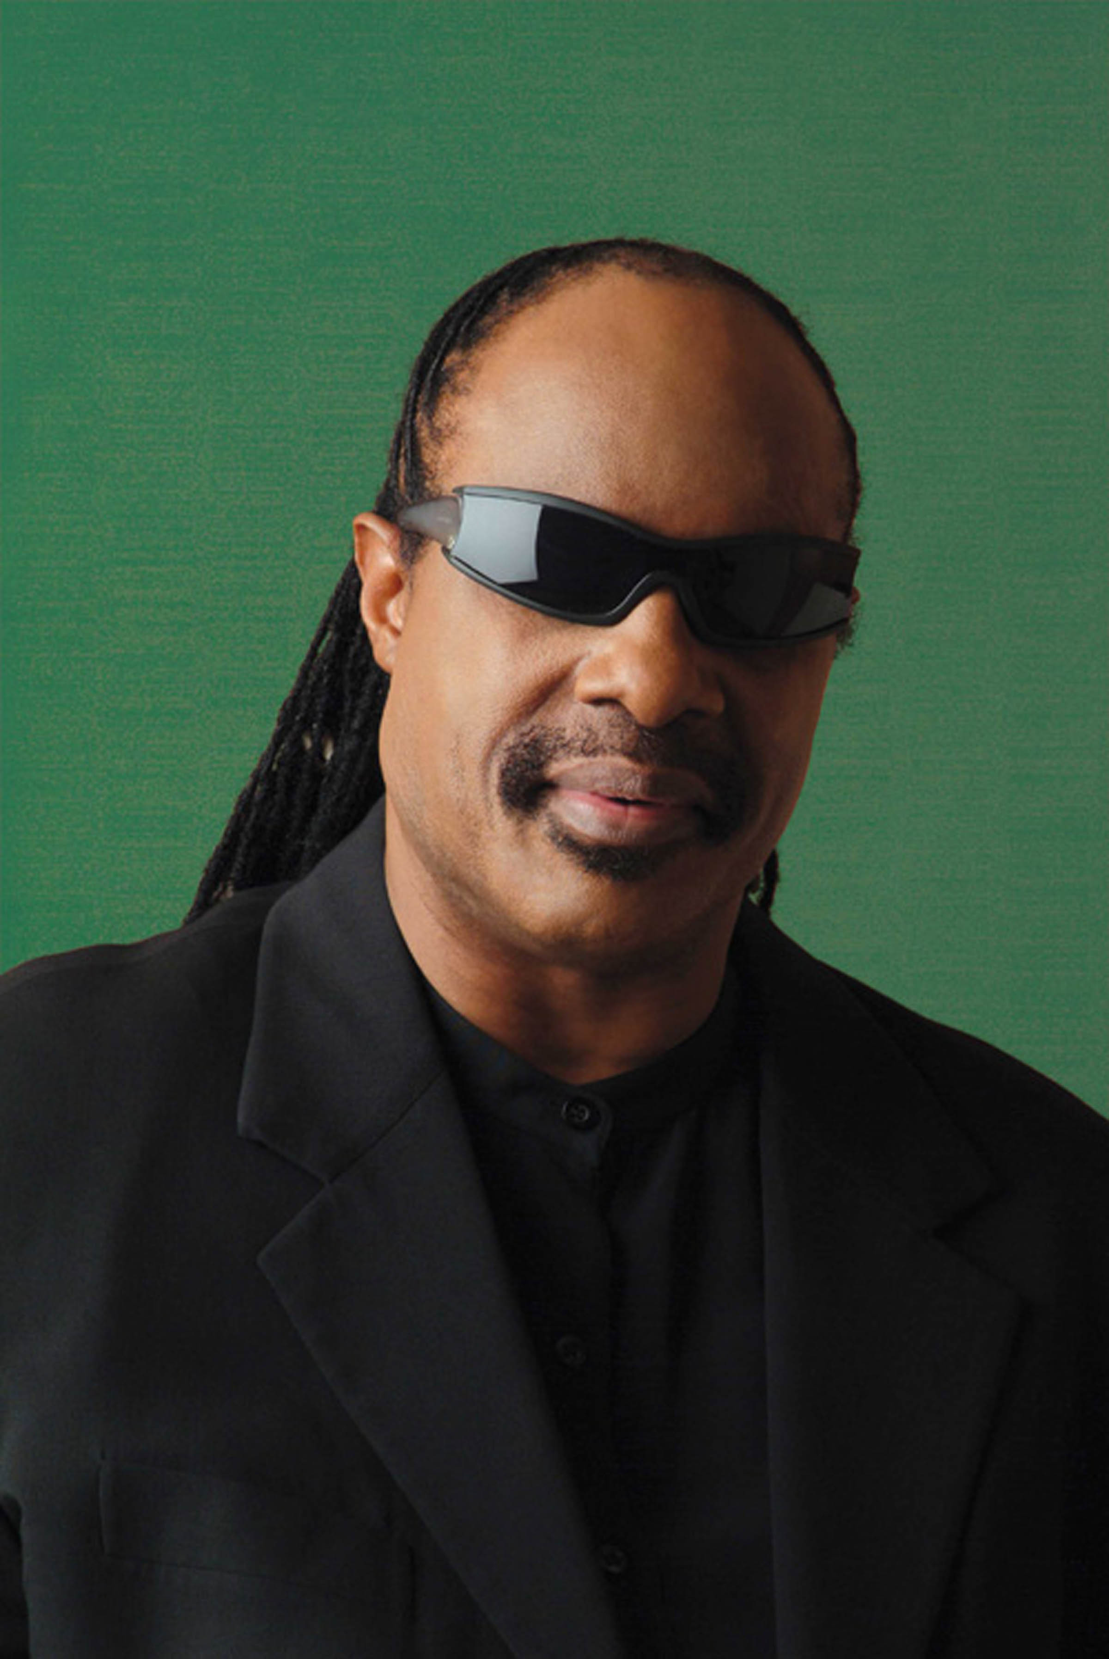


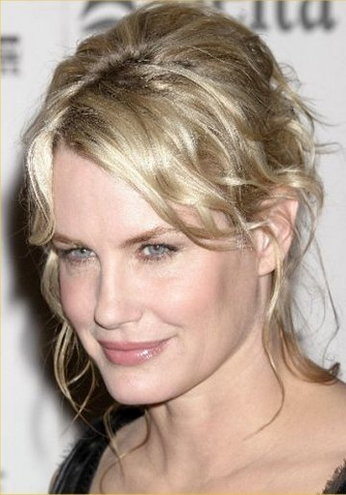




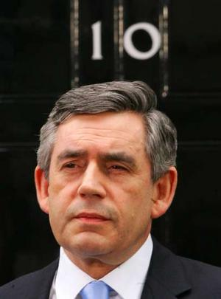
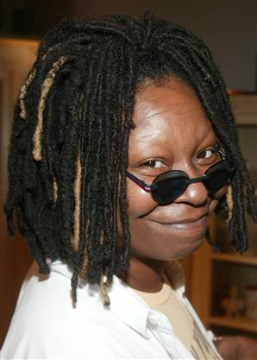

Learning Outcome: | 1. Understand disability issues
Assessment Criteria: | 1.3 Discuss the idea that disabled people want what others enjoy

Worksheet: Group Discussion – do disabled people want what others enjoy
The group will split into two groups and debate the following question:

‘Do disabled people want what others enjoy?’

Using the materials provided, one group will argue ‘Yes’ and the other will argue ‘No’. Note down the groups key points.

- ………………………………………………………………………………………………………………………………………

- ………………………………………………………………………………………………………………………………………

- ………………………………………………………………………………………………………………………………………

- ………………………………………………………………………………………………………………………………………

- ………………………………………………………………………………………………………………………………………

What is your personal view?

Criteria | Assessment | Date Achieved
1.3 | Discuss the idea that disabled people want what others enjoy.
Tutor Comments:

Tutor’s Signature: |  | Date:

Learning Outcome: | 2. Recognise the effects of disability discrimination
Assessment Criteria: | 2.1 Discuss the idea that disabled people may miss out on fun

Worksheet: Discussion – Disabled people may miss out on fun

Discuss the following statement:

‘Disabled people may miss out on fun.’

Some ideas you could think about during your discussion could include access, communication, self-esteem, inclusion and society.
Note down the groups key points…

- …………………………………………………………………………………………………………………………………………………..

- …………………………………………………………………………………………………………………………………………………..

- …………………………………………………………………………………………………………………………………………………..

- ………………………………………………………………………………………………………………………………………………….

- ………………………………………………………………………………………………………………………………………………….

Criteria | Assessment | Date Achieved
2.1 | Discuss the idea that disabled people may miss out on fun.
Tutor Comments:

Tutor’s Signature: |  | Date:

Learning Outcome: | 3. Recognise how language, behaviour and actions can achieve inclusion
Assessment Criteria: | 3.1 Identify appropriate and inappropriate language with respect to disability.  3.2 Illustrate the impact of word used

Worksheet: Impact of Words

In small groups, identify and note on the flip chart all the words used for people with a disability or learning difficulty. You can use slang as part of this exercise.
Note down some examples below:

- ………………………………………………………………………
- ………………………………………………………………………
- ………………………………………………………………………
Are they appropriate or inappropriate words? ………………………………………………………

Put together a role play where these inappropriate terms are used and show the impact this could have on an individual.
Give an overview of your role-play:

………………………………………………………………………………………………………………………………………………………………

………………………………………………………………………………………………………………………………………………………………

………………………………………………………………………………………………………………………………………………………………

How did the person feel being called these names? …………………………………………………….

…………………………………………………………………………………………………………………………………………………………

Why did they feel like this? What impact did these inappropriate terms have on the individual?
……………………………………………………………………………………………………………………………………………………………

……………………………………………………………………………………………………………………………………………………………

……………………………………………………………………………………………………………………………………………………………

Learning Outcome: | 3. Recognise how language, behaviour and actions can achieve inclusion
Assessment Criteria: | 3.1 Identify appropriate and inappropriate language with respect to disability.  3.2 Illustrate the impact of word used

Criteria | Assessment | Date Achieved
3.2 | Identify the impact of word used
Tutor Comments:

Tutor’s Signature: |  | Date:

Worksheet: Impact of Words Assessment



Learning Outcome: | 3. Recognise how language, behaviour and actions can achieve inclusion
Assessment Criteria: | 3.1 Identify appropriate and inappropriate language with respect to disability.  3.2 Illustrate the impact of word used

Worksheet: Appropriate Language

You now need to think of different terms to use that are non-discriminatory and therefore more appropriate.

Inappropriate terminology | Appropriate terminology
The Disabled, Invalid, Cripple, Handicapped
Disabilities
Suffers from…
Mentally ill
Mentally handicapped
The deaf/Deaf & Dumb
The blind
Carer
Wheelchair Bound
Normal person
What impact would using these appropriate terms have on an individual?

……………………………………………………………………………………………………………………………………………………………

……………………………………………………………………………………………………………………………………………………………

……………………………………………………………………………………………………………………………………………………………

……………………………………………………………………………………………………………………………………………………………

Learning Outcome: | 3. Recognise how language, behaviour and actions can achieve inclusion
Assessment Criteria: | 3.1 Identify appropriate and inappropriate language with respect to disability.

Worksheet: Etiquette Quiz

Complete the ‘Etiquette True or False Quiz’ below:

 | TRUE/FALSE | BECAUSE…
‘Treat disabled people as you would treat any other person.’

‘Always assume that an offer of assistance will be welcome.’

‘Address the disabled person’s assistant when asking a question (e.g. “Does he take sugar?”).’

‘It is ok to lean on a persons’ wheelchair.’
‘When talking to a person with a visual impairment identify yourself clearly, and introduce anyone else who is present and where he or she is placed in the room.’

‘Do not interact with or feed an assistance dog without prior agreement of the visually impaired person.’
‘When speaking to a person with a speech impairment, it is ok to speak for the person, or to finish their sentences.’
‘If you don't understand what is being said by a person with speech impairment, don't be afraid or embarrassed to ask the person to repeat it maybe several times.’

Learning Outcome: | 3. Recognise how language, behaviour and actions can achieve inclusion
Assessment Criteria: | 3.1 Identify appropriate and inappropriate language with respect to disability.

Worksheet: Etiquette Quiz Continued
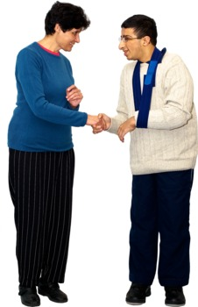
Describe ways in which behaviour and actions may help people feel confident to join in.

……………………………………………………………………………………………………………………………………………………………

……………………………………………………………………………………………………………………………………………………………

……………………………………………………………………………………………………………………………………………………………

……………………………………………………………………………………………………………………………………………………………

……………………………………………………………………………………………………………………………………………………………
‘If a person has a speech impairment they will probably have a hearing impairment or learning difficulties too.’
‘When speaking to a person with a hearing impairment or who is deaf, speak in a natural, conversational tone. It is not necessary to speak loudly or to over-enunciate.’

Learning Outcome: | 4. Understand the concept of inclusion and how to develop strategies to encourage it.
Assessment Criteria: | 4.1 Identify ways of including disabled people in everyday trips and games.

Worksheet: Inclusion
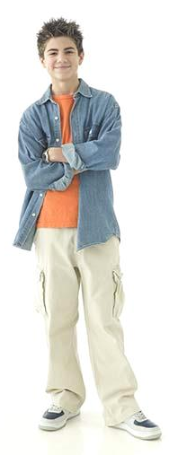
How could you include disabled people in everyday trips and games?

- …………………………………………………………………………………………………………………………………

- …………………………………………………………………………………………………………………………………

- …………………………………………………………………………………………………………………………………

- …………………………………………………………………………………………………………………………………

- …………………………………………………………………………………………………………………………………
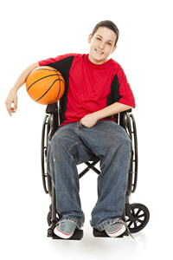
This is Joe and this is Adam.

Adam
Joe

They are friends and like to go out together during the evenings and weekends.

Read through the 2 scenarios on the following page and answer the questions.

Learning Outcome: | 4. Understand the concept of inclusion and how to develop strategies to encourage it.
Assessment Criteria: | 4.1 Identify ways of including disabled people in everyday trips and games.

Learning Outcome: | 4. Understand the concept of inclusion and how to develop strategies to encourage it.
Assessment Criteria: | 4.1 Identify ways of including disabled people in everyday trips and games.
Worksheet: Inclusion Scenarios

Scenario 1 - ‘At the Café'

One weekend Adam and Joe meet in a café for a drink and a chat. An able-bodied waiter approaches the boys and asks Adam, ‘What would your friend like to drink?’

How could Joe have been included? What would have been more appropriate?

…………………………………………………………………………………………………………………………………………………………………………

…………………………………………………………………………………………………………………………………………………………………………

…………………………………………………………………………………………………………………………………………………………………………

Scenario 2 - ‘At the Cinema’

Joe and Adam go to the cinema to watch the latest film. The entrance has steps. Adam goes in and asks a staff member about wheelchair access. They reply, ‘The disabled entrance is around the back’.

How could Joe have been included? What would have been more appropriate?

………………………………………………………………………………………………………………………………………………………………………

………………………………………………………………………………………………………………………………………………………………………

………………………………………………………………………………………………………………………………………………………………………

Learning Outcome: | 4. Understand the concept of inclusion and how to develop strategies to encourage it.
Assessment Criteria: | 4.1 Identify ways of including disabled people in everyday trips and games.

Learning Outcome: | 4. Understand the concept of inclusion and how to develop strategies to encourage it.
Assessment Criteria: | 4.1 Identify ways of including disabled people in everyday trips and games.
Worksheet: Inclusive Activities

Take a look at the games/activities/trips below and think how they could be made more inclusive?

Activity | How could it be made more inclusive?

Chess

Football

Cinema trip


Swimming
Other ideas…

Learning Outcome: | 4. Understand the concept of inclusion and how to develop strategies to encourage it.
Assessment Criteria: | 4.2 Discuss the importance of including people.

Discussion: Discuss the importance of including people.
Note down the key points…

- ……………………………………………………………………………………………………………………………………………

- ……………………………………………………………………………………………………………………………………………

- ……………………………………………………………………………………………………………………………………………

- ……………………………………………………………………………………………………………………………………………

- ……………………………………………………………………………………………………………………………………………

Criteria | Assessment | Date Achieved
3.2 | Discuss the importance of including people.
Tutor Comments:

Tutor’s Signature: |  | Date:

Additional Activity – Challenging Behaviours

When including people, it is important to be aware of acceptable and unacceptable behaviours from both disabled and non-disabled young people.

Take part in the, ‘Would You or Wouldn’t You?’ activity below:

Would you or wouldn’t you… | Non – disabled young person | Disabled young person
…tell a friend to stop if they were swearing?
…tell a friend to stop if they were waving their arms/hands erratically?
…tell a friend to stop if they were hitting someone else?
…tell a friend to stop if they were touching their genitals in a public place?
…tell a friend to stop if they were making unusual noises?

What have you discovered from taking part in this activity?

…………………………………………………………………………………………………………………………………………………………………….

………………………………………………………………………………………………………………………………………………………………………

………………………………………………………………………………………………………………………………………………………………………

………………………………………………………………………………………………………………………………………………………………………

………………………………………………………………………………………………………………………………………………………………………

When you are talking to someone do you… | Always | Quite a lot | Sometimes | Very  occasionally | Never
Let your mind wander to other things? | 0 | 1 | 2 | 3 | 4
Pay no attention to their body language? | 0 | 1 | 2 | 3 | 4
Focus on what you don’t like about the speaker? | 0 | 1 | 2 | 3 | 4
Cut in when they are speaking? | 0 | 1 | 2 | 3 | 4
Believe you already know what they are going to say? | 0 | 1 | 2 | 3 | 4
Concentrate on what you are going to say next? | 0 | 1 | 2 | 3 | 4
Think about what they are wearing? | 0 | 1 | 2 | 3 | 4
Additional activity - Are you a good listener?

Additional activity - Are you a good listener? - Results

What is your total score?

If you scored between 1 – 10

You’re a walking ideas factory. You’re passionate and excitable, but when it comes to listening maybe you just drift off a bit…

If you scored 11 – 20

You’re a bit of a mixture when it comes to listening. Sometimes you focus on people, sometimes you’re a space cadet. Does how much you listen depend on the person, the topic or what else is going on for you?

If you scored 21 – 28

You’re an expert listener. You read people well and give them space to express themselves

(Bored Meetings – Meeting skills for young decision makers)
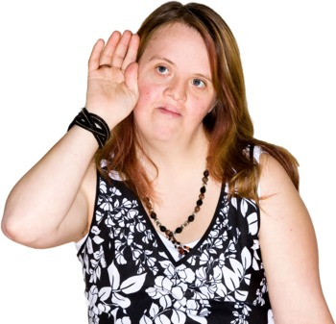

Learning Outcome: | 5. Actively participate in group activities and discussions
Assessment Criteria: | 5.1 Discuss the importance of listening to others

Worksheet: Listening

Discuss the importance of listening to others.

Note down the key points…

- ………………………………………………………………………………………………………………………

- ………………………………………………………………………………………………………………………

- ………………………………………………………………………………………………………………………

- ………………………………………………………………………………………………………………………

- ………………………………………………………………………………………………………………………
Criteria | Assessment | Date Achieved
5.1 | Discuss the importance of listening to others.
Tutor Comments:

Tutor’s Signature: |  | Date:

Learning Outcome: | 5. Actively participate in group activities and discussions
Assessment Criteria: | 5.2 Participate in training activity

Worksheet: Role Play
In pairs, you will take part in a joint activity. One participant will have a mock disability/impairment. The other will support that person to take part in the chosen activity.

It is important to note that this activity is about how you would support someone with a disability.
Once you have completed the activity, note how you supported the participant to carry out the task.

- ……………………………………………………………………………………………………………………

- ……………………………………………………………………………………………………………………

- ……………………………………………………………………………………………………………………

- ……………………………………………………………………………………………………………………

- ……………………………………………………………………………………………………………………

Criteria | Assessment | Date Achieved
5.2 | Participate in training activity.
Tutor Comments:

Tutor’s Signature: |  | Date:

