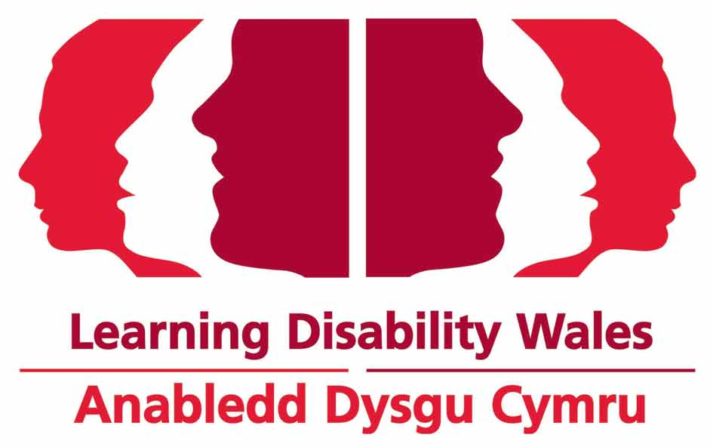

Learning Disability Wales
Real Opportunities Training and Information team
Work Experience Induction

Your Personal Details……………………………………………………………………………………….1
Learning Disability Wales…………………………………………………………………………………2
Information about the Real Opportunities Project……………………………..……………3
What Learning Disability Wales does for the Real Opportunities Project….……4
Your Placement………………………………………………………………………………………………..5
Work Timetable……………………………………………………………..…………………………………6
Induction Checklist…………………………………………………………………………………………..7
The Quiz…………………………………………………………………………………………………………..8
Work Experience Evaluation…………………………………………………………………………….9
Health and Safety Guide…………………………………………………………………………..10-11
Your Personal Details

Please fill in this information and hand it to you line manager on the first day of your placement.
Name:
Date of work experience placement: to

Address:
Telephone: |  |  |  |  |  | Mobile:
Emergency contact details
Name: |  |  |  |  |  | Relationship:
Contact number:
School Details (if applicable)
Contact Name: |  |  |  |  |  | Contact number:
School Address:

Student signature: |  |  |  |  |  | Date:
Print name:
Student supervisor signature: |  |  |  |  |  |  |  | Date:

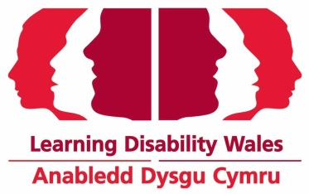

Learning Disability Wales

Mission:
"Creating a Wales that values and includes every child and adult with a learning disability"
Values:
Our work is underpinned by a staunch commitment to a specific set of values. Our values are:
- Community, empathy, equality, freedom, humanity, individuality, innovation, justice, self-challenging, strategic, teamwork, inclusion
Principles:
- the right to an ordinary pattern of life within the community.
- the right to be treated as an individual.
- the right to additional help and support in developing their maximum potential.
- the right to participate in all decision-making and service planning.
Aims:
- We have five organisational aims to guide our work:
- Reduce injustice, discrimination and prejudice experience by children and adults with a learning disability
- Increase and extend opportunities for the active and meaningful participation of children and adults with a learning disability in every aspect of their lives and community
- Increase commitment to the rights and concerns of children and adults with a learning disability
- Increase the diversity and quality of service responses to reflect the individuality of children and adults with a learning disability
- Maintain and enhance the accountability, efficiency, effectiveness, financial sustainability and governance of the organisation in order to uphold its values and deliver its mission and aims
How We Work:
- We work in partnership with other organisations, service users and their parents/carers
- We campaign to help children and adults with learning disabilities achieve valued lives
- We support the voluntary sector and its interests
- We provide and promote good practice

The Real Opportunities project

Real Opportunities is a project that has been funded by the European Social Fund.
There project works in 9 different local authorities in South Wales and in each local authority there is a ‘hub team’. | 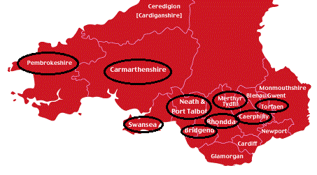
The hub team works with young people aged 14-19 years old who have severe and complex needs, a learning disability, those with an autistic spectrum disorder, and their families/carers. |  | 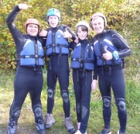
The hub teams help young people to transition from school to college - from being a young person to becoming an adult

The teams offer support to young people and families to help them achieve the things they want to do in life. They offer training courses, one-to-one support and person centred planning to help young people:

- Find employment and gain work experience
- Get involved in more leisure and social activities
- Develop independent living skills
- Improve things like confidence and self-esteem
- Plan for their transition and the future
As well as the hub teams, there are other teams who work for different organisations that also support young people and support the work of the project.

Elite, Mencap, Remploy and the National Autistic Society work in different areas to provide Employment Support.
The Welsh Centre for Learning Disabilities, based at Cardiff University is running a research project to see if Real Opportunities works for young people.
Lastly, Learning Disability Wales provides a training and information service.

Information Team
One Page Profile

Who is Involved?
Zoe Richards – Team Manager
Zoe oversees all of the work of the Training and Information team and ensures work is relevant and falls in line with project aims and current policy, as well as promoting the project.

Hannah Cox – Training Officer
Hannah organises, develops and delivers training courses for everyone involved in the project. Hannah also organises networking events, conferences and specialist master classes.
Laura Griffiths – Information Officer
Laura disseminates information about the project to project participants, professionals and the wider professional community via the newsletter, information materials, project website and social media.

What Learning Disability Wales does for the Real Opportunities Project…
Learning Disability Wales (LDW) has been contracted by the project to provide an information and training service.
LDW provides information about the project and training to the project staff, participants, families of participants and carers, and to the wider staff group who will be involved in the young people’s transition.
We offer a wide range of training including in-depth person centred planning, introduction to person centred planning, master classes, networking seminars, project briefings and project inductions.
The team will keep those involved with the project up to date with legislation, good practice examples, evaluation and research and project stories through newsletters, updates, social media and the project website, annual conferences and the project toolkit.
The team will also aim to disseminate information and good practice from the project as widely as possible by attending and representing the project at conferences and events, and developing, promoting and sharing a Real Opportunities toolkit.

Your Placement

Your line manager will discuss this with you.
Manager:
Your Line Manager:
Jobs you are interested in carrying out:
Goals for the placement:
Your tasks:

Notes:
Work Timetable

Week 1 | Monday | Tuesday | Wednesday | Thursday | Friday
AM
PM
Week 2 | Monday | Tuesday | Wednesday | Thursday | Friday
AM
PM
Week 3 | Monday | Tuesday | Wednesday | Thursday | Friday
AM
PM
Week 4 | Monday | Tuesday | Wednesday | Thursday | Friday
AM
PM
Week 5 | Monday | Tuesday | Wednesday | Thursday | Friday
AM
PM
Induction Check List
Environment | Date Discussed
Toilets/Restroom
Break/Refreshments
Use of mobile phones.
Use of the internet.
Security - pass/door codes, where to keep personal possessions.
Health and Safety | Date Discussed
Review health and safety guide (see appendix 1).
Fire Safety | Date Discussed
Explain the procedure for when the fire alarms are activated.
Locate nearest fire exit.
Where to assemble if the fire alarms sound.
Who are the fire wardens on your floor/ department?
When do you return to the build?
How often is the fire alarm tested?
First Aid Facilities | Date Discussed
Who is first aid trained?
Where is the first aid boxes kept?
What is contained in the first aid box?
Visits | Date Discussed
Which department or services have you visited?
What staff members would it be relevant to meet?

The Quiz
What is the name of the Chief Executive Officer of Learning Disability Wales?
Answer: ___________________________________

What is the name of the Real Opportunities Project Manager?
Answer: ___________________________________

What is the name of the appointed first aider(s) in your team?
Answer: ___________________________________

Who is the manager of your team?
Answer: ___________________________________

Name one core value of Learning Disability Wales
Answer: ___________________________________

Give two aims of the Real Opportunities project
Answer: ___________________________________
Answer: ___________________________________

Where is the Learning Disability Wales Head Office?
Answer: ___________________________________
Work Experience Evaluation
Date Discussed
Did you achieve all your learning goals?
What activities did you undertake within the department?
What did you learn about the team and what they do?
What did you learn about yourself?
What did you feel most comfortable doing?
What were you unsure of doing?
What was the best/ funniest incident of your placement?
Has your experience changed what you thought you would like to do in the future? If so what areas?
Any other comments?
Annex 1

Health & Safety Guide

Fire Precautions and Emergency Evacuation
Ensure work experience student understands the actions to be taken on discovering a fire or on hearing the alarm and give specific information regarding fire call points and muster points.
Actions on discovering a fire:
- If the fire is in a meeting room or other enclosed location exit the room and close the door behind you.
- Operate the nearest “fire call point”
- Evacuate the building using the emergency exits.
- Do not use lifts.
- Go directly to the evacuation muster point and wait for further instructions.

Actions on hearing the fire alarm:
- If you have visitors with you, request that they follow you.
- Close all doors behind you.
- Evacuate the building using the nearest emergency exit.
- Do not use lifts.
- Go directly to the muster point and inform reception staff that your visitors are with you.

Discuss the escape route, both internally and externally, to be walked. Describing:
- How the call points (the red break glass boxes) are activated.
- Where fire extinguishers are located and what classes of fire they are to be used on. Note: all fire extinguishers will either be red or silver therefore it is important to understand the colour codes on the extinguishers and their uses, for example:
  - RED colour code = water
  - BLACK colour code = Carbon Dioxide
  - BLUE colour code = dry powder
  - CREAM colour code = foam
- The purpose of the fire doors and the necessity to keep these doors closed to contain the spread of smoke.
- How the final exit operates e.g. breakable glass bolt fastening, push bars, etc.
- The alternate route is also to be walked, and the assembly area visited or pointed out and the reporting action described.

First Aid
Advise of location of first aid facilities, action when requiring first aid and names of first aiders. Where a trained first aider is not immediately available, the first aid response falls to the manager/supervisor responsible for the workplace.

Workplace/Activities Precautions
The following procedures, assessments and instructions are to be brought to the notice of the work experience student where they apply:
- Office Safety Guidance
- Display Screen Equipment and work station assessments,
- Email and internet policy.

Risk Assessment
A. Relevant risk assessments as identified by manager/supervisor.

Reporting
Arrangements for accident/incident reporting as contained in the Staff Handbook.

Safety Policy
Manager/supervisor to confirm work experience student has read and understands relevant Health and Safety Policies. Documents can be found on the shared area at: My computer > Shared on Ldw-server (S:) > My Documents > Human Resources > Staff Handbook >Section 4. Policies. You can refer to these if you have any questions about any aspects of work, and/or you can talk to your manager or a colleague you feel comfortable with.

Workstation assessment requested and carried out
Please make staff member aware of these items:

Health and Safety Manager
Jim Crowe ext. 163

