Easy Read

Continuing NHS Healthcare
Response form
Please tell us what you think by 21st August 2019
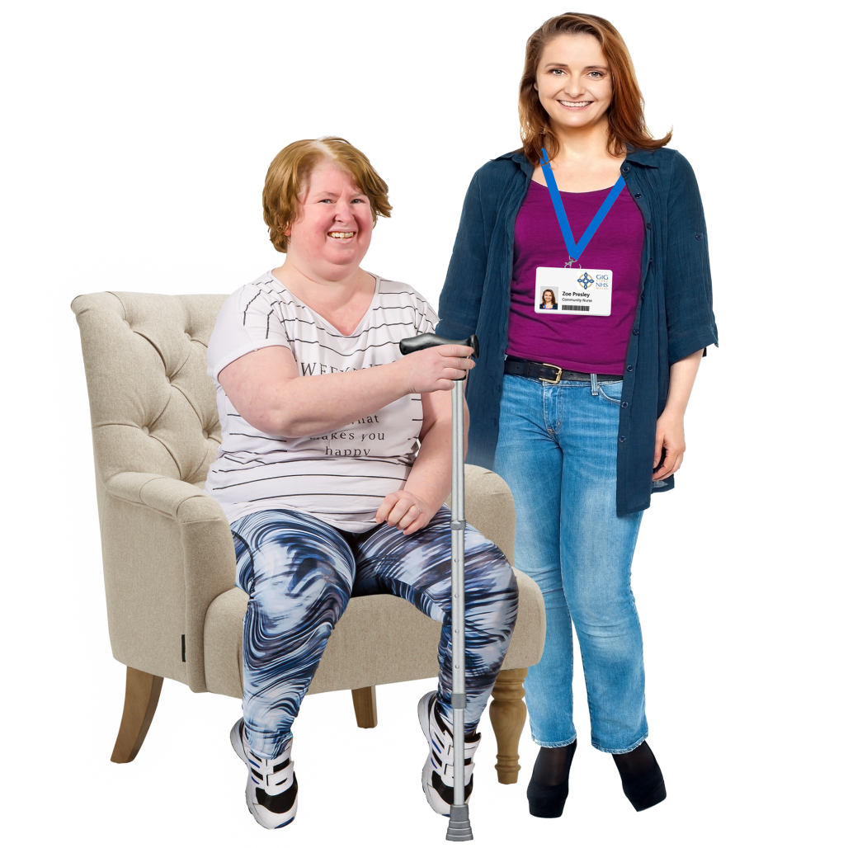

This is an easy read version of the Welsh Government Consultation Document: Continuing NHS Healthcare. The National Framework for Wales.
July 2019

How to fill in this response form
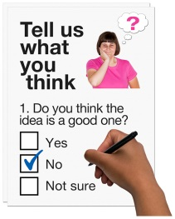
These questions are about our ideas for our guide on providing Continuing NHS Healthcare (CHC).

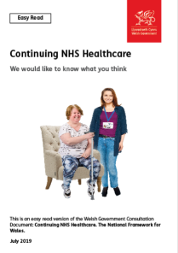
Before you answer the questions, please read the main easy read document: Continuing NHS Healthcare (CHC) – We would like to know what you think.

Please try to explain your answers. And give your own thoughts and ideas too.

You may need support to read and understand this document. Ask someone you know to help you.

Some words may be difficult to understand. These are in blue writing and have been explained on page 24 of the main document.

Where the document says we, this means the Welsh Government.

Please send this form back to us by 21st August 2019.

Address: Complex, Unscheduled Care and Disability Branch
Partnership and Cooperation Division
Welsh Government
4th Floor, North Cathays Park
Cardiff, CF10 3NQ

The response form is also on our website: https://gov.wales/draft-national-frameworkcontinuing-nhs-healthcare

And can be emailed back to us at: CHCFramework.Consultation@gov.uk

How we use the information you give us
Welsh Government will be looking at your answers in this response form to make decisions about how to support people in the best way.

Sometimes we ask other organisations to help us make decisions. They may also see the answers that people gave in the response forms.

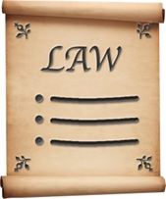
We will make sure we follow the law when you use your information.

We will write a report about what people said.

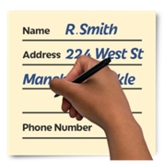
We might write some people’s answers in full with their names and addresses in the report or on the internet.

When you send us your answers, please tell us if you do not want us to write your name and address in the report or on the internet.

The data protection laws give you the right to:

- Know what information we have about you and how you can see it.

- Make us change any mistakes in the information about you.

- Ask us not to use the information in some cases.

- Ask us to delete the information we have about you in some cases.

- Move the information about you somewhere else in some cases.

- Complain to the Information Commissioner’s Office.
If you would like to know more about how your information is kept and used please contact us at:

Data Protection Officer
Welsh Government
Cathays Park
CARDIFF
CF10 3NQ
Email: Data.ProtectionOfficer@gov.wales

You can also contact the Information Commissioner’s Office:

Wycliffe House
Water Lane
Wilmslow
Cheshire
SK9 5AF
Tel: 01625 545745 or 0303 123 1113

Website: https://ico.org.uk
About you
Your name:

The organisation you are answering for or with:

Your email address:

Your address and phone number:

Do you want your answers to be shown on the internet and in a report?

Yes | ☐ |  | No | ☐

Questions
- We are changing the guide for providing CHC. Are there any problems you think we need to deal with to make sure it is used properly?

Yes | ☐ | No | ☐ | Not sure | ☐

If you said yes what are they?

- The guide is for staff who run services. Should we make an easier guide for staff and people who use services to see?
Yes | ☐ | No | ☐ | Not sure | ☐

If you said yes what should it look like?

- Do the changes we want help make it clear how CHC should be organised?
Yes | ☐ | No | ☐ | Not sure | ☐

Is there anything you want to say about this?

- How can we make sure organisations like health boards and councils work well together?

- Do you think the new guide for how we provide CHC will be clearer?

Yes | ☐ | No | ☐ | Not sure | ☐

Is there anything you want to say about this?

- Please see pages 8 to 13. We want to make changes to:
- Assessments
- Deciding if someone is eligible for CHC
- Using a checklist and Decision Support Tool.

Do you agree with the changes we want to make to these areas?

Yes | ☐ | No | ☐ | Not sure | ☐

Is there anything you want to say about this?
- Do you think people and their families are involved enough in assessments?
Yes | ☐ | No | ☐ | Not sure | ☐

Is there anything you want to say about this?

- Do you think the new guide will work well with other health and social services policies?
Yes | ☐ | No | ☐ | Not sure | ☐

Is there anything you want to say about this?

- On page 22 we talked about retrospective reviews. And said there should be 2 stages to this.

Do you agree with what we want to change?
Yes | ☐ | No | ☐ | Not sure | ☐

Is there anything you want to say about this?

- Do you think the Welsh language will be used the same as English in the new guide?
Yes | ☐ | No | ☐ | Not sure | ☐

Is there anything you want to say about this?

- Is there anything else you would like to say? If so please write it here:

