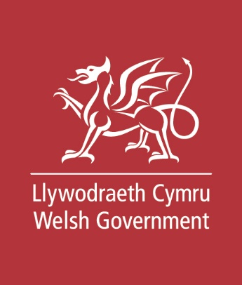
Easy Read

Keeping children safe from sexual exploitation
Response Form
Please tell us what you think by 7 October 2019

This is an easy read version of the questions from Welsh Government’s ‘Consultation Document. Statutory guidance in relation to Part 7 of the Act - safeguarding children from child sexual exploitation’.
July 2019

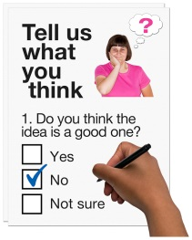
How to fill in this response form

This response form has questions about our guidance on child sexual exploitation.

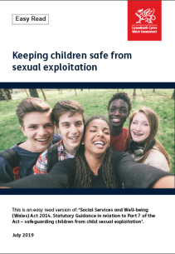
Before you answer these questions please read the main easy read document: Protecting Children from sexual exploitation.

Please try to explain your answers. And give your own thoughts and ideas too.

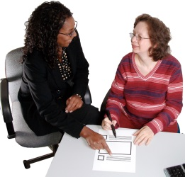
You may need support to read and understand this document. Ask someone you know to help you.

Some words may be difficult to understand. These are in blue writing and have been explained on page 26 of the main document.

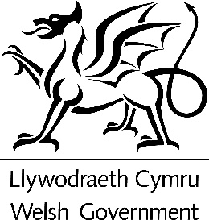
Where the document says we, this means the Welsh Government.
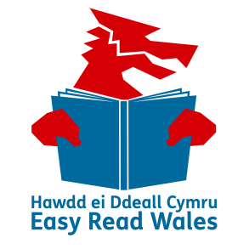
This document was made into easy read by Easy Read Wales using Photosymbols.

Please send this form back to us by 7 October 2019.

By post: Sam Clutton
Safeguarding and Advocacy Branch,
Social Services and Integration Directorate,
Welsh Government,
Crown Buildings, Cathays Park,
Cardiff, CF10 3NQ

For more information please call: 03000 651656

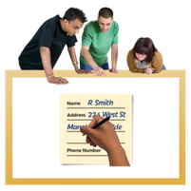
How we will use the information you give us
Welsh Government will be looking at your answers in this response form. We will use your answers to update our guidance for dealing with child sexual exploitation.

Sometimes we ask other organisations to help us update our guidance. They may also see your answers.
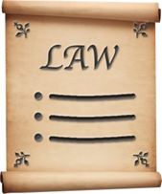
We will follow the data protection laws when we use your information.
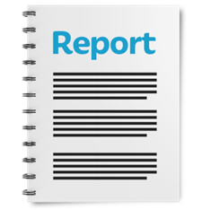

We will write a report about what people said.

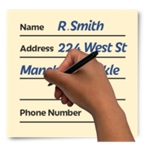
We might write some people’s answers in full with their names and addresses in the report or on the internet.

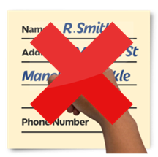
When you send us your answers, please tell us if you do not want us to write your name and address in the report or on the internet.
The data protection laws give you the right to:
- Know what information we have about you and how you can see it.

- Make us change any mistakes in the information about you.

- Ask us not to use the information in some cases.

- Ask us to delete the information we have about you in some cases.

- Move the information about you somewhere else in some cases.

- Complain to the Information Commissioner’s Office.

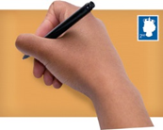
If you would like to know more about how your information is kept and used please contact us at:
Data Protection Officer
Welsh Government
Cathays Park
CARDIFF
CF10 3NQ

Email: Data.ProtectionOfficer@gov.wales
You can also contact the Information Commissioner’s Office:
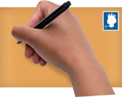
Wycliffe House
Water Lane
Wilmslow
Cheshire
SK9 5AF
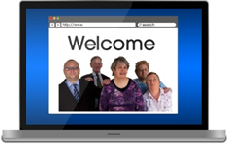
Tel: 01625 545745 or 0303 123 1113

Website: https://ico.org.uk

About you
Your name:

The organisation you are answering for or with:

Your email address:

Your address:

Do you want your name and address on the answers we send out?

Yes | ☐ |  | No | ☐

Questions
Keeping children safe from child sexual exploitation

Please look at pages 6, 7 and 8 of the main document.

- Do you think the way we described child sexual exploitation is clear?

Yes | ☐ | No | ☐ | Not sure | ☐

Is there anything you want to say about this?

Please look at pages 8, 9 and 10 of the main document.

- Does the document say how to stop child sexual exploitation from happening in a clear way?

Yes | ☐ | No | ☐ | Not sure | ☐

Is there anything you want to say about this?

Please look at pages 10 and 11 of the main document.

- Does this part say what staff need to do if they are worried a child is at risk in a clear way?

Yes | ☐ | No | ☐ | Not sure | ☐

Is there anything you want to say about this?
Please read page 11 of the main document.

- Does this part say how to support the care and support needs of the child in a clear way?

Yes | ☐ | No | ☐ | Not sure | ☐
Is there anything you want to say about this?

Please read page 12 of the main document.

- Does this part show what needs to happen to people who cause child sexual exploitation in a clear way?

Yes | ☐ | No | ☐ | Not sure | ☐
Is there anything you want to say about this?

- The next 2 questions are about the Welsh language.

In the box below can you tell us if you think this guide will help people to use the Welsh language?

And

Will Welsh be treated the same as the English language?

- Do you think the ideas in the main document will affect groups of people with protected characteristics?

Protected characteristics are:
- Age
- Disability
- Gender – if the person is male or female.
- Marriage – if the person is married to another person
- Pregnancy
- Maternity – this is after someone has had a baby
- Race – this is where a person came from or their family came from
- Religion – this is what a person believes in.

Yes | ☐ | No | ☐ | Not sure | ☐

Is there anything you want to say about this?

- Is there anything else you would like to say about the document?

