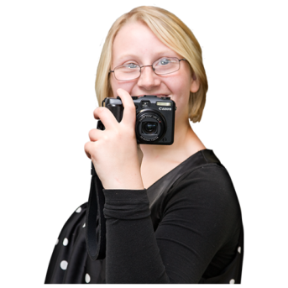
Right here photo competition
Entry form

About me
Name
Phone number
Email address
Address
Postcode

About my photo
Title
What does this picture mean to you
Permission
It is very important to us that we only use pictures that we are allowed to.
We can only accept your photo if you answer all of these questions
If there are any people in your picture do you have their permission to give this photo to Learning Disability Wales and Able Radio? |  | Yes
 |  | No
Do you give permission for Learning Disability Wales and Able Radio to show this picture at our conference and use it in future to promote our work and the rights of disabled people? |  | Yes
 |  | No

Send your completed application form and photo to rhobat.bryn@ldw.org.uk by 14 October 2019.
If you have trouble sending your picture give Rhobat a ring on 029 20681160

You can decide at any time that you don’t want us to use your photo anymore. Just phone or email us and let us know. 029 2068 1160 Enquriries@ldw.org.uk
We will not give your photo to anyone else to use.

