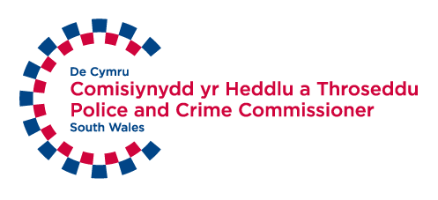
Easy Read Survey
Your local police service in South Wales
We want to know what you think by Monday 16 December 2019
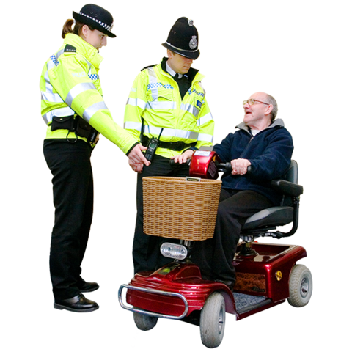

This document was written by the South Wales Police and Crime Commissioner. It is an easy read version of their document ‘Police Precept Survey 2020/21’.
November 2019

About this survey
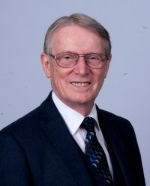 | Your Police and Crime Commissioner is called Alun Michael.
 | He would like to hear your views on the work that South Wales Police does. And how we should pay for it.
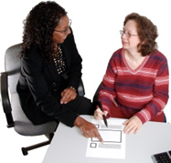 | You may need support to read and understand this document. Ask someone you know to help you.
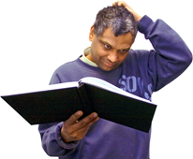 | Words in bold blue writing may be hard to understand. They have been explained in a blue box.
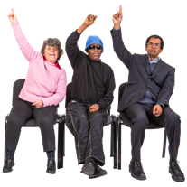 | If you have any questions about this survey please email us at:  sarah.mahon@south-wales.pnn.police.uk
 | This survey has been made into easy read by Easy Read Wales using Photosymbols.

Introduction
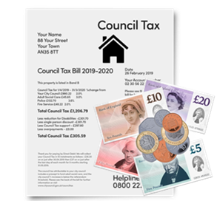 | Every month a bit of your council tax goes towards paying for part of your local police service.
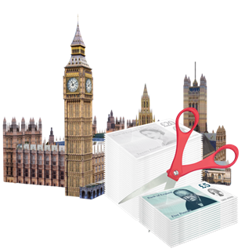 | The rest of the money comes from the government. But over the last few years the government has cut the amount of money it gives to the police.
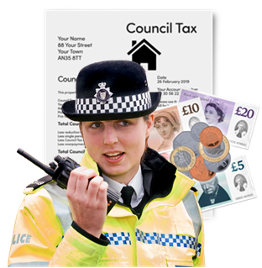 | This means that the money the police get from your council tax is more important than ever.
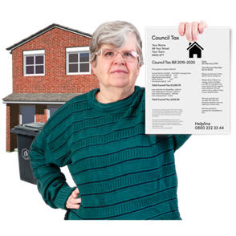 | We know that if people have to pay more council tax it might be difficult for them. So we are thinking very carefully about what we should do.
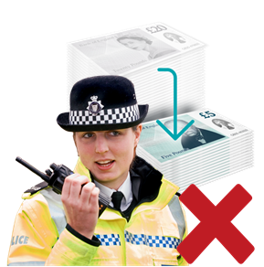 | If the public does not pay any more money we will not have enough to keep doing the work we are doing.
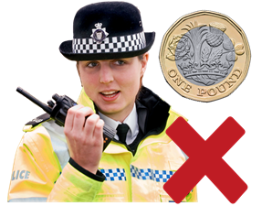 | If people pay £1 more every month we will still not have enough money to keep doing the work we are doing.
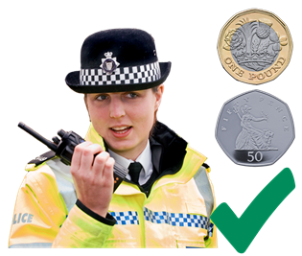 | If people pay £1.50 more every month we will have enough money to keep doing the same work we are doing now.
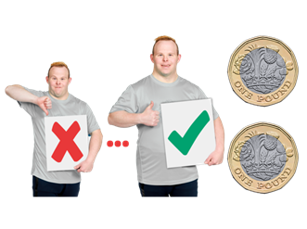 | If people pay £2 more every month we will be able to make our police service better.
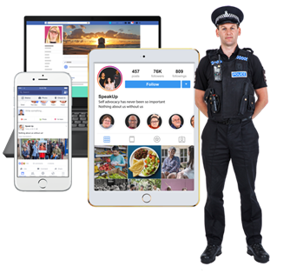 | We will be able to use better technology. And we will be able to do more work to stop crime before it happens.

Questions
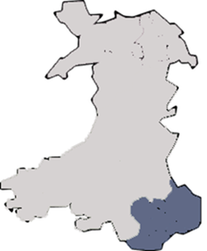 | Question 1  Do you live in South Wales?  Yes ☐ No ☐  If yes, what county do you live in?

Bridgend | ☐ | Rhondda Cynon Taf | ☐
Cardiff | ☐ | Swansea | ☐
Merthyr Tydfil | ☐ | Vale of Glamorgan | ☐
Neath Port Talbot | ☐

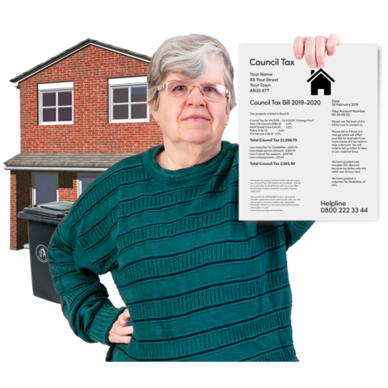 | Question 2  Do you pay council tax?  Yes ☐ No ☐

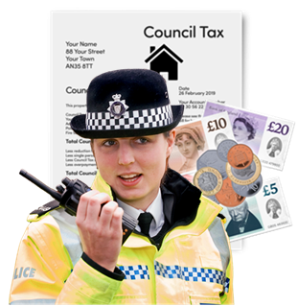 | Question 3  Did you know that part of your council tax pays for police work?  Yes ☐ No ☐

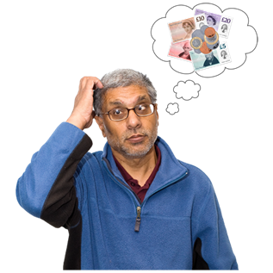 | Question 4  How much more council tax would you be happy to pay every month to support police work?  No more ☐ £1 ☐ £1.50 ☐ £2 ☐  Please tell us more about your answer:
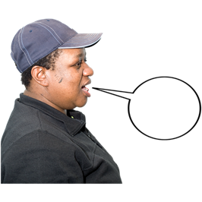

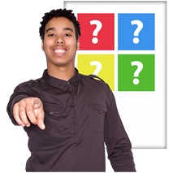 | The Police and Crime Commissioner would like to know what you think is important for the police to focus on.
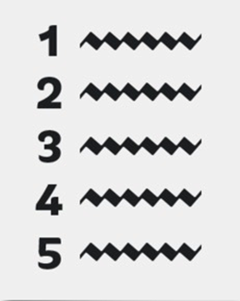 | Question 5  Please choose the 5 things you think are most important for the police to focus on.  Please put them in order of how important you think they are. For example put a 1 in the box you think is most important.

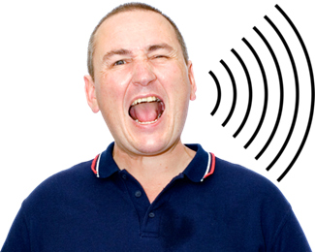 | - Anti-social behaviour  Anti-social behaviour is when you do things in a public place that make other people uncomfortable. Like shouting, throwing rubbish or drinking on the street. | ☐
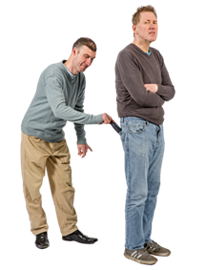 | - Burglary and theft. For example breaking into somebody’s house and stealing their things. | ☐
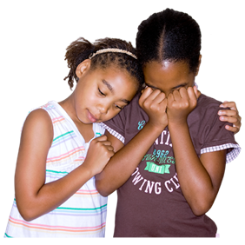 | - Child sexual exploitation. For example giving children gifts to get them to perform sexual acts. | ☐
 | - Stopping terrorist activity from happening.  Terrorist activity is when people or a group of people use violence against the public. | ☐
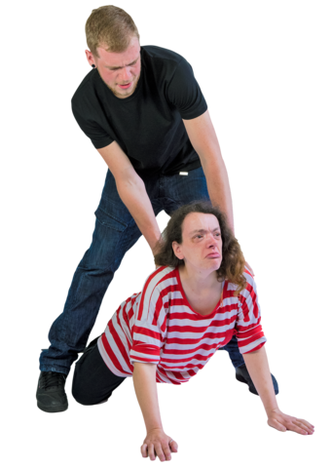 | - Domestic abuse  Domestic abuse can happen to anyone. It involves any behaviour that causes harm to someone that is carried out by a partner, ex-partner or family member. | ☐
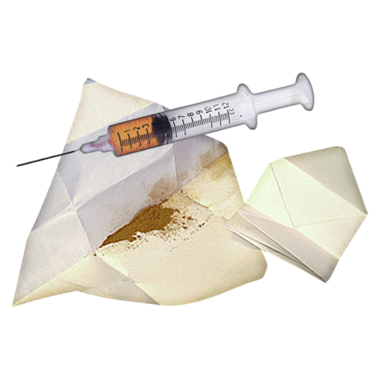 | - People using illegal drugs. | ☐
 | - Fraud  Fraud is when people pretend to be someone else in order to steal money from them. | ☐
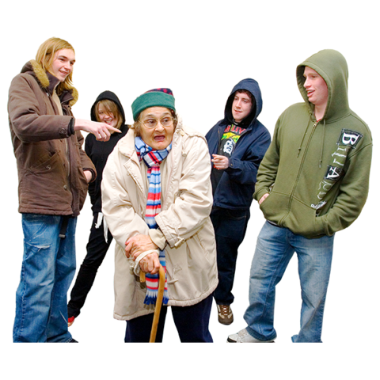 | - Hate crime  Hate crime is when somebody is attacked or bullied because of who they are. For example their age, disability or religion. | ☐
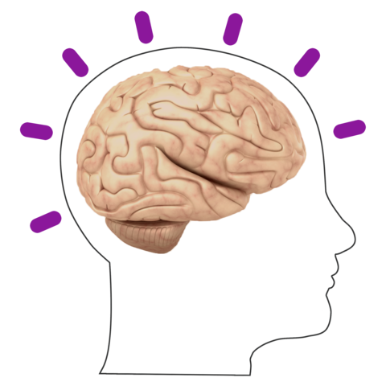 | - Mental health. | ☐
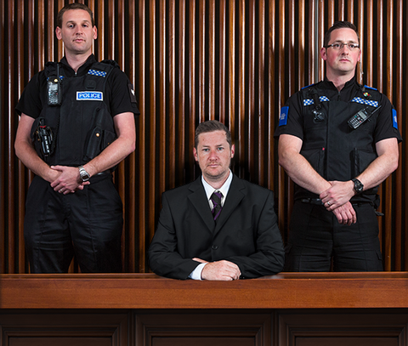 | - Serious and organised crime. | ☐
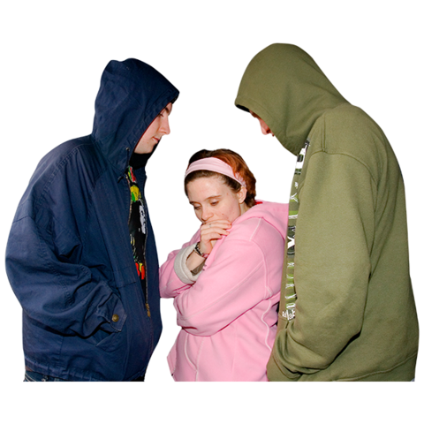 | - Stalking and harassment. For example following someone after they have asked you to leave them alone. | ☐
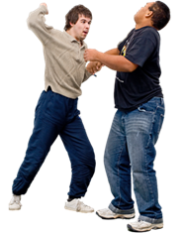 | - Violent crime. | ☐

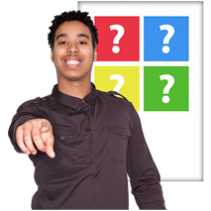 | The Police and Crime Commissioner would like to know how well you think the police in South Wales are doing their job.
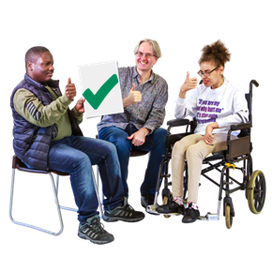 | Question 6  Please tell us 1 thing you think South Wales Police does well.
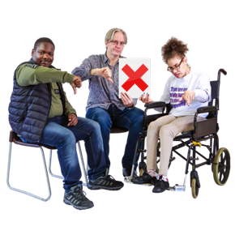 | Please tell us 1 thing that you think South Wales Police could do better:
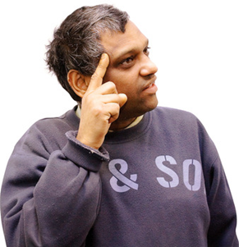 | Question 7  Do you think you understand what the Police and Crime Commissioner does?  Yes ☐ No ☐
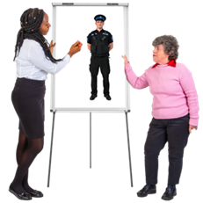 | Question 8  How do you think we could tell the public about what the Police and Crime Commissioner does in a clear way?
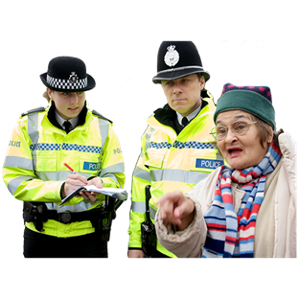 | Question 9  Have you reported an incident to South Wales Police in the past year?  Yes ☐ No ☐
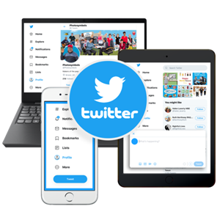 | Question 10  Do you follow the Police and Crime Commissioner on any social media channels?  Yes ☐ No ☐  Do you follow South Wales Police on any social media channels?  Yes ☐ No ☐
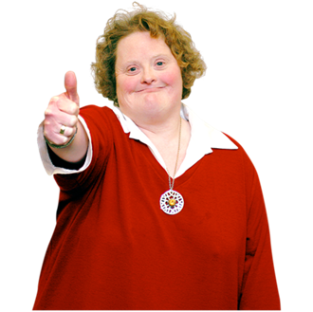 | Thank you for your views.

About you

- How old are you?

Between 16 and 24 | ☐ | Between 45 and 54 | ☐
Between 25 and 34 | ☐ | Between 55 and 64 | ☐
Between 35 and 44 | ☐ | Over 65 | ☐

- How do you describe yourself?
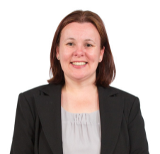 | Female | ☐
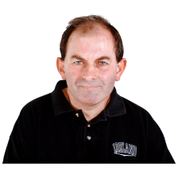 | Male | ☐
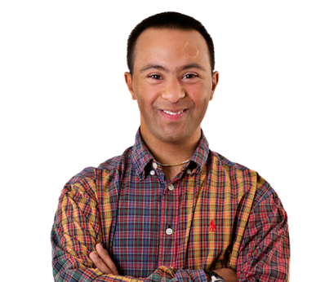 | Non-binary  If someone is non-binary it means they don’t identify as male or female. They could be both or neither. | ☐

- Is your gender identity the same as the gender you were given at birth?

 | Yes | ☐ | No | ☐ | I would rather not say | ☐

- Which of these words best describes how you think of yourself?
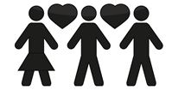 | Bisexual - I am attracted to men and women | ☐
 | Gay - I am a man and am attracted to other men | ☐
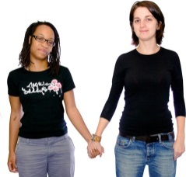 | Lesbian - I am a woman and am attracted to other women | ☐
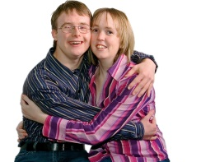 | Heterosexual - I am attracted to people of the opposite sex | ☐
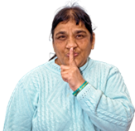 | I would rather not say | ☐
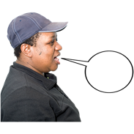 | Other | ☐
 | If you ticked other please tell us what:

- What is your religion?

 | I do not have a religion | ☐
 | I am Christian (All types) | ☐
 | I am a Buddhist | ☐
 | I am Hindu | ☐
 | I am Jewish | ☐
 | I am Muslim | ☐
 | I am Sikh | ☐
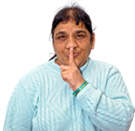 | I would rather not say | ☐
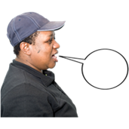 | Other | ☐
 | If you ticked other please tell us what:

- What is your ethnic group?

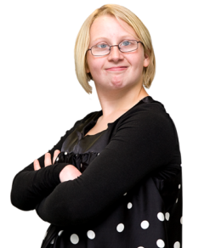 | White
 | White English, Welsh, Scottish, Northern Irish or British | ☐
 | White Irish | ☐
 | White Gypsy or White Irish Traveller | ☐
 | Any other White background. Please tell us what this is: | ☐
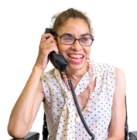 | Mixed or multiple ethnic groups
 | White and Black Caribbean | ☐
 | White and Black African | ☐
 | White and Asian | ☐
 | Any other mixed or multiple ethnic background. Please tell us what this is: | ☐
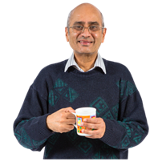 | Asian or Asian British
 | Indian | ☐
 | Pakistani | ☐
 | Bangladeshi | ☐
 | Chinese | ☐
 | Any other Asian background. Please tell us what this is: | ☐
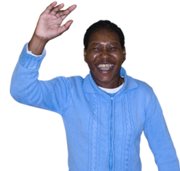 | Black, African or Caribbean or Black British
 | Black African | ☐
 | Black Caribbean | ☐
 | Any other Black, African or Caribbean background. Please tell us what this is: | ☐
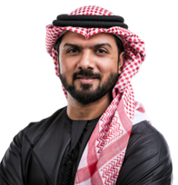 | Other ethnic group
 | Arab | ☐
 | Any other ethnic group | ☐
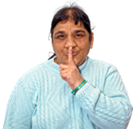 | I do not want to say | ☐

- Do you have a disability?

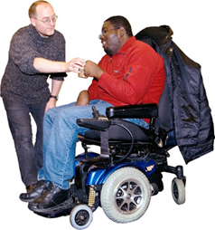 | Yes. | ☐
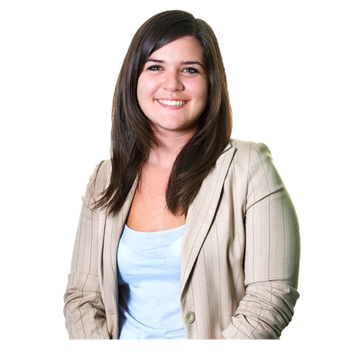 | No. | ☐
 | I do not want to say | ☐

If yes please say what kind of disability you have:

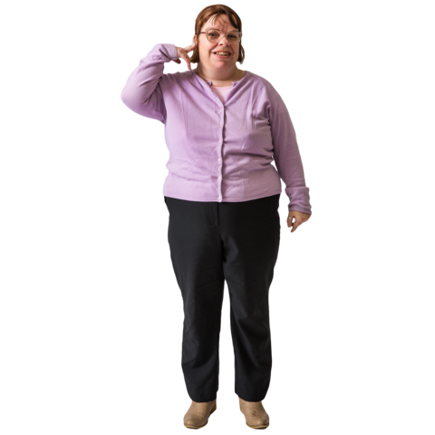 | Hearing | ☐
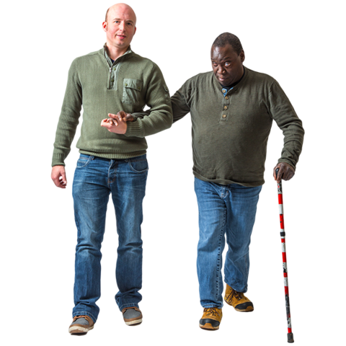 | Seeing | ☐
 | Moving around | ☐
 | Mental health condition | ☐
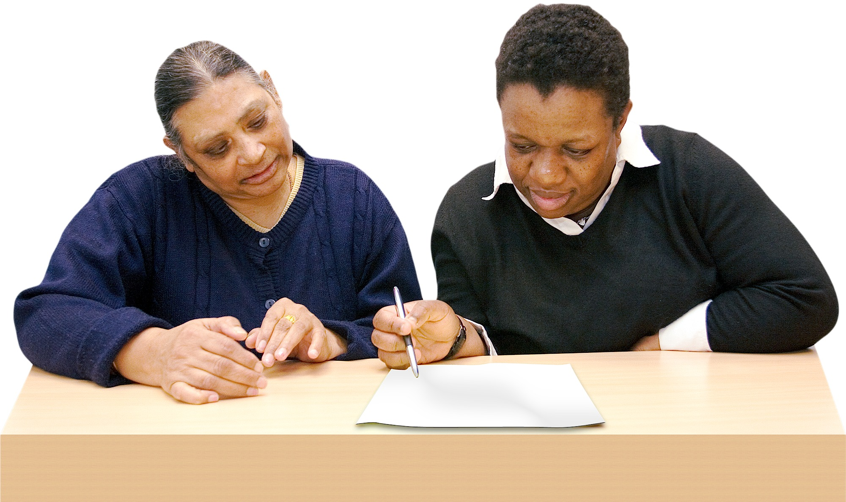 | Learning Disability | ☐
 | Other (please tell us more): | ☐

Thank you.

