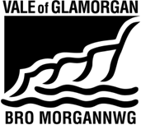
Easy Read Form

Equal opportunities form

 | We are the Vale of Glamorgan Council.
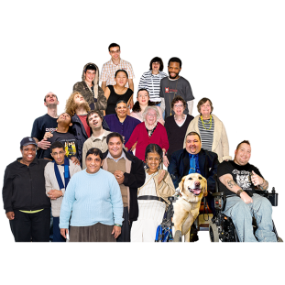 | We want to make sure everyone is able to give us their views about services.
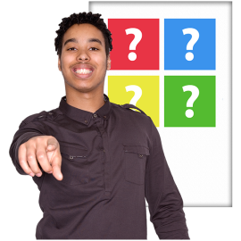 | When we ask people to tell us their views, we also ask them about themselves.
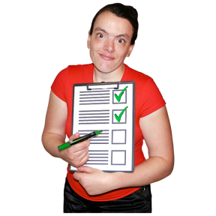 | We do this to make sure all types of people are getting the chance to give their views. And get and use our services.
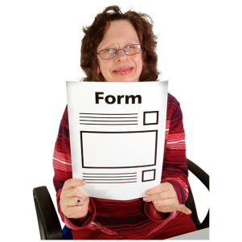 | To help us with this we would like you to fill out this form. And give us information about yourself.
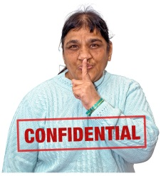 | We will keep your information private.
 | We will not show anyone your information without asking you first.
 | We will not give your information to other organisations.
 | If you would like to know more you can read our Equality Policy.
 | You can call us on 01446 700111 and we will send you a copy. Or you can read it on our website: https://www.valeofglamorgan.gov.uk/Documents/Our%20Council/Equal%20Opportunities/Equality-Policy-E-2015.pdf

Thank you.

Questions

- How do you describe yourself?
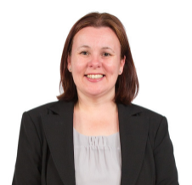 | Female | ☐
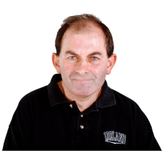 | Male | ☐
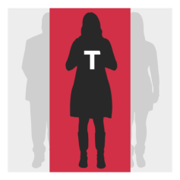 | Trans - people who feel different inside in some way to the gender they were born as. | ☐
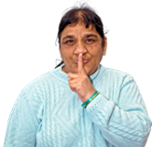 | I do not want to say | ☐
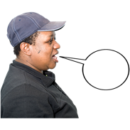 | Other | ☐
 | If you said other, please tell us how you describe yourself:

- Do you find every day activities difficult because of a:
- health condition
- illness
- or disability
that has lasted or will last for 1 year or more?

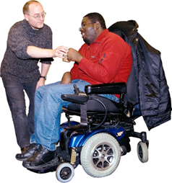 | Yes. I find everyday activities very difficult. I am limited a lot. | ☐
 | Yes. I find everyday activities quite difficult. I am limited a little. | ☐
 | No | ☐
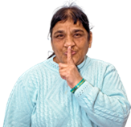 | I do not want to say | ☐

- What date is your birthday?

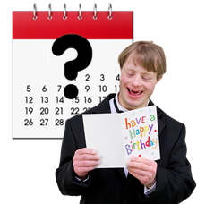

- What is your national identity?

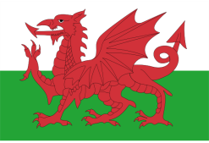 | I am Welsh | ☐
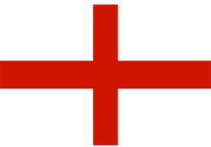 | I am English | ☐
 | I am Scottish | ☐
 | I am Northern Irish | ☐
 | I am British | ☐
 | I do not want to say | ☐
 | Other | ☐
 | If you said other, please tell us what it is:

- What is your ethnic group?

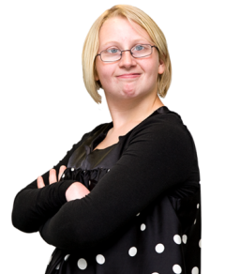 | White
 | White English, Welsh, Scottish, Northern Irish or British | ☐
 | White Irish | ☐
 | White Gypsy or White Irish Traveller | ☐
 | Any other White background. Please tell us what this is: | ☐
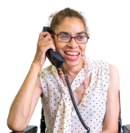 | Mixed or multiple ethnic groups
 | White and Black Caribbean | ☐
 | White and Black African | ☐
 | White and Asian | ☐
 | Any other mixed or multiple ethnic background. Please tell us what this is: | ☐
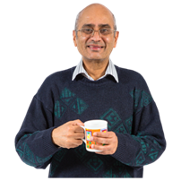 | Asian or Asian British
 | Indian | ☐
 | Pakistani | ☐
 | Bangladeshi | ☐
 | Chinese | ☐
 | Any other Asian background. Please tell us what this is: | ☐
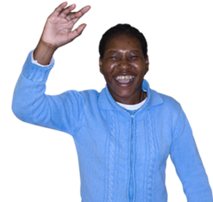 | Black, African or Caribbean or Black British
 | Black African | ☐
 | Black Caribbean | ☐
 | Any other Black, African or Caribbean background. Please tell us what this is: | ☐
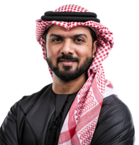 | Other ethnic group
 | Arab | ☐
 | Any other ethnic group | ☐
 | I do not want to say | ☐

- Which of these words best describes how you think of yourself?

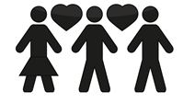 | Bisexual - I love and fancy men and women | ☒
 | Gay - I am a man and I love and fancy other men | ☐
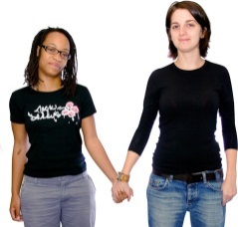 | Lesbian - I am a woman and I love and fancy other women | ☐
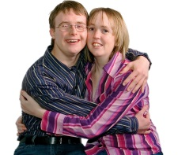 | Heterosexual - I love and fancy people of the opposite sex | ☐
 | I would rather not say | ☐
 | Other | ☐
 | If you ticked other please tell us what:

- What is your religion?

 | I do not have a religion | ☐
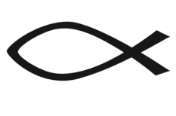 | I am Christian (All types) | ☐
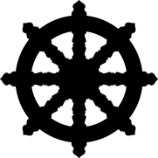 | I am a Buddhist | ☐
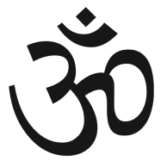 | I am Hindu | ☐
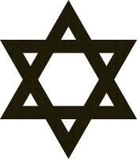 | I am Jewish | ☐
 | I am Muslim | ☐
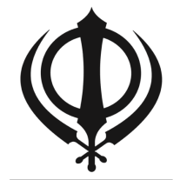 | I am Sikh | ☐
 | I would rather not say | ☐
 | Other | ☐
 | If you ticked other please tell us what:

- Are you pregnant or on maternity leave? Please tick the answers that describe you.

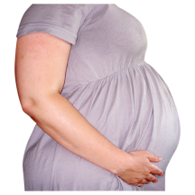 | I am pregnant, or have been pregnant in the last year. | ☐
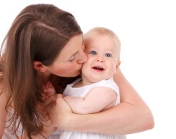 | I have taken maternity leave from work in the last year. | ☐
 | I would rather not say | ☐

- Please tell us what your marital status is.

 | I am single. I have never been married or had a civil partnership. | ☐
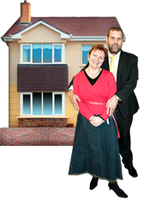 | I am married and I live with my husband or wife. | ☐
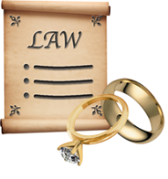 | I am separated, but still married by law. | ☐
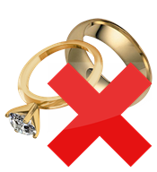 | I am divorced. | ☐
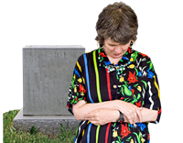 | I am widowed. | ☐
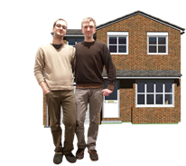 | I am in a same sex civil partnership. And I live with my partner. | ☐
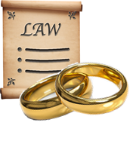 | I am separated, but I am still in a same sex civil partnership by law. | ☐
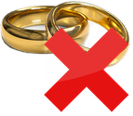 | I was in a civil partnership. But this has been ended by law. | ☐
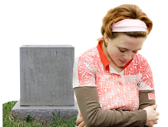 | My civil partner died | ☐
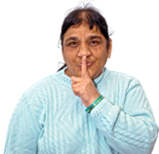 | I would rather not say | ☐

Thank you.
We will keep your information private.

