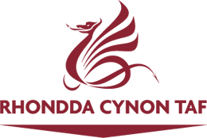
Easy Read

Our plans to raise and spend money on services in Rhondda Cynon Taf

Please tell us what you think by 7 February 2020
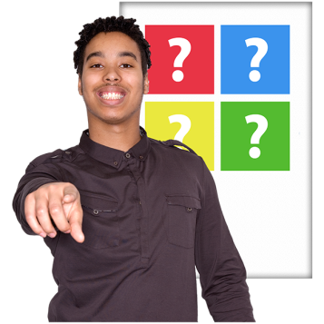
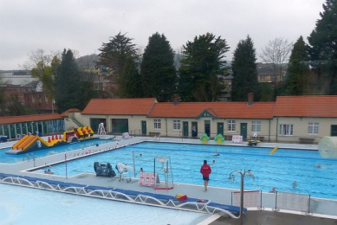
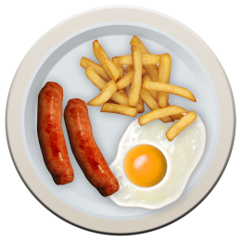
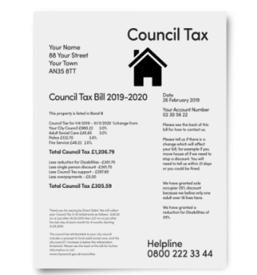
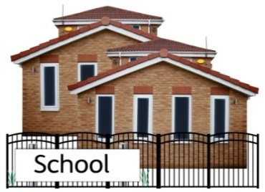

This document was written by Rhondda Cynon Taf County Borough Council. It is an easy read version of ‘Budget Consultation 2020/21’.

January 2020

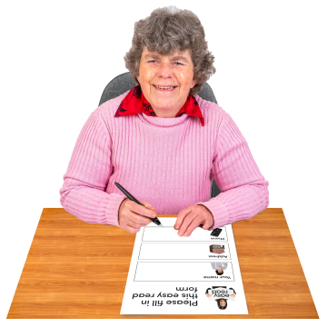
How to fill in this response form
These questions are about our plan to raise and spend money on services in Rhondda Cynon Taf.

We want to know what you think. Please try to explain your answers. And give your own thoughts and ideas too.

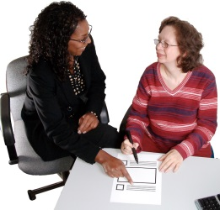

You may need support to read and understand this document. Ask someone you know to help you.

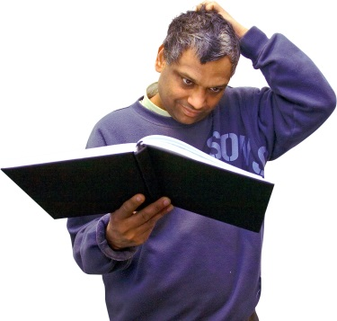

Words in blue writing may be hard to understand. They are explained in a box underneath.

Where the document says we, this means Rhondda Cynon Taf County Borough Council.

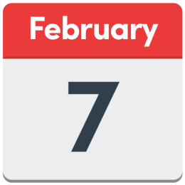
Please send this form back to us by
7th February 2020.

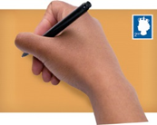
Address:
Freepost RSBU-HJUK-LSS
Research & Consultation
The Pavillions
Clydach Vale
Tonypandy
CF40 2XX
consultation@rctcbc.gov.uk

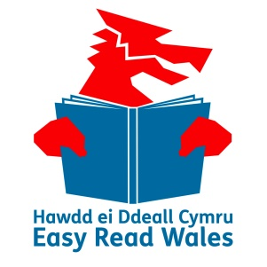

This document was made into easy read by Easy Read Wales using Photosymbols.

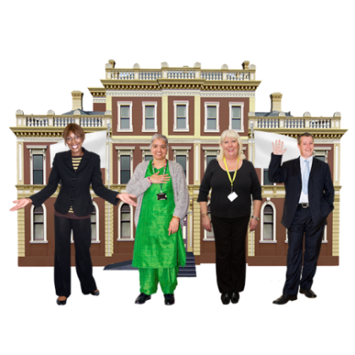
Introduction

At the end of 2019 we asked people living in Rhondda Cynon Taf what they think about:

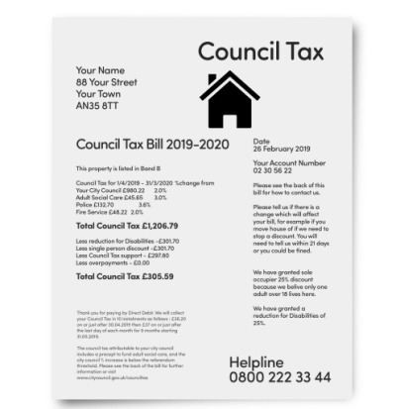
- How much Council Tax they pay

Council Tax is money that people have to give to their local authority to pay for things like schools, social services, recycling and parks.

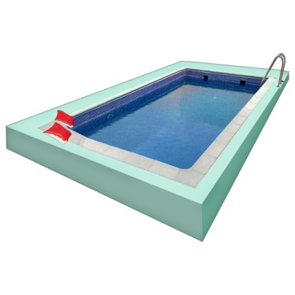
- How much we spend on services like social services and recycling.

- What services are most important to people.

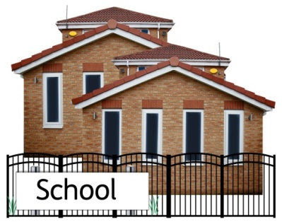
- How much we charge people for things like going to the swimming pool or meals on wheels.

- How we help people pay their Council Tax.

- How much money we give to schools.

We are now asking you to help us make some decisions about these things.

Increasing Council Tax
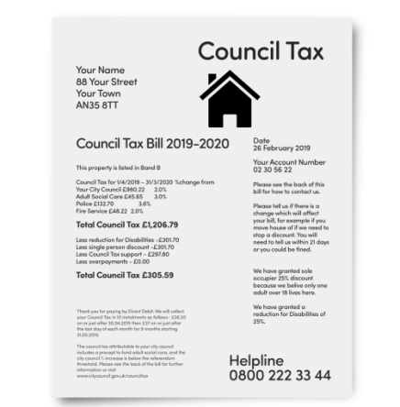
This year we increased the amount of Council Tax people had to pay us.

Out of all the councils in Wales we increased Council Tax the least amount this year.

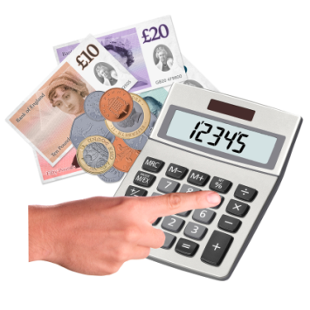
We would like to increase Council Tax by 2.85% next year.

This means that if your Council Tax was £1,000 this year you would have to pay £28.50p more next year. Or 55p more per week.

Do you think this is a fair increase to Council Tax?
Yes | ☐
No | ☐
Not sure | ☐

Is there anything you would like to say about this?

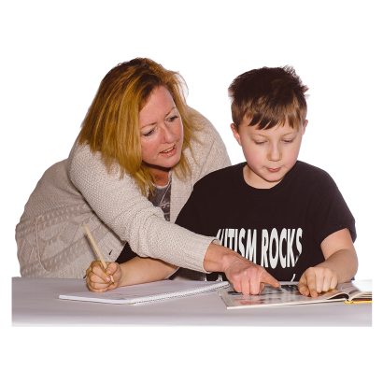
Spending money on schools

We want to spend an extra £12.7 million on schools next year.

Do you think we should spend our money on this?
Yes | ☐
No | ☐
Not sure | ☐

Is there anything you would like to say about this?

Spending money carefully
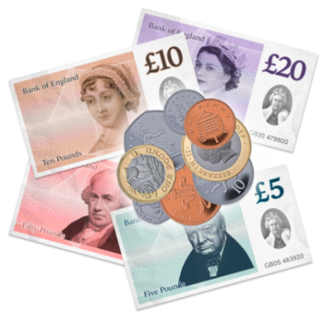
We have been working more efficiently over the last 10 years and have saved £95 million.

Efficiently means being better at what we do and spending money carefully so we can spend less money and still provide services that people need.

We are going to save £6 million next year by working even more efficiently.

Do you think we should carry on being more efficient?
Yes | ☐
No | ☐
Not sure | ☐

Is there anything you would like to say about this?

Paying for other things
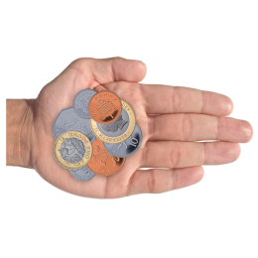
We charge you for some of the services we provide.

Next year the cost of using leisure centres (if you are a member), car parks and playing fields will not go up.

But you will have to pay more for using some things though.

- Meals on wheels will cost 10p more per meal.

- School meals will cost 5p more per meal.

- Swimming at the Lido in Pontypridd will cost 50p more for adults.

Do you think it is fair to charge people more for these things?
Yes | ☐
No | ☐
Not sure | ☐

Is there anything you would like to say about this?

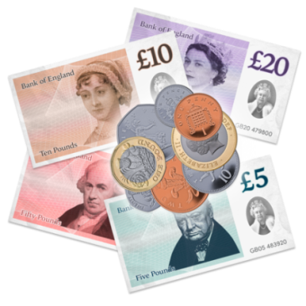
Borrowing money to make things better

We would like to borrow £7.5 million to spend on:

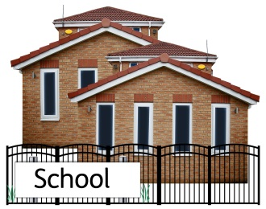
- Building more schools and improving old schools.

- Improving roads and transport.
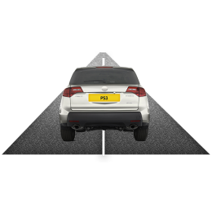
- Recycling.
- Making town centres better.
- Making empty homes good to live in again.
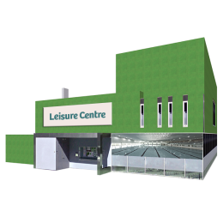
- Making leisure centres better.
- Making play grounds and parks better.
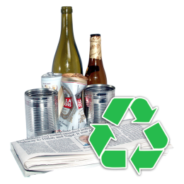
- Help older people be more independent.
- Helping people get jobs.
- Making places to visit and theatres better.
- Protecting people from floods.

Do you think we should borrow money to make these things even better?
Yes | ☐
No | ☐
Not sure | ☐

Is there anything you would like to say about this?

Helping young people
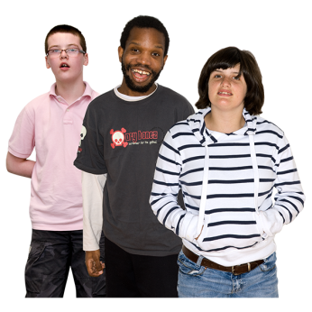
We think it is important to help young people learn better at school and get on well in life.
We want to spend £250,000 (250 thousand pounds) to help young people.

Do you think we should spend £250,000 more on helping young people?
Yes | ☐
No | ☐
Not sure | ☐

Is there anything you would like to say about this?

Paddling pools

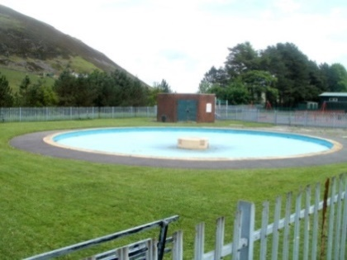
We want to work with local communities to help them open paddling pools in parks in the summer holidays.

We want to spend £50,000 (50 thousand pounds) to make this happen.

Do you think we should spend £50,000 more on paddling pools?
Yes | ☐
No | ☐
Not sure | ☐

Is there anything you would like to say about this?

Muni Arts Centre

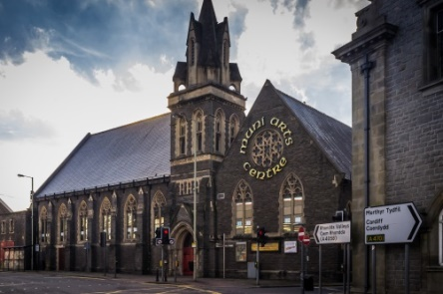
The Muni Arts Centre in Pontypridd has a theatre and café as well as rooms that can be used for parties, meetings and other events.

The Muni Arts Centre is closed at the moment.

An organisation called the Awen Cultural Trust is planning to open it again this summer.

We want to give £105, 000 (105 thousand pounds) to help.

Do you think we should spend £105,000 on the Muni Arts Centre?
Yes | ☐
No | ☐
Not sure | ☐

Is there anything you would like to say about this?

Spending our saving
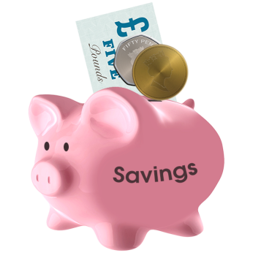
We get money from the Welsh Government and from Council Tax to spend on the things we need to do. This money is called our income.

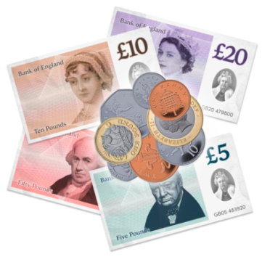
Income is the amount of money we have to spend.

We have some money saved just for when we do not have enough income to spend on the things we want to do each year.

Next year we want to spend £804,000 (804 thousand pounds) of our savings. We would still have £3,500,000 (3 and a half million pounds) left in our savings.

Do you think we should spend £804,000 of our savings?
Yes | ☐
No | ☐
Not sure | ☐

Is there anything you would like to say about this?

Equality

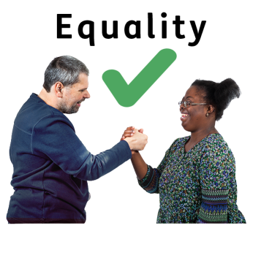
We want to make sure that everything we do is fair to people. This is called Equality.

Equality means treating people fairly and making sure they have the same chances in life.

We want to make sure that people have equality because of:
- Their age.
- Whether they are a woman or man or describe themselves in another way.
- Their disability.
- Their race or background. For example black, white or Asian.
- Whether they are gay, lesbian, bisexual or straight.
- Their religion.
- If they are married, single or in a civil partnership.
- If they are pregnant.
- The language they prefer to use.

Do you think our plans will treat people fairly and make sure they have the same chances in life?

Yes | ☐
No | ☐
Not sure | ☐

Is there anything you would like to say about this?

Welsh language
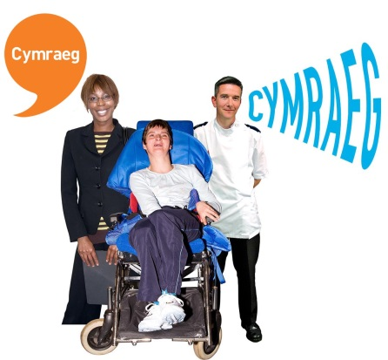
We want to make sure that people can use Welsh when they want to and more people get the chance to use Welsh.

We want to make sure that our plans don’t make it harder for people to use Welsh if they want to.

Do you think our plans could make it harder for people to use Welsh if they want to?
Yes | ☐
No | ☐
Not sure | ☐

Is there anything you would like to say about this?

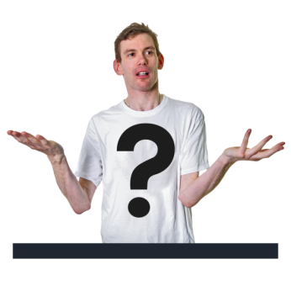
Anything else

Is there anything you would like to say about our plans?

Tell us about yourself

We need to know a little bit about you so we can understand your answers better.

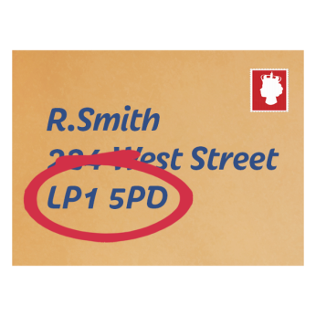

What is your postcode?

Why did you fill out this form?
I live in Rhondda Cynon Taf |  | ☐
I run a business in Rhondda Cynon Taf |  | ☐
I work for Rhondda Cynon Taf County Borough Council |  | ☐
I belong to a community group in Rhondda Cynon Taf |  | ☐
Other

Thank you

Thank you for filling out this form

Please send this form back to us by 7 February 2020.

Address:
Freepost RSBU-HJUK-LSS
Research & Consultation
The Pavillions
Clydach Vale
Tonypandy
CF40 2XX
consultation@rctcbc.gov.uk

