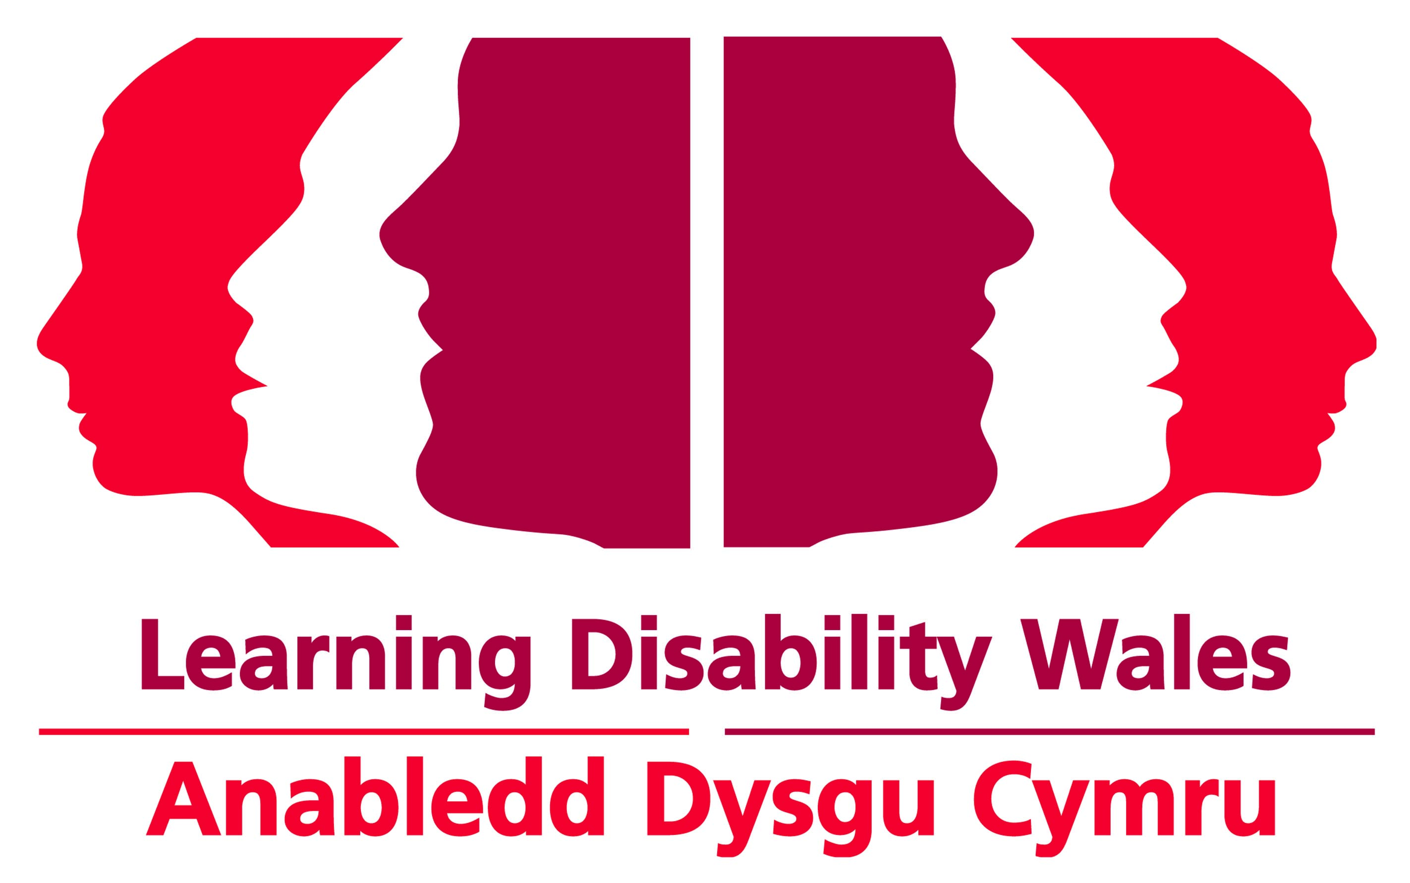
Easy Read

What we will give you if you work for Learning Disability Wales

 | Gig Buddies Project Coordinator
Pay
LDW Grade 4 - £20,272 to £22,803 per year for full time hours.
Hours
30 hours a week split between 2 people.
March | How long for?  This post is funded until 31 March 2021. It is very likely that we will be able to fund this post for longer.
Your well-being
We want to support you to balance your work life with your home life. We have policies and ways of working to make this easier for you.
Holidays
You will get 25 days off a year. Plus days off for bank holidays. You will get 1 extra day off each year you work for us, until you reach 28 days in total.
Pension
We have a group pension scheme with Scottish Widows. We will pay 7.5% of your pay each month into your pension. As long as you pay 0.5% or more.
Probationary period
A probationary period is a set amount of time to try out the job. The probationary period for this job is 3 months.
Equipment
We will give you everything you need to do your job. For example, a laptop and mobile phone.

