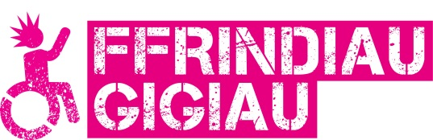
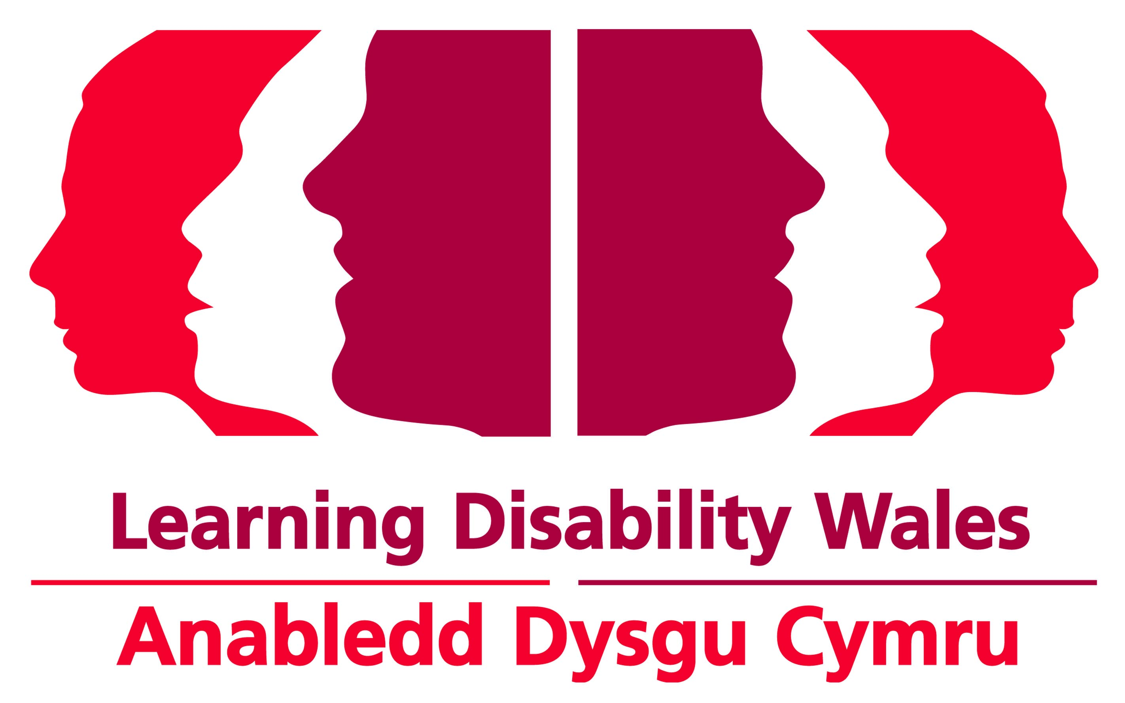
Easy Read

Gig Buddies North Wales

We need 2 new Project Coordinators in North Wales

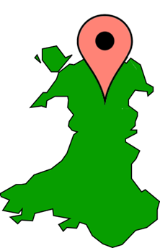 | We will soon be starting the Gig Buddies project in North Wales.
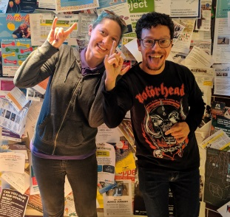 | Gig Buddies matches people with a learning disability or autism with volunteers who like the same things.
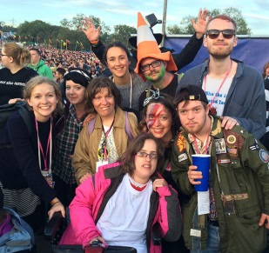 | They go to gigs and events together, like music concerts, comedy nights and rugby matches.
 | We need 2 new Project Coordinators.
 | We need our 2 new Project Coordinators to work 30 hours a week between them. For example, they might work 15 hours each.
 | We can talk about how many hours each person works, and what works best for everyone.
 | The pay is £20,272 to £22,803 a year pro rata. This is Grade 4 of the Learning Disability Wales Pay Scale.
The pay is based on someone who works full time hours. Pro rata means we will work out how much money you should be paid based on:
- the full time pay
- and how many hours you work.
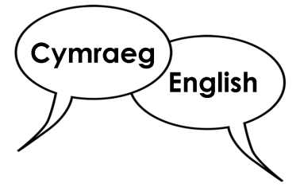 | We would like it if you could speak and write in Welsh and English.
 | Our Project Coordinators will be based in their own homes.
 | We will arrange a workplace in the community that you can use when needed. For example for meetings or training.
If you want to talk about the job further please contact Lyndsey Richards, Innovation Manager:
By email: lyndsey.richards@ldw.org.uk
By phone: 029 2068 1160

 | How to apply
 | Please apply by Monday 7 September 2020. The interview will take place week beginning 14 September.
Click on the links on our website to download the application pack.
www.ldw.org.uk/gig-buddies-north-wales-project-coordinator-vacancies
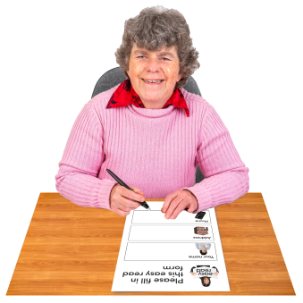 | To apply for the job you can:  Fill out the application form and send it back to us by post or email.
 | You can also apply for the job by sending in a video clip. There are instructions on how to do this in the How To Apply By Video document in the application pack.
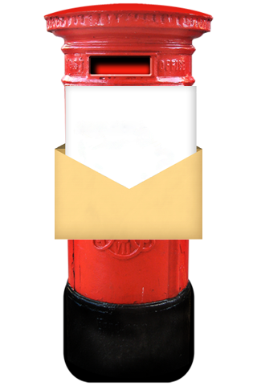 | Post: Gig Buddies North Wales Recruitment  Learning Disability Wales  41 Lambourne Crescent  Cardiff Business Park  Llanishen, Cardiff  CF14 5GG
Email: enquiries@ldw.org.uk
Please write Gig Buddies North Wales Recruitment in the subject line

