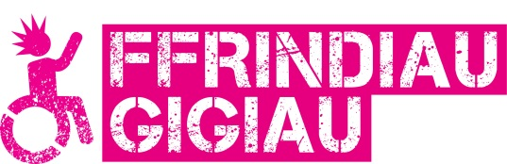
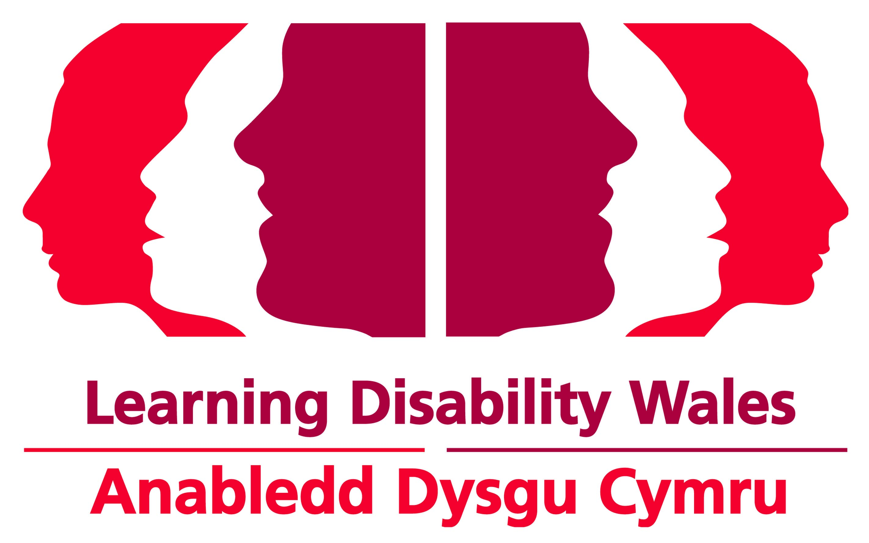
Easy Read

Skills a Gig Buddies Project Coordinator needs
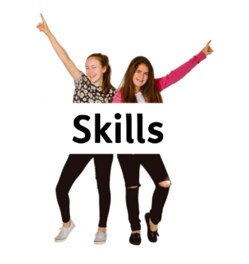 | Here are the skills you must have to be a Project Coordinator. We have also written about skills that we would like you to have.
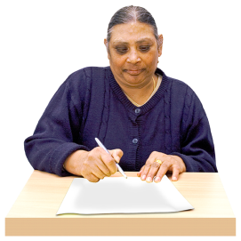 | Please write or talk about these skills in your application form, or video application. Tell us about things you have done that show you have these skills.
 | Qualifications
 | You must have:
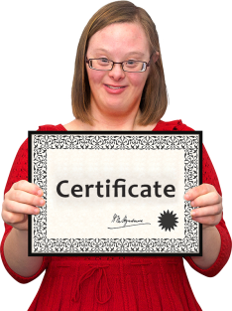 | - Good GCSEs or A levels. Or the same sort of experience in a similar role.
 | Knowledge and experience
 | You must have:
 | - Promoted and told people about a service before.
 | We would like it if you:
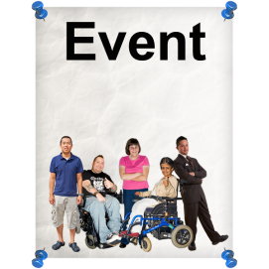 | - Have organised events before.
 | - Know about local music and events.
 | - Have worked with people with a learning disability or autism before.
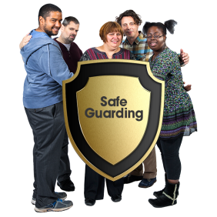 | - Know a bit about safeguarding.
 | - Have written information in plain English before.
 | Skills and values
 | You must be able to:
 | - Write information well and speak to people well.
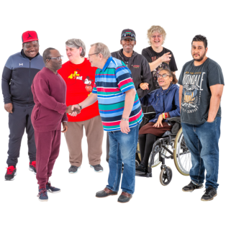 | - Get on well with all different types of people.
 | - Use a computer, and be able to learn new things on the computer.
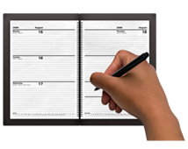 | - Organise your own work and work to deadlines.
 | - Stand up for the rights of disabled people
 | - Work well in a team and be able to make presentations to people.
 | We would like it if you:
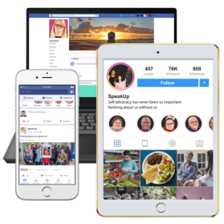 | - could use social media to talk about Gig Buddies
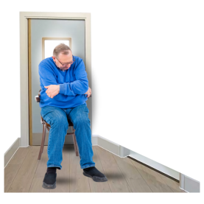 | - understood the types of things that stop people with a learning disability taking part.
 | Other
 | You must be able to:
 | - Work at different times and on different days when needed.
 | - Work without judging others.
 | We would like it if you:
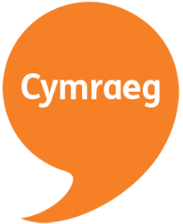 | - Could speak and write in Welsh. We will still consider your application if you cannot speak or write in welsh.

