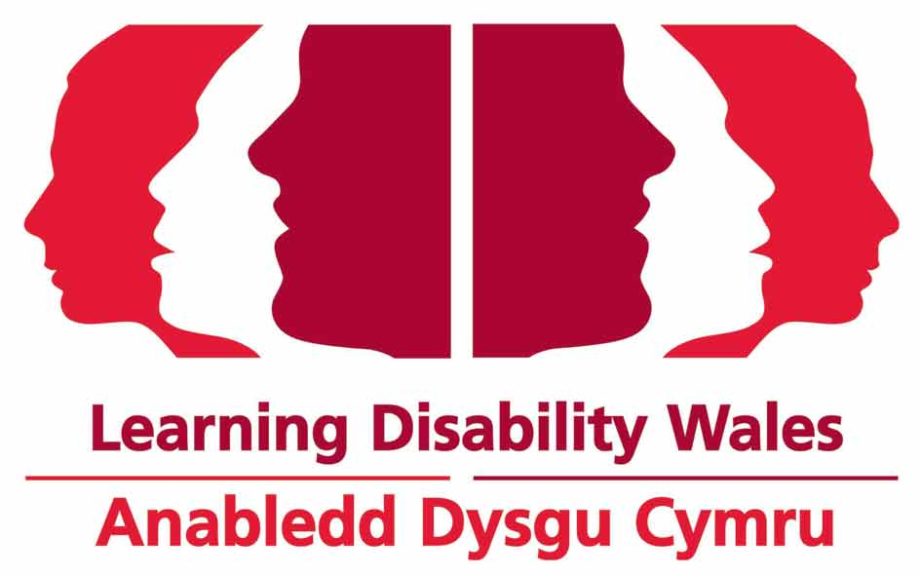
Job Application Form
Job title: |  |  |  | Click here to enter text.
1. |  | Personal Information
To make sure our process is fair this information is taken off your application before short listing.
Surname: |  |  |  |  |  |  | Other Names:
Address
and postcode:
Contact details:
Mobile: Click here to enter text.
Home:
Work:
E-mail Address :
2. | Asylum and Immigration Act 1996
If you have come to the UK from another country please tell us:

Are you allowed to work in the UK?

Are there any rules about you having a job in the UK?

Please explain :

3. | Rehabilitation of Offenders Act 1974 (exception) Order 1975
Do you have a criminal conviction that is not spent?

☐Yes ☐No

If yes, please give details and dates on a separate sheet marked confidential.

Disclosure and Barring Service

If you are applying for a job that involves working with children, young people or vulnerable adults, you must tell us if you have a criminal record, spent or unspent as the post is exempt under the Rehabilitation of Offenders Act 1974.

If successful, you will be asked to complete a Disclosure and Barring Service (DBS) form this is called a DBS check (formerly a CRB check).

Do you have a criminal conviction that is spent?

☐Yes ☐No

If yes, please give details and dates on a separate sheet marked confidential.

The information you write down will be treated in confidence. This means we will not pass it on to anyone else unless we think it might help to detect a crime or stop one from happening.

4. | References – Please give us details of 2 referees
A referee is someone who knows you well and can tell us if you are suitable for this job.

Referee 1 should be your current or most recent employer.
Referee 2
Name:

Address:

Job Title:

Relationship to you:

Phone
Number:

Email
Address:

Can we contact this referee before interview?

☐Yes ☐No

Referee 1
Employer Name:

Business Address:

Job Title:

Relationship to you:

Phone
Number:

Email
Address:

Can we contact this referee before interview?

☐Yes ☐No

5. |  |  | Please sign and date your form
I promise that the information I have given in Part 1 and 2 of this application is true and correct.

I accept that if any of the information I put on this application is found to be untrue I could lose my job straight away.

Please sign the application form.

When you sign it you are telling us that we can use the information as long as we follow the Data Protection Act 1998

Sign

Date

Please also compete the Equal Opportunities monitoring form at the back of this application form. This helps us check that everyone is getting an equal chance to work for Learning Disability Wales.

Part 2 - Application
Job title:

1. | Education, Qualifications and Training
Tell us about all of your qualifcations including exams you passed at secondary school, college and university. Also any relevant training courses attended or membership to professional bodies.

2. | Do you have a job now?
☐Yes ☐No (If no please go to question 3)
Job title:

Date started:
Tell us about your responsibilities

What is your current annual salary?
How much notice do you have to give if you want to leave your job?

Your Current Employer
Employer’s Name:

Employer’s Address
and Postcode:

Contact details:

Phone

Email
3. |  |  | Please list all the jobs you have had
Date Started |  |  |  | Date Finished |  | Name & Address of Employer |  |  | Job Title, Duties and Reason You Left
4. |  | Knowledge, Experience, Skills and Abilities
Please use this section to demonstrate why you think you would be suitable for the post in relation to all of the job criteria listed as essential and desirable in the person specification.

Please use additional sheets as necessary.

5. | More about you
If you have any hobbies or work experience that are relevant please tell us.

Thank you for your interest in working for Learning Disability Wales
Please email your completed application to: enquiries@ldw.org.uk
Please label the subject of your email as ‘Recruitment’.
Or post to:
Human Resources & Governance Manager
Learning Disability Wales
41 Lambourne Crescent
Cardiff Business Park
Llanishen
Cardiff CF14 5GG

