Easy Read

Chair of The Board of Trustees
Application Form 2020-2022

If you would like to be the Chair of the Board of Trustees for Learning Disability Wales, please:
- fill out this application form
Please send it back to us by post or email.
- or make your own video
Use a phone with a camera, or a tablet like an iPad, to record your answers to the questions in this application form.
When you have made your video please email it to us. It should be no longer than 5 minutes long.
Please send us your application form or video by 23 September 2020 to:
Post: Learning Disability Wales
41 Lambourne Crescent
Cardiff Business Park
Llanishen
Cardiff
CF14 5GG
Email: joanne.moore@ldw.org.uk
If you need any support or for more information call Joanne Moore on: 029 2068 1160

Your details
 | Name:
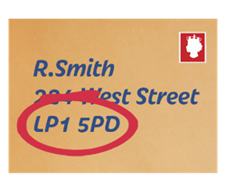 | Address and postcode:
 | Email address:
 | Telephone Number:
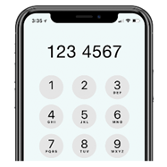 | Mobile Number:
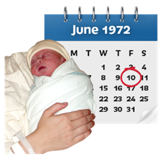 | Date of birth:
Questions
- Why do you want to become Chair of Learning Disability Wales?
- Tell us about the skills and experience that you can bring to the role.

Please write about the skills listed in the person specification.
- What areas of our work are you interested in? And how can we make things better?

References
We will ask for 2 references before interview.

Please give us details for 2 people we can contact to ask if you would be good for this role.
Referee 1
Their name:
Their job title:
Their email address and telephone number:
Relationship to you:
Referee 2
Their name:
Their job title:
Their email address and telephone number:
Relationship to you:

Declaration
Please make sure you fill this part in.

I confirm that I am suitable to be a Chair, Trustee and Director of the Company:
Signed:
Date:

