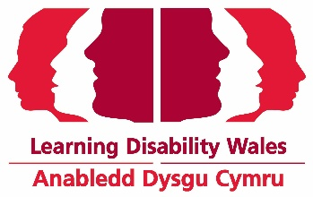
Easy Read

Anabledd Dysgu Cymru

Mae Anabledd Dysgu Cymru yn chwilio am Gadeirydd newydd

'Rydym am i Gymru fod y Wlad orau i bobl ag anabledd dysgu fyw, dysgu a gweithio' ac rydym yn chwilio am Gadeirydd ar gyfer ein Bwrdd Ymddiriedolwyr i'n helpu i gwyflawni hyn.
We are looking for a Chair of Trustees to help us achieve this.
I gael rhagor o wybodaeth am ein gwaith a'n cynllun Strategol

www.ldw.org.uk
This job is for 2 years.
this job will be for 2 terms. You will be the Chair of Trustee for the second term if you get elected again.
There is no pay for this job.
But you can claim back the money you spent on travel or stay because of this job.
Our Chair of Trustee will have to be a good leader to the Board of Trustees and include everyone on the board.
Our Chair of Trustee will have to support the Chief Executive Officer in making the organisation better.
The new Chair will work with our present Chair of Trustee for some time.
This will be until we get approval from our members at our Annual Conference in December 2020.
If you want to talk about the job further please contact Phil Madden, Chair of Trustee:
By email: philmadden31@googlemail.com
By phone: 07836 380778

How to apply
Please apply by Wednesday 23 September 2020.
The interview will take place by Zoom in the week beginning Monday 28 September.
Date will be confirmed later.

Click on the links on our website to download the application details
To apply for the job you can:

Fill out the application form and send it back to us by post or email.
You can also apply for the job by sending in a video clip.
Post: Chair Recruitment
Joanne Moore
Learning Disability Wales
41 Lambourne Crescent
Cardiff Business Park
Llanishen, Cardiff
CF14 5GG
Email: joanne.moore@ldw.org.uk
Please write Chair Recruitment in the subject line

