Easy Read

Learning Disability Wales is looking for a new Chair

Ar
'Learning Disability Wales’ goal is to make Wales the best Country for people with a learning disability to live, learn and work.
We are looking for a Chair of Trustees to help us achieve this.
For more information about our work and our please click on the link

www.ldw.org.uk/about-us/strategic-plan/plan

www.ldw.org.uk
This job is for 2 years.
You will be the Chair of Trustee for the 2nd term if you get elected again.
There is no pay for this job.
But you can claim back the money you spent on travel or stay because of this job.
Our Chair of Trustee will have to be a good leader to the Board of Trustees and include everyone on the board.
Our Chair of Trustee will have to support the Chief Executive Officer in making the organisation better.
The new Chair will work with our present Chair of Trustee for some time.
This will be until we get approval from our members at our Annual General Meeting in December 2020.
If you want more information about the job please contact Phil Madden, Chair of Trustee:
By email: philmadden31@googlemail.com
By phone: 07836 380778

 | How to apply
 | Please apply by Wednesday 23 September 2020.
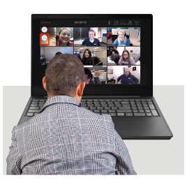 | The interview will take place by Zoom in the week beginning Monday 28 September.  Date will be confirmed later.
 | Click on the links on our website to download the application details.
To apply for the job you can:

Fill out the application form and send it back to us by post or email.
 | You can also apply for the job by sending in a video clip. You can email your video clip to joanne.moore@ldw.org.uk
Post: Chair Recruitment
Joanne Moore
Learning Disability Wales
41 Lambourne Crescent
Cardiff Business Park
Llanishen, Cardiff
CF14 5GG
Email: joanne.moore@ldw.org.uk
Please write Chair Recruitment in the subject line

