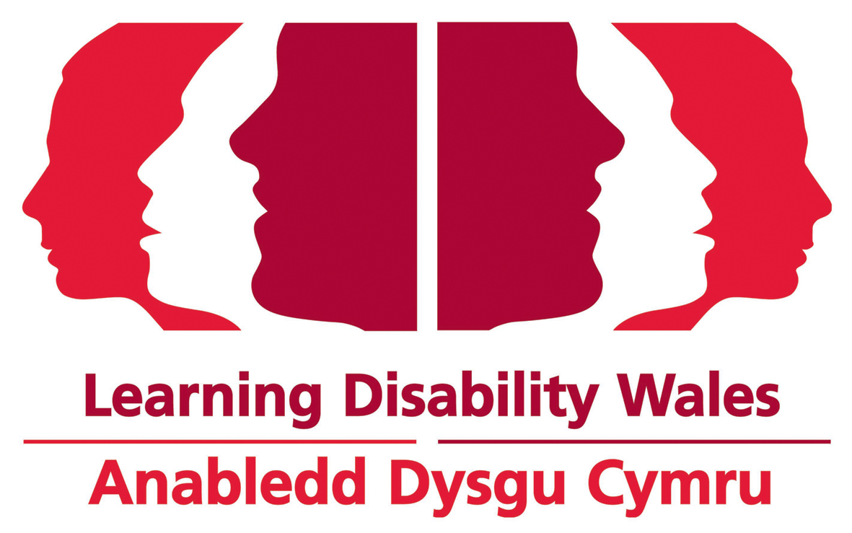Person Specification for Innovation Manager

Section | Job Criteria |  | Assessment Method | Essential or  Desirable
Qualifications | 1. | Educated to further/higher level or equivalent professional development. | Application | Essential
Knowledge and Experience | 2. | Proven ability of successful project management .  Proven ability to develop relationships and co produce support for people with a learning disability. | Application Interview  Probation | Essential
 | 3. | Evidence of understanding the barriers and challenges faced by people with a learning disability and/or autism. | Application Interview  Probation | Essential
 | 4. | Experience of managing projects with people of all ages with a learning disability and/or autism. | Application Interview  Probation | Essential
 | 5. | Evidence of a commitment to promoting the rights and inclusion of people of all ages with a learning disability and/or autism. | Application Interview  Probation | Essential
 | 6. | Experience of managing budgets and interpreting a range of financial information. | Application Interview  Probation | Essential
 | 7. | Experience of working alongside a wide range of stakeholders including people with a learning disability and/or autism to reach a positive outcome. | Application Interview  Probation | Essential
 | 8. | Knowledge and understanding of the UN Convention and relevant UK and Welsh Government Policies for people of all ages with a learning disabilty and their family carers. | Application Interview  Probation | Essential
 | 9. | Knowledge and understanding of Welsh structures and networks. | Application Interview  Probation | Essential
 | 10. | Experience of managing people and leading, supporting and motivating a team. | Application Interview  Probation | Essential
 | 11. | Experience of writing reports for a range of different audiences | Application Interview  Probation | Essential
Skills, Awareness, Abilities and Attitude | 12. | Ability to deliver under pressure. | Application Interview  Probation | Essential
 | 13. | Ability to be organised, planned and structured in your approach. | Application Interview  Probation | Essential
 | 14. | Aptitude to problem solve, negotiate and persuade when necessary to ensure the success of the project. | Application Interview  Probation | Essential
 | 15 | Demonstrate ability to work independently and equally well with others. | Application Interview  Probation | Essential
 | 16. | Proficient ICT skills, including a good understanding of digital communication, marketing and multimedia and at ease using social media. | Application Interview  Probation | Essential
 | 17. | Excellent interpersonal, verbal and written communication and presentation skills. | Application Interview  Probation | Essential
 | 18. | Ability to build and maintain effective and productive partnerships. | Interview  Probation | Essential
Other | 19. | Willingness to travel. | Application Form | Essential
 | 20. | Ability to speak Welsh. | Application Form | Desirable
 | 21. | Available to work flexibly. | Application Form | Essential

Learning Disability Wales
January 2021

