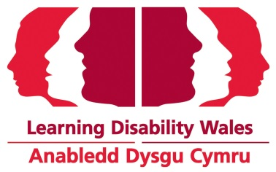

JOB DESCRIPTION

Job Title: Senior Research & Policy Officer

Grade: LDW Salary Scale, Grade 5-6

Hours: 30 hours per week

Accountability: Responsible to the Policy & Communications Manager

Purpose: Support the Learning Disability Consortium and Learning Disability Wales’s contribution to Welsh Government policy on Covid-19 and other policy areas to ensure the needs of people with a learning disability are met.

Responsibilities

  - Act as Secretariat to the Learning Disability Consortium Covid-19 specific meetings.

  - Research and analyse information that will inform the Learning Disability Consortium response to Covid-19.

  - Represent the organisation’s policy brief at internal and external meetings.

1.4 Coordinate and support the preparation of the Learning Disability Consortium and Learning Disability Wales response to consultations.

1.5 Assist the Learning Disability Consortium to influence government and statutory agency policies.

1.6 Analyse key policy initiatives from the Welsh Government and UK Government, and monitor their impact.
1.7 Assist with Covid Study Research Project including recruitment, publicising findings and assisting with influencing government and statutory policies.

1.8 Working with the Communications team, prepare informative reports, online articles,
social media and briefings on policy issues.

1.9 Act as media spokesperson on the organisations policy brief.

1.10 Work directly with people with a learning disability and stakeholders to ensure their perspectives influence the preparation of policy consultations and reports.
1.11 Contribute to Learning Disability Wales internal meetings on policy matters and
campaign and events activity.

1.12 Offer advice to the CEO, managers and enquirers on Covid related and other policy matters.

2 Other

2.1 Maintain and develop relationships with members and other key stakeholders.

2.2 Actively contribute to the organisation’s work.

2.3 Undertake a range of duties within the scope of your role to ensure the delivery of our strategic plan.

Learning Disability Wales
Dec 2020

