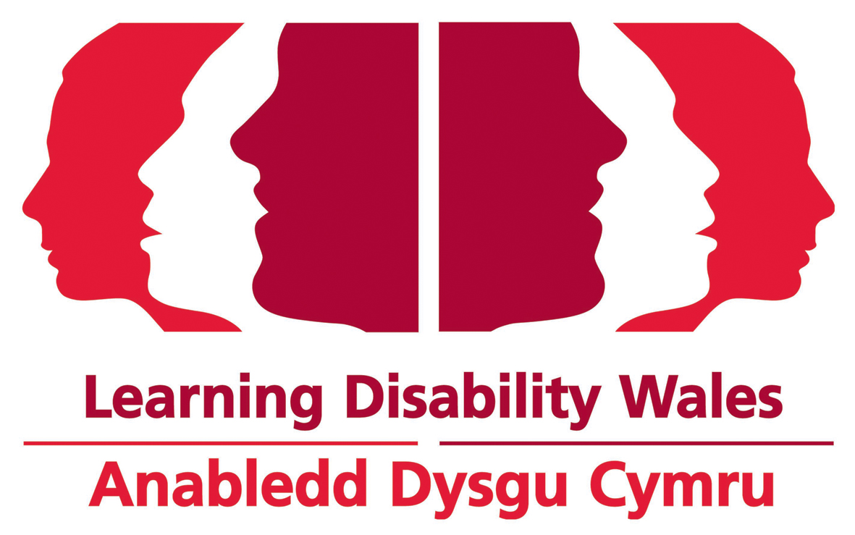
Person Specification for Senior Research and Policy Officer

Section | Job Criteria |  | Assessment Method | Essential or  Desirable
Qualifications | 1. | Educated to further/higher level or equivalent professional development. | Application | Desirable
Knowledge and Experience | 2. | Proven ability to confidently present policy positions to a range of audiences. | Application Interview  Probation | Essential
Knowledge and Experience | 3. | Ability to research and gather a range of information | Application Interview  Probation | Essential
Knowledge and Experience | 4. | Excellent interpersonal, verbal and written communication skills. | Application Interview  Probation | Essential
Knowledge and Experience | 5. | Evidence of understanding the barriers and challenges faced by people with a learning disability and/or autism. | Application Interview  Probation | Essential
Knowledge and Experience | 6. | Experience of working with people with a learning disability and/or autism. | Application Interview  Probation | Desirable
Knowledge and Experience | 7. | Proven research and analytical skills. | Application  Probation | Essential
Knowledge and Experience | 8. | Knowledge of current Welsh Government, Welsh Parliament and UK Government structures. | Application Interview  Probation | Essential
Skills, Awareness, Abilities and Attitude | 9. | Ability to be organised planned and structured in your approach and work to tight deadlines | Application  Probation | Essential
Skills, Awareness, Abilities and Attitude | 10. | Ability to write clear and concise briefings and articles. | Application  Probation | Essential
Skills, Awareness, Abilities and Attitude | 11. | Demonstrate ability to work independently and equally well with others. | Application Interview  Probation | Essential
Skills, Awareness, Abilities and Attitude | 12. | Proficient ICT skills including a good digital communication, marketing and multimedia and at ease using social media. | Application  Probation | Essential
Other | 13. | Ability to speak Welsh. | Application Form | Desirable
Other | 14. | Available to work flexibly. | Application Form | Essential
 | 15. | Willingness to travel. | Application Form | Desirable

Learning Disability Wales
Dec 2020

