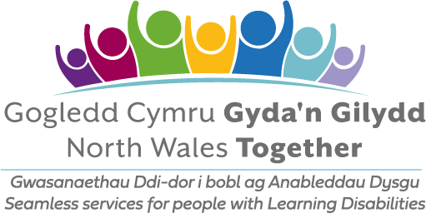
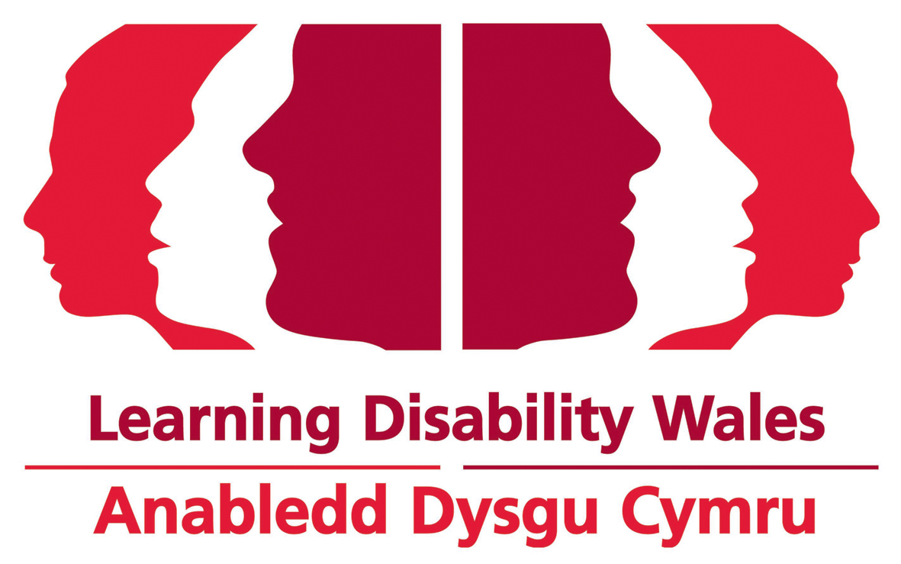
\

Hello
Thanks for being interested in having a Gig Buddy!
We have attached an easy read application form for you to complete.
If you need any help, ask someone to support you to answer the questions. You can also phone or email us, and we can help you. Our contact details are at the end of this letter.
We have included an easy read leaflet about our Gig Buddies project. And we have included below some more information for you.
If you have any questions please let us know.

Changes due to Covid-19
Before the pandemic Gig Buddies were going to gigs and events together once a month.
The pandemic has stopped many gigs and events taking place. So Gig Buddies are staying connected and having fun by meeting online. There are lots of fun things you can do online with friends, like clubnights, gigs, parties, keep fit, quizzes, theatre, watching films, and lots, lots more!
Whenever it is safe to do so, Gig Buddies are meeting up outdoors.
And as soon as we can Gig Buddies will go back to attending gigs, events, and festivals together.
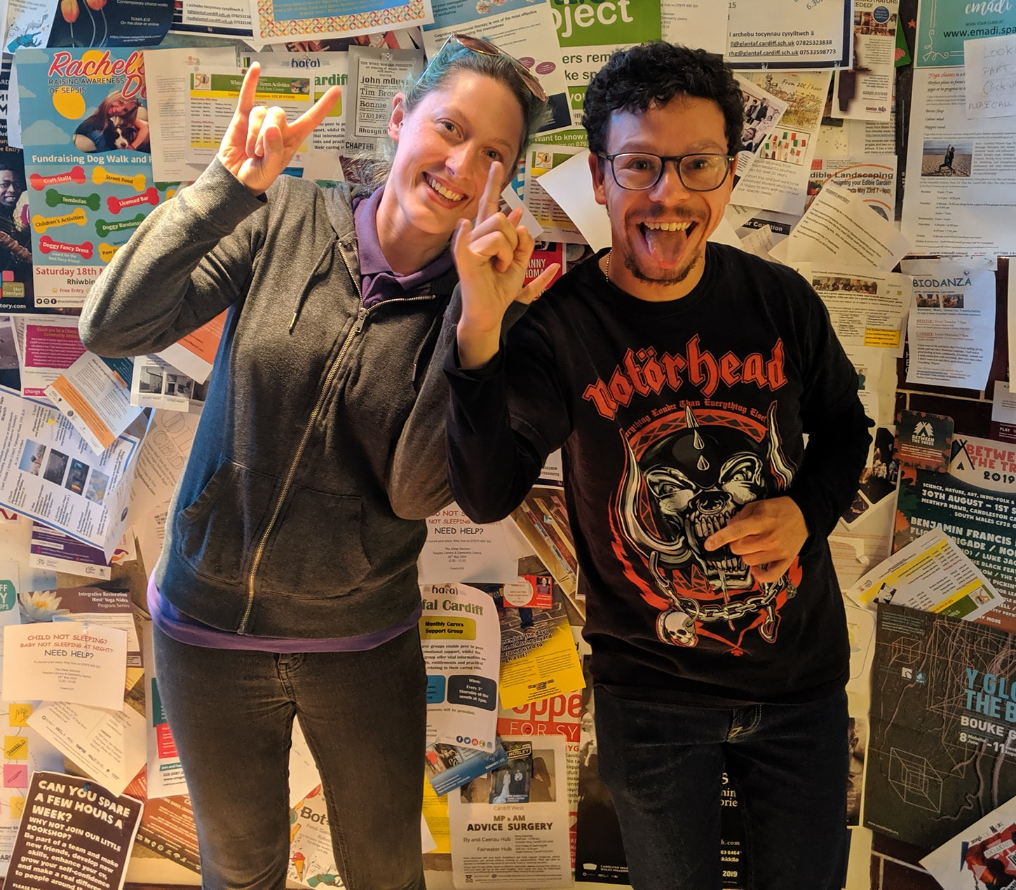
What happens next?
As soon as we receive your application form we will arrange to meet with you. This is so we can find out a little more about you.
When it is safe to do, we can meet in a café or at your home. Or we can meet using a video call – like Zoom, or WhatsApp.
After this, we will start to match you with a Gig Buddy. This may take a little time as we want to make sure we make a match with a volunteer who has similar interests to you, and you will get on together.
We will let you know when we think we have made a good match, and can then arrange for you and your Gig Buddy to meet each other.
About the training that volunteers get
All our Gig Buddy volunteers have to attend a day’s free Gig Buddy training, as well as pass a DBS check – a police check, to make sure they are safe people. And provide 2 references.
The free training covers lots of things about being a great Gig Buddy:
- an introduction to learning disability and autism
- communication
- safeguarding (keeping your Gig Buddy safe)
- how to make sure your Gig Buddy has a good time when you are out together.
What is expected of Gig Buddy volunteers?
Before and after the pandemic: We ask your Gig Buddy to attend, on average, 1 gig or event with you every month.
We also ask your Gig Buddy to meet up with you for a short meeting every month so you can plan your next gig. You can do this at a café or pub, or somewhere else that you like to go.
Every month we also hold Gig Buddies socials, where we invite all our Gig Buddies to get together for an event.
We will support you and your Gig Buddy at your first gig together.
During the pandemic: Our Gig Buddies are meeting online for virtual parties and digital events, and whenever it is safe to do so, meeting up outdoors.

More information
You can more information about our project on our website at www.ldw.org.uk/project/ffrindiau-gigiau-gig-buddies
There is also a very good FAQ about Gig Buddies at the Gig Buddies Brighton website: https://stayuplate.org/faqs-gig-buddies/
Kai, Kylie, Heather and Rachel
Ffrindiau Gigiau / Gig Buddies
Office (Learning Disability Wales): 029 2068 1160

Email: gigbuddies@ldw.org.uk
(Our working days are Tuesdays, Wednesdays and Thursdays)

www.facebook.com/FfrindiauGigiau
https://twitter.com/FfrindiauGigiau
Application form to have a Gig Buddy

All about me…
 | Your name:
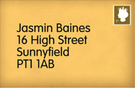 | Your address:  If you change address, please let the Gig Buddies team know.
 | Your date of birth:
Your telephone numbers:

Home:

Mobile:

 | Your email address:
 | What music are you into? (this could be types of music, like ‘rock’ or bands / singers, like ‘Beyonce’)
 | What are your hobbies?
 | Do you have any preferences about the person you are matched with (age, gender, interests)?
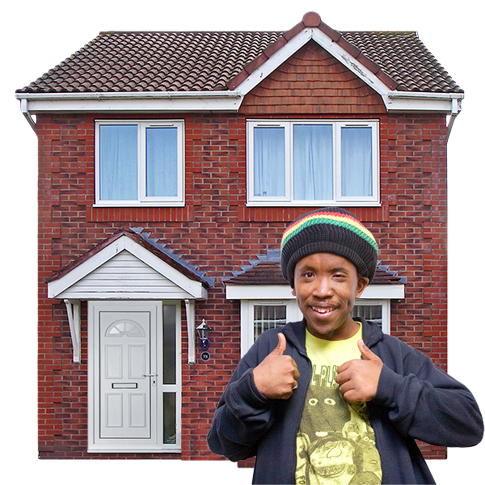 | Please tell us about your home. Please tick the box next to where you live.  - I live in my own home  - I live with my family  - I live in supported living or  residential care  Please us the name of your support provider:  _____________________________
Is your house owned by FCHA? (First Choice Housing Association). Please tick the answer

Yes

No

Do you have support worker(s) or PA(s) to help you, and if so approximately how many hours a week do they work with you?
What provider (or direct payments) do they work for?

 | How do you get to places? Do you travel alone or do you need support to travel?
 | Do you have any specific health needs (for example, epilepsy)? Would your buddy need any special training to help you with this?
 | Is there anything else that your buddy will need to know about support that you need?
Please could you give us the name of somebody else we can contact if we cannot get hold of you (this could be a parent or support worker)

Name:

Relationship to you:

Address:

Telephone:

You can email the form back to us, or scan a copy and forward it to gigbuddies@ldw.org.uk
You can also post it to us: Gig Buddies-Learning Disability Wales
Lambourne Crescent, Cardiff Business Park, 41, Cardiff CF14 5GG
Any questions please phone 029 2068 1160.

