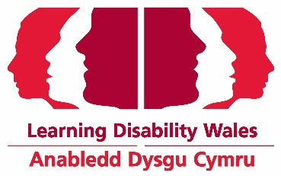
Equal Opportunities Monitoring Form
This form is confidential, it is not seen by the shortlisting panel and used only for the purpose of monitoring our recruitment.
1. Gender
What best describes your gender?
Male Female Non-binary Prefer not to say
Prefer to self describe:

Is your gender identity the same as you were assigned at birth?
Yes No Prefer not to say

- Age

How old are you?
16-25 26-35 36-45

46-55 56-65 66 +

Prefer not to say
- Marital Status

Are you:
Single Married Cohabiting
Prefer not to say

4. Ethnicity

White  British  English  Scottish  Welsh  Irish  Any Other White Background | Mixed Heritage  Black Caribbean and White  Black African and White  Asian and White  Any Other Mixed Background
Asian, Asian British, Asian English, Asian Scottish, Asian Welsh  Indian  Pakistani  Bangladeshi  Any Other Asian Background | Black, Black British, Black, English, Black Scottish, Black Welsh  Caribbean  African  Any Other Black background
Chinese, Chinese British, Chinese English, Chinese Scottish, Chinese Welsh  Chinese  Any Other Chinese Background | Other ethnic background  Please state:  Prefer not to say
How would you describe your ethnic origin?

- Disability

By disability we mean:
A long term physical or mental impairment (such as a physical or learning disability, sensory impairment, mental health issues, health conditions controlled by medication/equipment or a progressive illness) that has a long term adverse effect on your ability to carry out normal day to day activities?

Do you consider yourself disabled?
Yes No Prefer not to say
Sexual Orientation
How would you describe your sexual orientation?
Heterosexual Bisexual Gay Man

Lesbian / Gay Woman Prefer not to say
Prefer to self describe:
- Religion and Belief

The list below is a list of religions most commonly found in Britain. They are listed in alphabetical order and not intended to signify rank in terms of importance.
What is your religion or belief?
Christian Buddhist Hindu Jewish Muslim
Sikh None Prefer not to say

Other (please specify):
8. What is your first language?

English Welsh Other, please specify

9. Where did you see the post advertised?

LDW website LDW Facebook Twitter
Linkedin

Other, please specify

Thank you for your interest in working for Learning Disability Wales

LDW
Jan 2021

