Hello
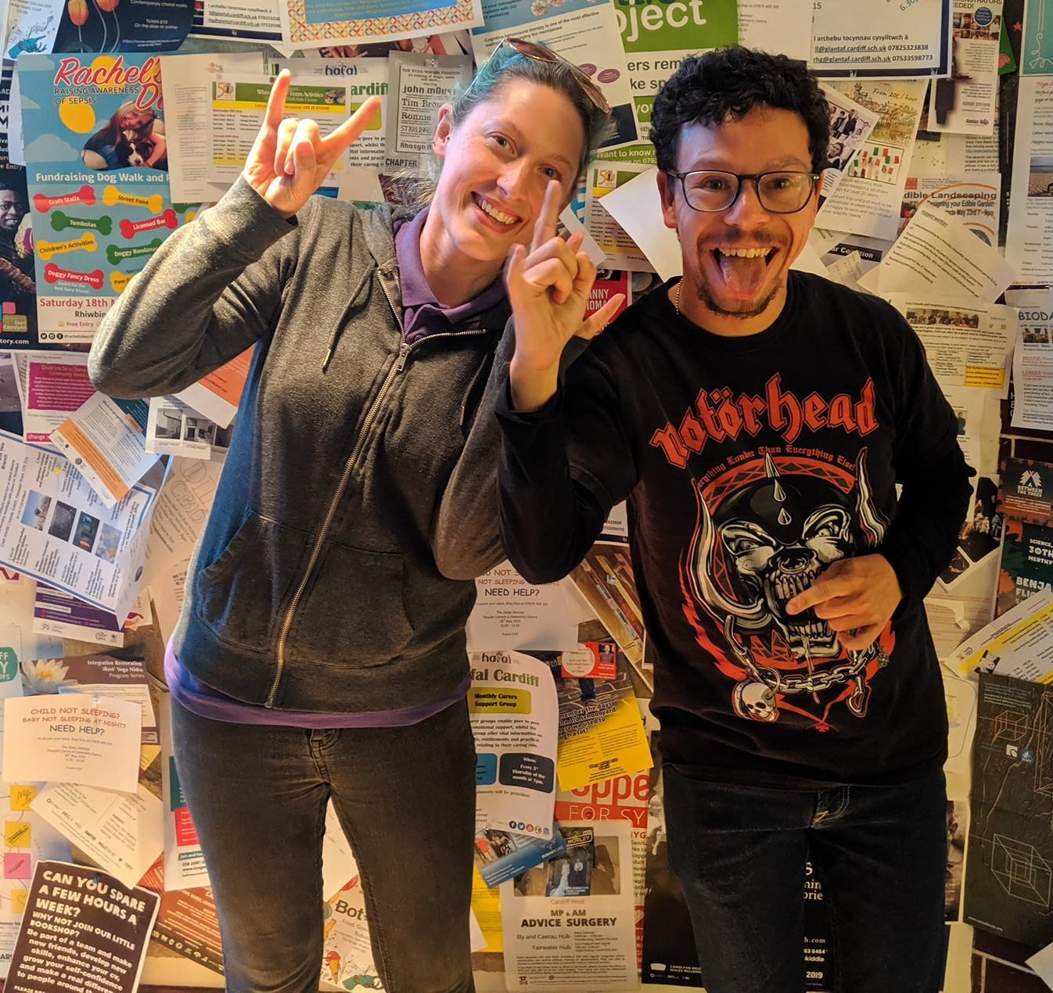
Thanks for being interested in having a Gig Buddy!
Please can you complete the form on pages 4 to 8.
If you need any help, ask someone to support you to answer the questions.
You can also phone or email us, and we can help you. Our contact details are on page 3.
We have included below some information about what will happen after you join Gig Buddies.
We also have an easy read leaflet about Gig Buddies. Let us know if you would like us to send you the easy read leaflet about Gig Buddies.
What happens next?
After we have got your application form we will arrange to meet you. This is so we can find out a little more about you.
After this, we will start to match you with a Gig Buddy. This may take a little time as we want to make sure we make a match with a volunteer who has similar interests to you, and you will get on together.
We will let you know when we think we have made a good match. And then we can arrange for you and your Gig Buddy to meet each other.
About the training that Gig Buddy volunteers get
All our Gig Buddy volunteers have to attend Gig Buddy training. The free training covers lots of things about being a great Gig Buddy:
- an introduction to learning disability and autism
- safeguarding – this means keeping your Gig Buddy safe
- how to make sure your Gig Buddy has a good time when you are out together.
Volunteers also have to pass a DBS check – this is a police check that makes sure they are safe people.

And volunteers also have to get 2 people they know to give us references. A reference is a letter that says they can confirm that the volunteer is a good person.

What is expected of Gig Buddy volunteers?
We ask your Gig Buddy to attend, on average, 1 gig or event with you every month.
We also ask your Gig Buddy to meet up with you for a short meeting every month so you can plan your next gig. You can do this at a café or pub, or somewhere else that you like to go.
Every month we also hold Gig Buddies socials, where we invite all our Gig Buddies to get together for an event.
We can support you and your Gig Buddy at your first gig together.

Changes due to Covid-19: September 2021
The need for friendship and social contact has been more important than ever during the pandemic.
Gig Buddies have stayed connected by meeting online for virtual parties and activities, enjoying digital events together, and whenever it has been safe to do so meeting up outdoors.
Over the past few months some Gig Buddies have been attending gigs and events again. However, some Gig Buddies may still be anxious about attending events in person, particularly in large crowds, so we are supporting all our Gig Buddies to take things at their own pace.

More information
Find out more about Gig Buddies on our website and social media: www.ldw.org.uk/gigbuddies
@FfrindiauGigiau

Email: gigbuddies@ldw.org.uk Phone: 029 2068 1160
(Our working days are Tuesdays, Wednesdays and Thursdays)
Kai, Kylie, Heather, Rachel, and Karen
Gig Buddies Cymru / Ffrindiau Gigiau Cymru

Application form to have a Gig Buddy
All about me…
 | Your name:
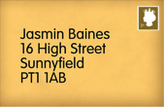 | Your address:  If you change address, please let the Gig Buddies team know.
 | Your date of birth:
Your telephone numbers:

Home:

Mobile:

 | Your email address:
 | How did you hear about Gig Buddies?
What music are you into? (this could be types of music, like ‘rock’ or bands / singers, like ‘Beyonce’)

Is there any music that you really don’t like?

 | What are your hobbies? Please tell us about any other interests you have.
 | Do you have any preferences about the person you are matched with (age, gender, interests)?
Please tell us about your home. Please tick the box next to where you live.

- I live in my own home
- I live with my family
- I live in supported living or
residential care
Please us the name of your support provider:
_____________________________
Is your house owned by First Choice Housing Association? Please tick the answer

Yes

No

Do you have support worker(s) or PA(s) to help you, and if so approximately how many hours a week do they work with you?
What provider (or direct payments) do they work for?

 | How do you get to places? Do you travel alone or do you need support to travel?
 | Do you have any specific health needs (for example, epilepsy)? Would your buddy need any special training to help you with this?
 | Is there anything else that your buddy will need to know about support that you need?
Please could you give us the name of somebody else we can contact if we cannot get hold of you (this could be a parent or support worker)

Name:

Relationship to you:

Address:

Telephone:

You can email the form back to us, or take a photos of the form and send it to gigbuddies@ldw.org.uk
You can also post it to us: Gig Buddies, Learning Disability Wales
Lambourne Crescent, Cardiff Business Park, 41, Cardiff CF14 5GG
If you have ny questions please phone 029 2068 1160.

