Easy Read

Neurodevelopmental services
in Wales
We want to know what you think
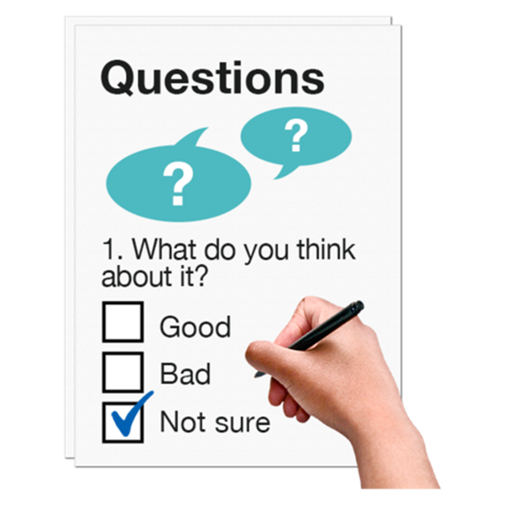

This questionnaire was written by the Welsh Government. It is an easy read version of ‘Neurodevelopmental services questionnaire’.

February 2022

How to use this document
This is an easy read form. But you may still need support to read it. Ask someone you know to help you.
Words in bold blue writing may be hard to understand. Hard words are in bold the first time they are used.

Where the document says we, this means Welsh Government. For more information contact:
Address: Learning Disability, Autism and
Neurodevelopmental Team
Welsh Government
Cathays Park
Cardiff
CF10 3NQ
Website: https://gov.wales
E-mail: Neurodiversity@gov.wales
This survey was made into easy read by Easy Read Wales using Photosymbols. To tell us what you think about this easy read version, click here.

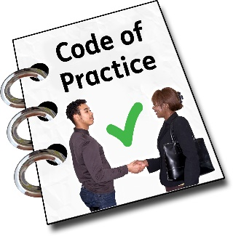
Introduction
We have written a new Code of Practice to say how autism services should work. And what type of services we should have.
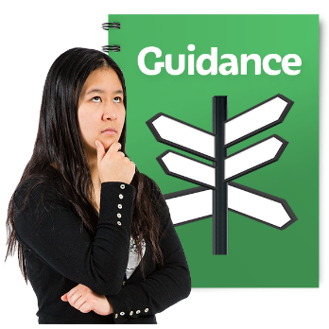

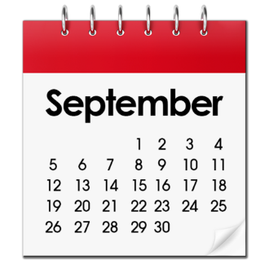
A Code of Practice gives rules and advice about the best ways of working. It explains how to follow laws and plans. We will call it the Code for short.
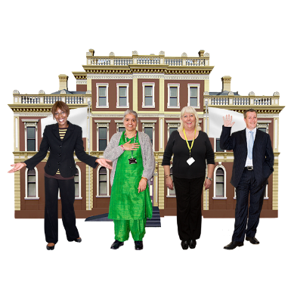
The new Code of Practice started from 1 September 2021.
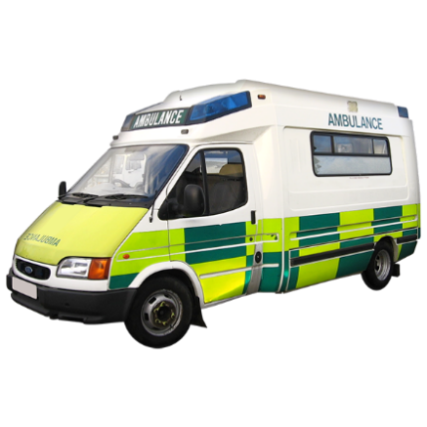
We are working with local authorities, local health boards and NHS trusts. We are working together to make sure the Code helps to make autism services in Wales better.

NHS trusts are organisations like the Welsh Ambulance Service and Public Health Wales.

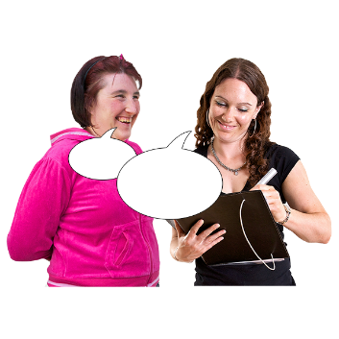
About this questionnaire
We got feedback from people about the Code of Practice. People told us that the Code should also include neurodevelopmental conditions.
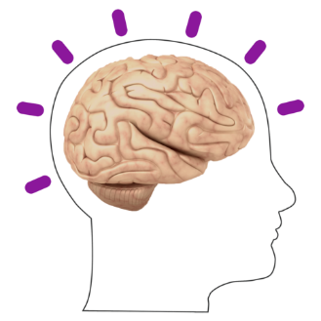

A neurodevelopmental condition is when the brain has developed in a different way which affects a person’s behaviour, memory or ability to learn.
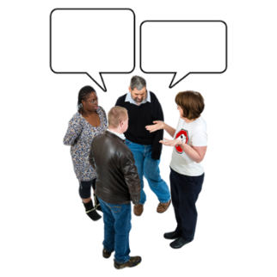
We want to know more about people's experiences with neurodevelopmental conditions.
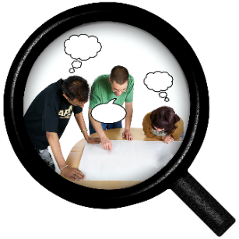
The Learning Disability, Autism and Neurodevelopmental Team in Welsh Government have written this questionnaire.

We would like you to answer the questions if you:
- are on the waiting lists for
- or have already had a diagnosis.

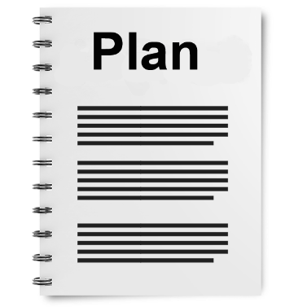
The Welsh Government is working on writing a National Neurodevelopmental Action Plan.

The information we get through this questionnaire will help to write this plan.

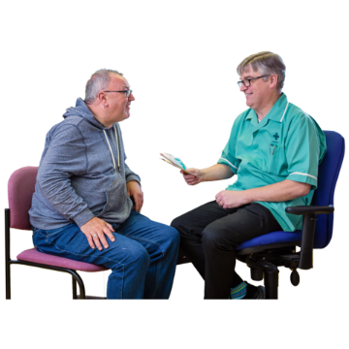
Through this questionnaire, we want to:

- Understand how services work for people with neurodevelopmental conditions.
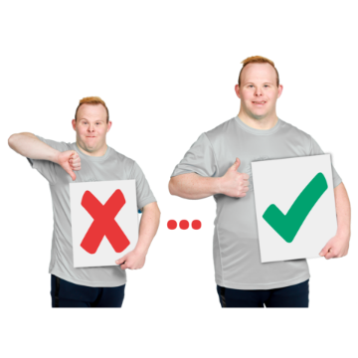

- Find out how to improve services for people with neurodevelopmental conditions and their families.
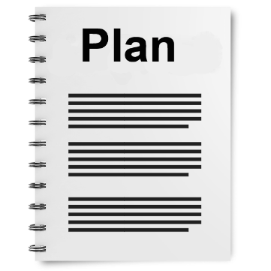

- Use what we learn to write the National Neurodevelopmental Action Plan.

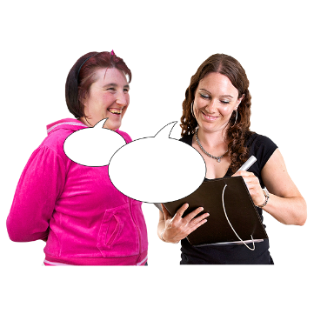
- Give people with neurodevelopmental conditions, their families and carers a chance to share their views, and experiences about services.
You do not have to answer questions that do not apply to you.

Questions

You can ask a person to help and support you answer the questions if needed.
- Are you or the person you support waiting for an assessment?

An assessment is a set of questions and tests that can be done to see if a person has a certain condition, or to see if they need care and support.

Yes ☐

No ☐

Before the diagnosis

- Tell us about who made the referral and which service you were referred for?

A diagnosis is when a doctor looks at a person’s health and behaviour and decides if they have a condition or not.

Referral means to send someone to a service or for an assessment.

- Tell us if you had any problems getting a referral. Or if you were told you could not have an assessment.

- What support or information did you or have you had when waiting for an assessment? And was it helpful?

After the diagnosis
- Did you get a diagnosis for a neurodevelopmental condition? If yes, what was the diagnosis?

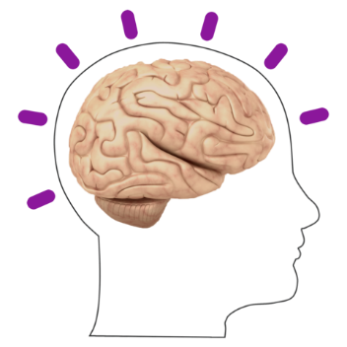

- Did you get a diagnosis for more than 1 neurodevelopmental condition? If yes, what were the conditions?

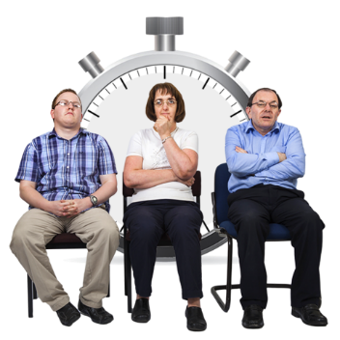

- Are you waiting for any more assessments?

Yes ☐

No ☐

- Tell us if you had any information or support after your diagnosis? If yes, was it helpful?

- If you were not given a diagnosis, were you offered any other support or services?

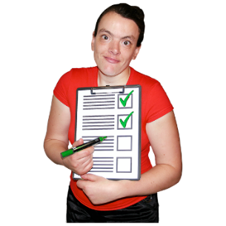
- What other support and information would have been of benefit?

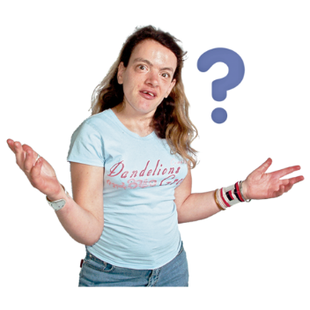
- If you were given the support and information to take care of your condition, do you think you would still want a diagnosis?

Yes ☐

No ☐

Thank you

