**Easy Read**

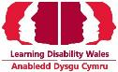

**Reducing restrictive practice workshop**

**Registration form**

**October 2022**

# Registration form

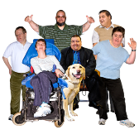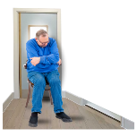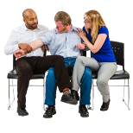

Please fill out this form to register for a place at 1 of our workshops about **restrictive practices**.

**Restrictive practices** are ways of stopping people from doing something. Or controlling people. For example:

* holding someone down to stop them hurting themselves or others
* giving them medicine to stop them doing something harmful
* making them stay in a room away from other people.

There are a certain number of places at each workshop. They will be given to people who register first.



We will tell you if you have a place at your chosen workshop as soon as possible.

**Name:**

**Your e-mail address:**

**Your phone number**

**Which workshop do you want to go to?**

* **Cardiff** - South Wales



Tuesday 4 October 2022

Village Hotel, Cardiff

* **Conwy** - North Wales

Thursday 6 October 2022

Conwy Business Centre, Conwy

* **Carmarthen** - West Wales

Thursday 27 October 2022

Ffos Las Racecourse, Kidwelly

**Are you able to travel to and from the workshop by yourself?**

Yes

No

**If you said no, a member of the team will contact you**

**We want to make sure you enjoy the workshop. Please let us know your access or disability needs:**

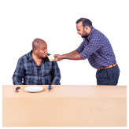

**Would you like to take part in the workshop in English or Welsh?**

Cymraeg | Welsh

Saesneg | English

**Do you have any dietary needs or allergies? If yes please tell us what they are in the box below:**

**Will you want to bring someone with you to support you on the day?**



Yes

No

**If yes please tell us your supporters Name, Email and Telephone number:**

**Supporter’s name:**

**Supporter’s e-mail address:**

**Supporter’s phone number**